Lesson 14 Practice Problems
- A pyramid has a height of 5 inches and a volume of 60 cubic inches. Select all figures that could be the base for this pyramid.
  - a square with side length 6 inches
  - a 3 inch by 4 inch rectangle
  - a 4 inch by 9 inch rectangle
  - a circle with radius 4 inches
  - a right triangle with one side 5 inches and the hypotenuse 13 inches
  - a hexagon with an area of 36 square inches
- A company makes a block of cheese in the shape of a rectangular prism with dimensions 4 inches by 2 inches by 2 inches. They want to make a new block, in the shape of a rectangular pyramid, that uses the same amount of cheese. Determine two sets of possible dimensions for the pyramid.
- Select all the solids with volume 40 cubic units.

- A. rectangular prism
- 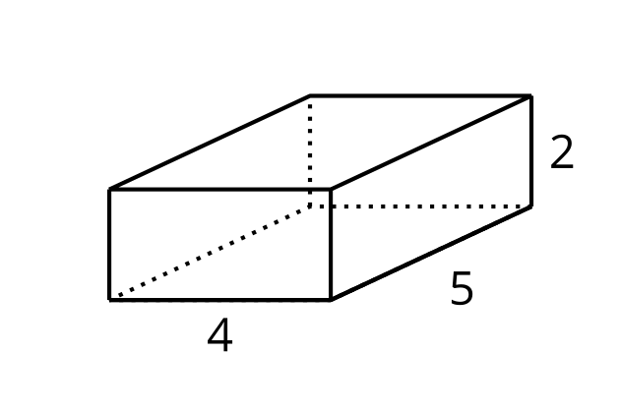

- B. right rectangular pyramid
- 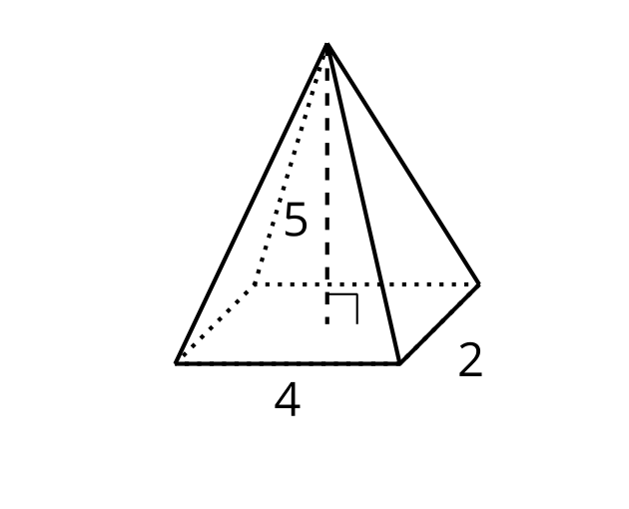

- C. right cone
- 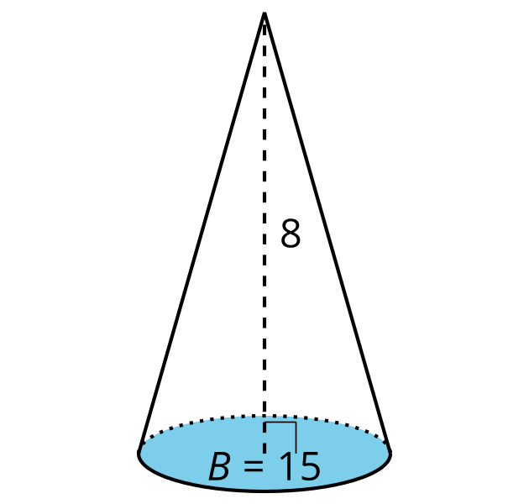

- D. triangular pyramid
- 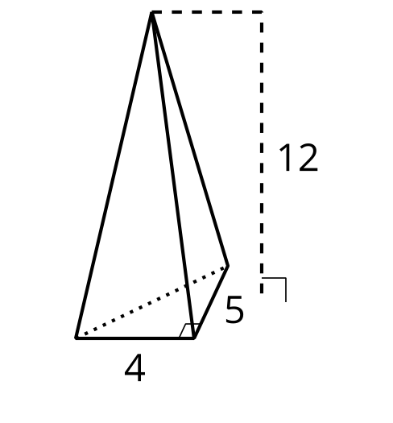

- E. right cylinder
- 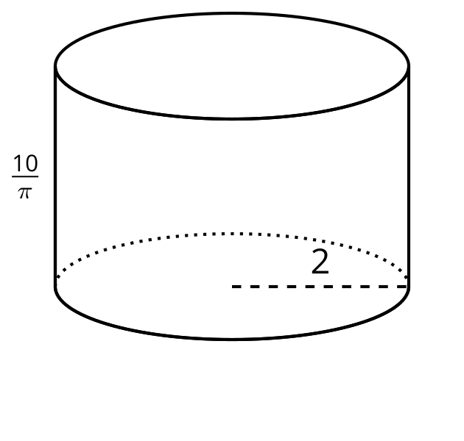

- F. right hexagonal prism
- 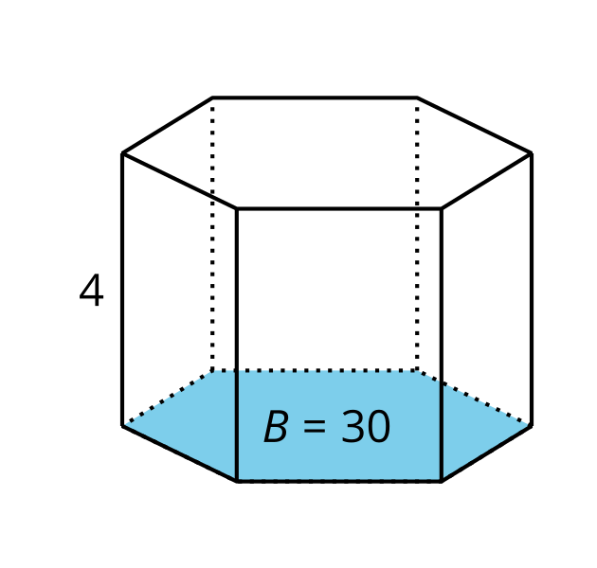
  - Solid A
  - Solid B
  - Solid C
  - Solid D
  - Solid E
  - Solid F
- The volume of a pyramid is 50 cubic units. The base is a square with sides of length 5. What is the height?
  - 2 units
  - 4 units
  - 6 units
  - 10 units
- (From Unit 5, Lesson 13.)
- A cone and a cylinder have the same radius and height. The volume of the cone is $100π$ cubic feet. What is the volume of the cylinder?
- (From Unit 5, Lesson 13.)
- A solid can be constructed with 2 congruent triangles and 3 rectangles. What is the name of this solid?
  - right triangular pyramid
  - right triangular prism
  - square pyramid
  - rectangular prism
- (From Unit 5, Lesson 12.)
- An oblique cylinder with a base of radius 3 is shown.
- The top of the cylinder can be obtained by translating the base by the directed line segment $AB$ which has length $6\sqrt{2}$. The segment $AB$ forms a ${45}^{∘}$ angle with the plane of the base. What is the volume of the cylinder?
- 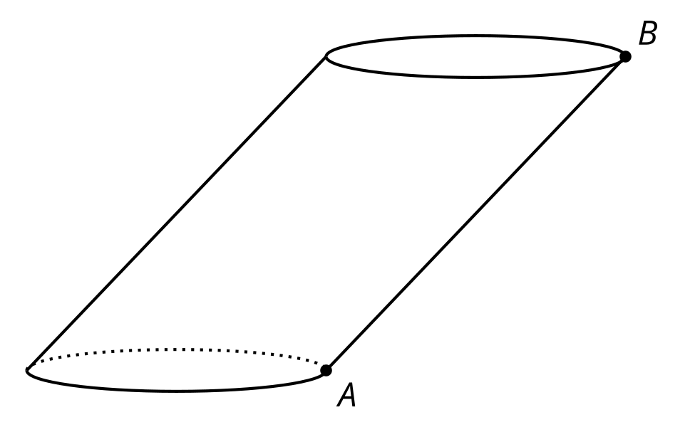
  - $18π$ cubic units
  - $18π\sqrt{2}$ cubic units
  - $36π$ cubic units
  - $54π$ cubic units
- (From Unit 5, Lesson 11.)
- Mai, Andre, and Lin are discussing the volume of a scaled box. The orginal box holds 7 cubic inches. The new box holds 448 cubic inches. Mai thinks the scale factor is 4, Andre thinks the scale factor is 16, and Lin thinks the scale factor is 64. Do you agree with any of them? Explain your reasoning.
- (From Unit 5, Lesson 6.)
© CC BY 2019 by Illustrative Mathematics®

