Unit 6 Lesson 4: Distances and Circles

1 Going the Distance (Warm up)

Student Task Statement
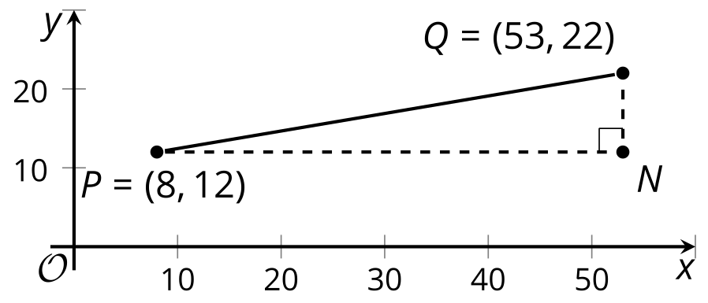
Andre says, “I know that I can find the distance between two points in the plane by drawing in a right triangle and using the Pythagorean Theorem. But I’m not sure how to find the lengths of the legs of the triangle when I can’t just count the squares on the graph.”
Explain to Andre how he can find the lengths of the legs in the triangle in the image. Then, calculate the distance between points $P$ and $Q$.

2 Circling the Problem

Student Task Statement
The image shows a circle with center $\left(6,10\right)$ and radius 17 units.
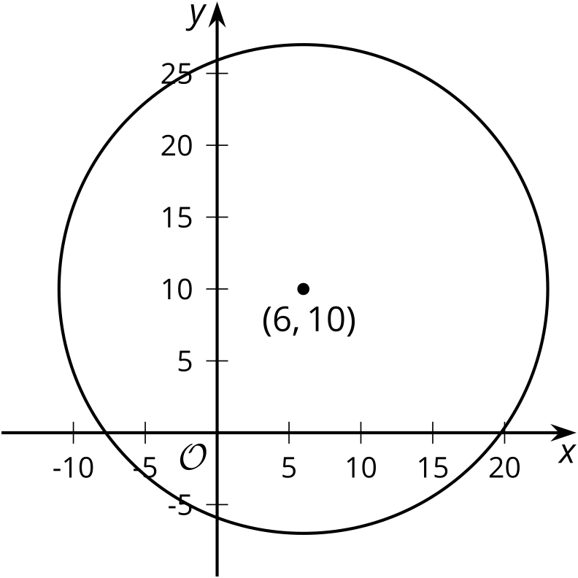
- The point $\left(14,25\right)$ looks like it might be on the circle. Verify if it really is on the circle. Explain or show your reasoning.
- The point $\left(22,3\right)$ looks like it might be on the circle. Verify if it really is on the circle. Explain or show your reasoning.
- In general, how can you check if a particular point $\left(x,y\right)$ is on the circle?

Activity Synthesis
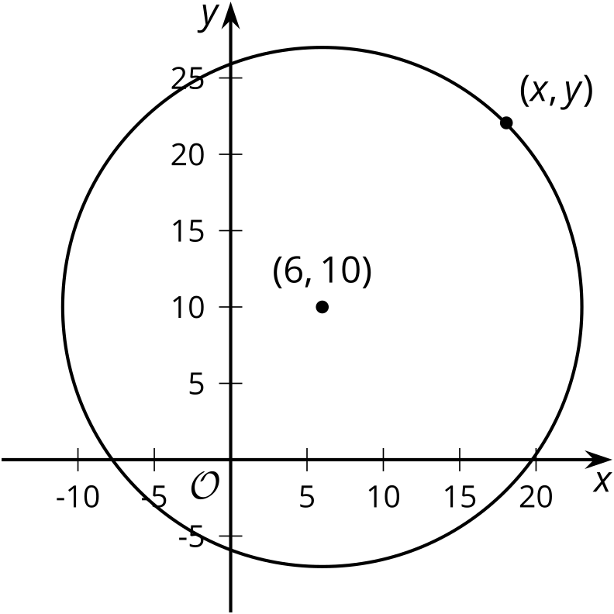

3 Building an Equation for a Circle

Student Task Statement
The image shows a circle with center $\left(\text{-}3,6\right)$ and radius 13 units.
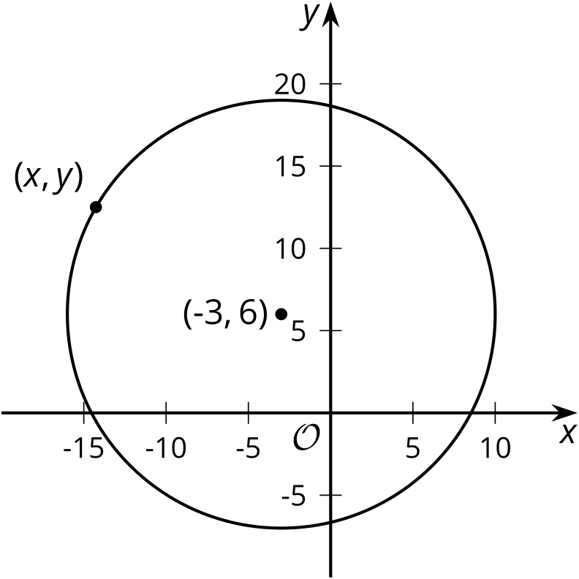
- Write an equation that would allow you to test whether a particular point $\left(x,y\right)$ is on the circle.
- Use your equation to test whether $\left(9,1\right)$ is on the circle.
- Suppose you have a circle with center $\left(h,k\right)$ and radius $r$. Write an equation that would allow you to test whether a particular point $\left(x,y\right)$ is on the circle.

Activity Synthesis
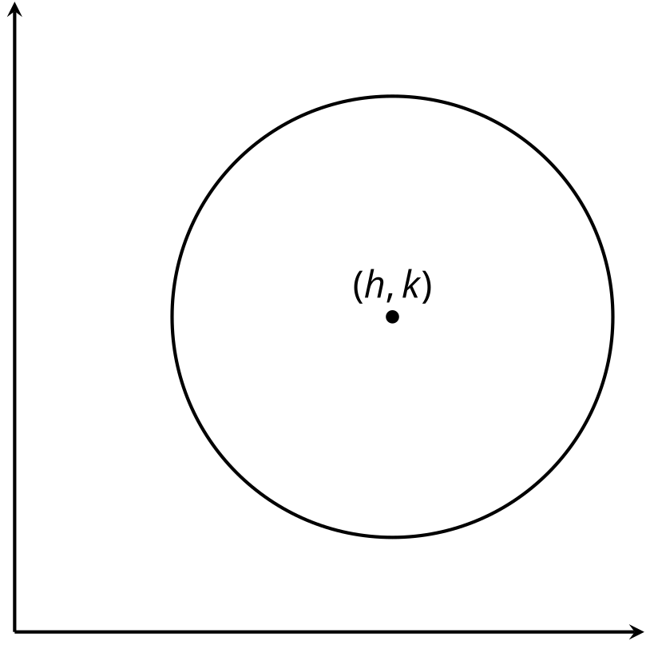

Images for Activity Synthesis
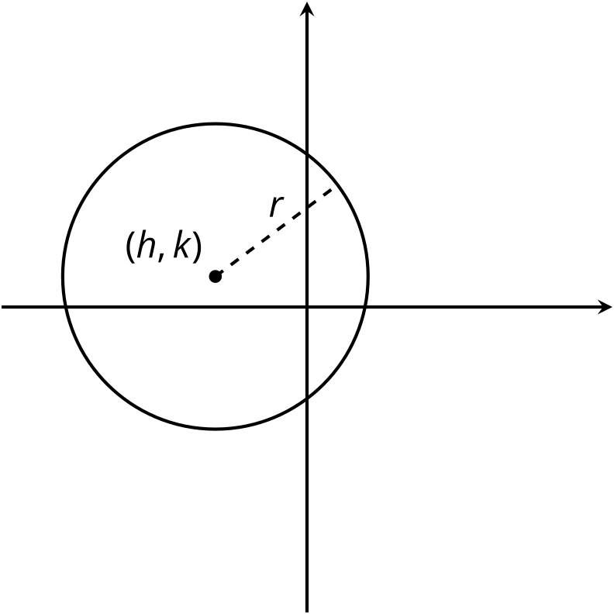
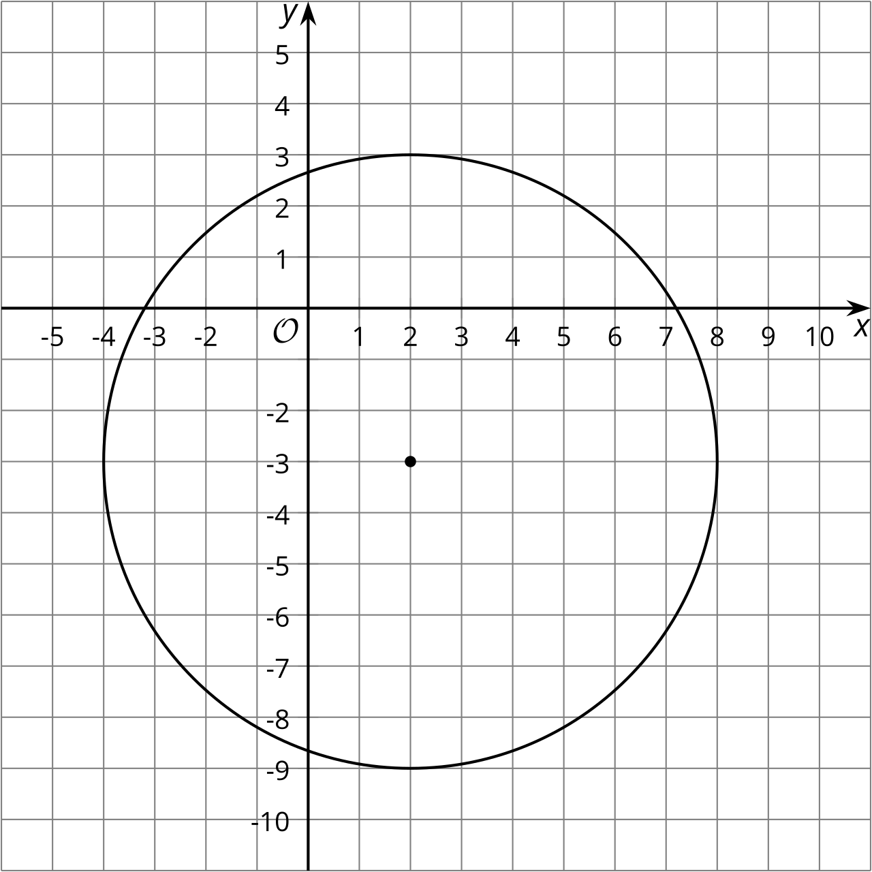
© CC BY 2019 by Illustrative Mathematics®

