Lesson 7: Put Together Flat Shapes
- Let’s build a new shape from smaller shapes.

Warm-up: Notice and Wonder: Dogs
What do you notice?
What do you wonder?
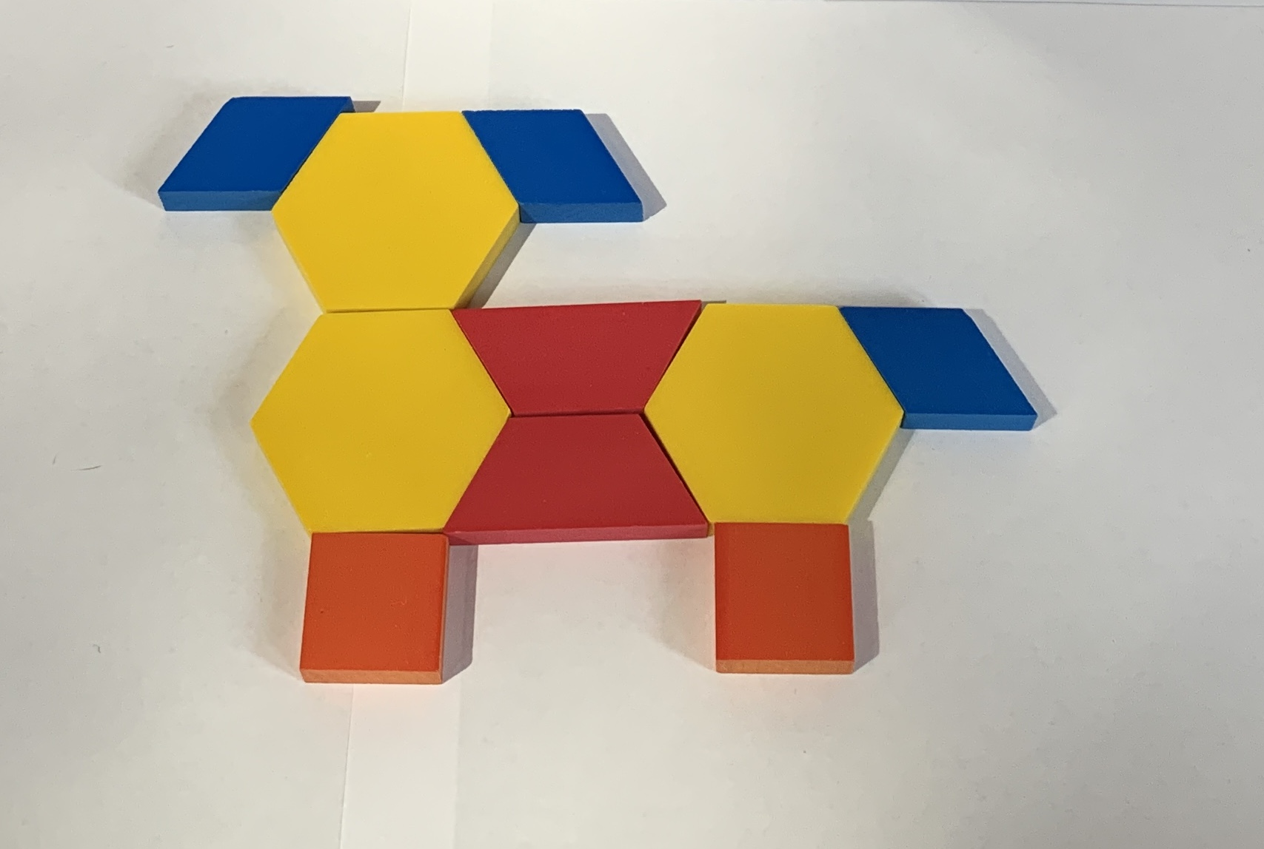
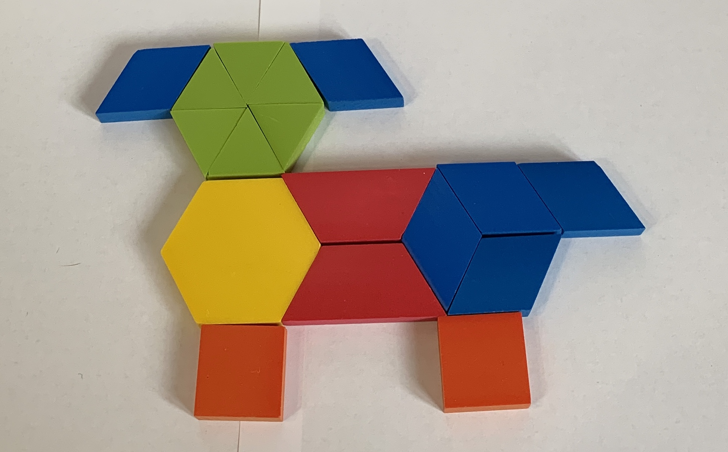

7.2: Shape Pictures
- Build something using the pattern blocks.
- Trace what you made and record how many pattern blocks you used.
- 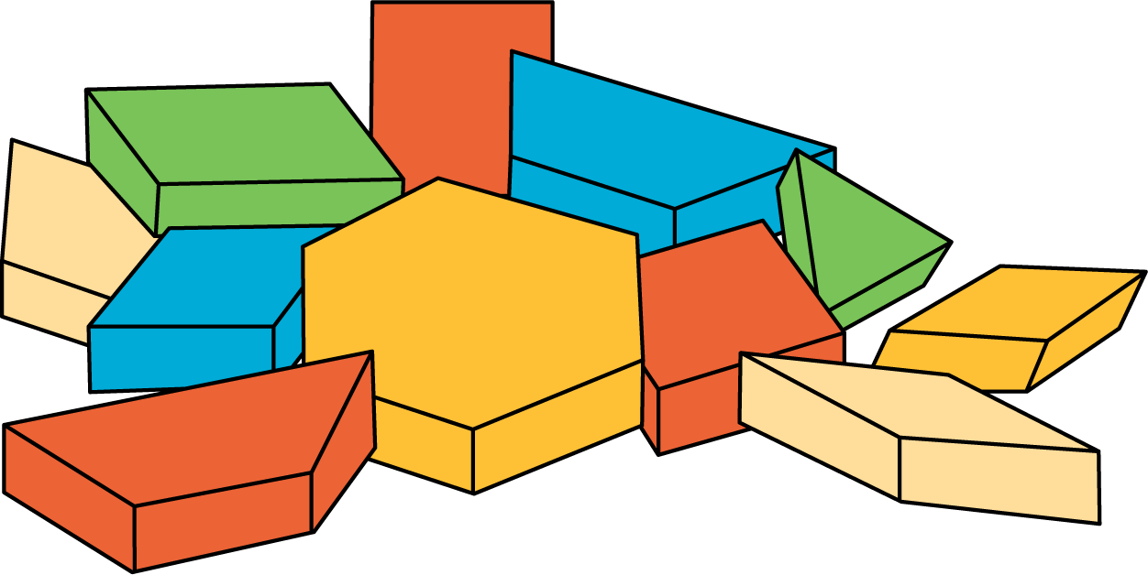
- Make the same object you just made, using different pattern blocks.
- Record how many pattern blocks you used.
If you have time: Build the same object again, using the most pattern blocks you can.
Record how many pattern blocks you used.

Section Summary
Section Summary
We learned about solid shapes.
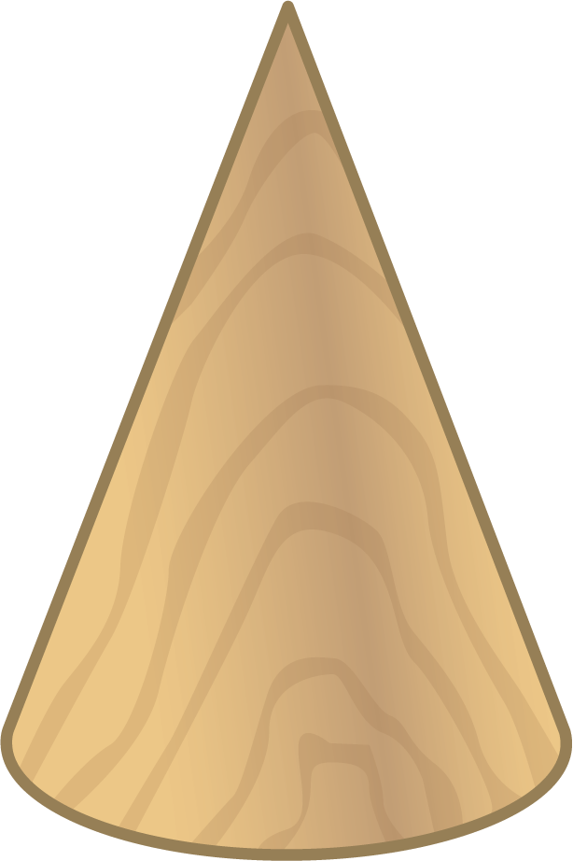
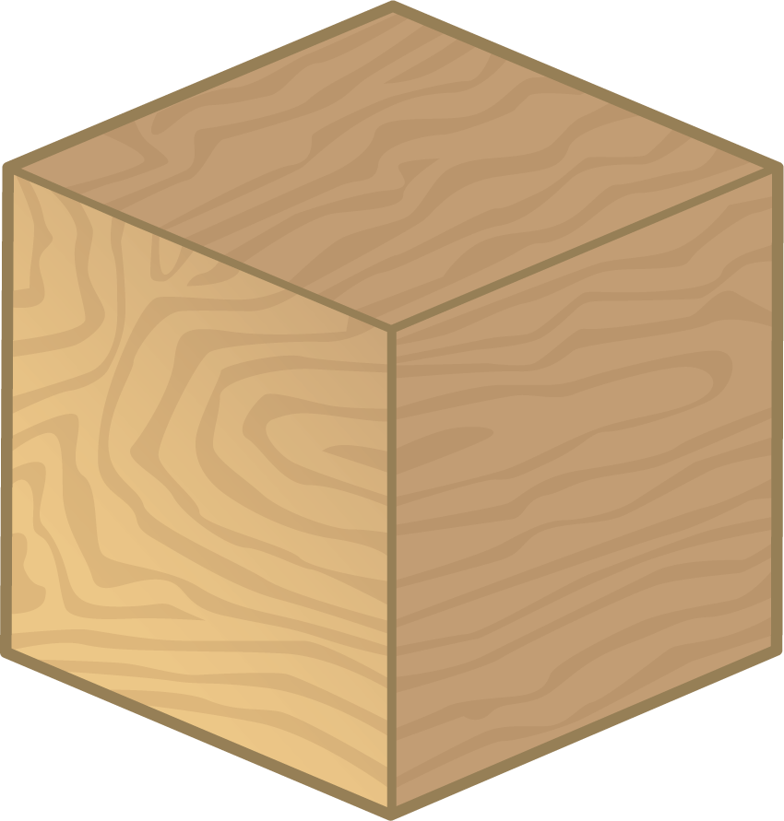
We learned about flat shapes.
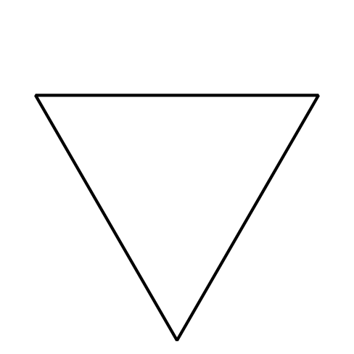
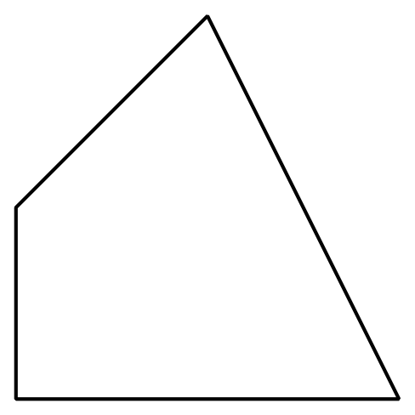
We described and named shapes.
This shape is a triangle because it has 3 straight sides and 3 corners.
These shapes are all rectangles because they have 4 straight sides and 4 square corners.
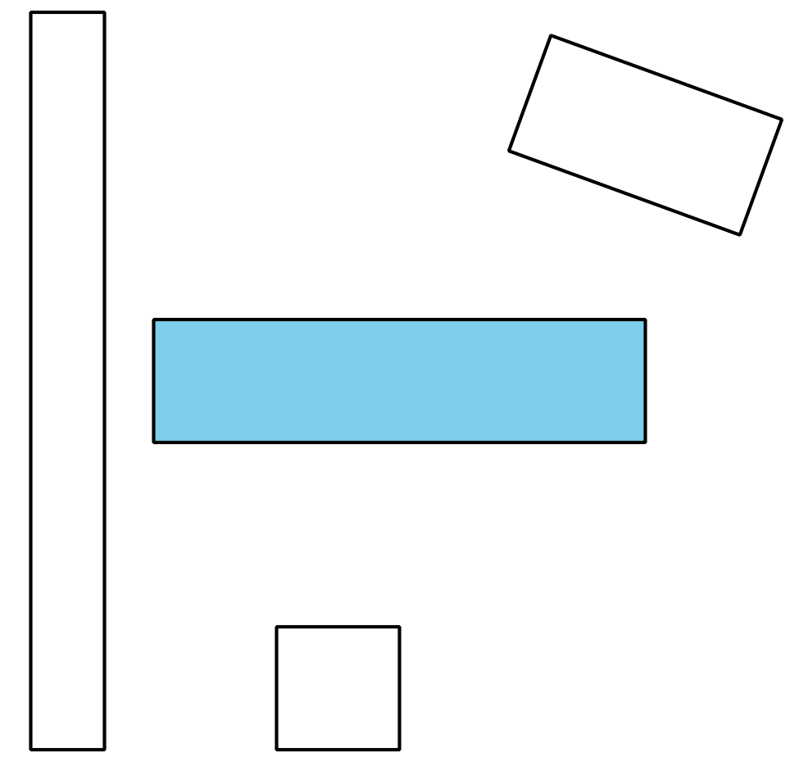
We built larger shapes from smaller shapes.
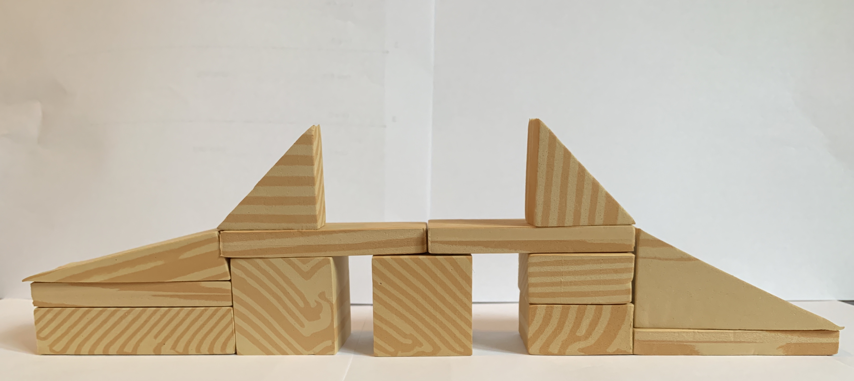
© CC BY 2021 Illustrative Mathematics®

