Unit 3 Lesson 15: Finding This Percent of That

1 Number Talk: Decimals (Warm up)

Student Task Statement
Find the value of each expression mentally.
$\left(0.23\right)⋅100$
$50÷100$
$145⋅\frac{1}{100}$
$7÷100$

2 Audience Size

Student Task Statement
A school held several evening activities last month—a music concert, a basketball game, a drama play, and literacy night. The music concert was attended by 250 people. How many people came to each of the other activities?
- Attendance at a basketball game was 30% of attendance at the concert.
- Attendance at the drama play was 140% of attendance at the concert.
- Attendance at literacy night was 44% of attendance at the concert.

3 Everything is On Sale

Student Task Statement
During a sale, every item in a store is 80% of its regular price.
- If the regular price of a T-shirt is $10, what is its sale price?
- The regular prices of five items are shown here. Find the sale price of each item.
 | - item 1 | - item 2 | - item 3 | - item 4 | - item 5
- regular price | - $1 | - $4 | - $10 | - $55 | - $120
- sale price
- You found 80% of many values. Was there a process you repeated over and over to find the sale prices? If so, describe it.
- 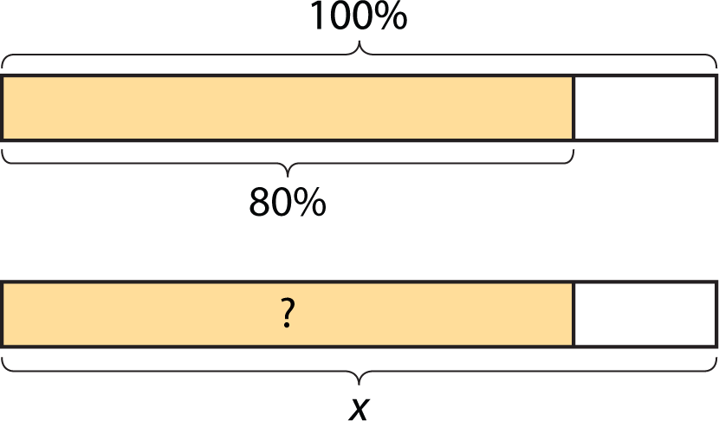
- Select all of the expressions that could be used to find 80% of $x$. Be prepared to explain your reasoning.
- $\frac{8}{100}⋅x$
- $\frac{80}{100}⋅x$
- $\frac{8}{10}⋅x$
- $\frac{4}{10}⋅x$
- $\frac{8}{5}⋅x$
- $\frac{4}{5}⋅x$
- $80⋅x$
- $8⋅x$
- $\left(0.8\right)⋅x$
- $\left(0.08\right)⋅x$
© CC BY Open Up Resources. Adaptations CC BY IM.

