Unit 8 Lesson 17: Designing Simulations

1 Number Talk: Division (Warm up)

Student Task Statement
Find the value of each expression mentally.
$\left(4.2+3\right)÷2$
$\left(4.2+2.6+4\right)÷3$
$\left(4.2+2.6+4+3.6\right)÷4$
$\left(4.2+2.6+4+3.6+3.6\right)÷5$

2 Breeding Mice

Student Task Statement
A scientist is studying the genes that determine the color of a mouse’s fur. When two mice with brown fur breed, there is a 25% chance that each baby will have white fur. For the experiment to continue, the scientist needs at least 2 out of 5 baby mice to have white fur.
To simulate this situation, you can flip a coin twice for each baby mouse.
- If the coin lands heads up both times, it represents a mouse with white fur.
- Any other result represents a mouse with brown fur.
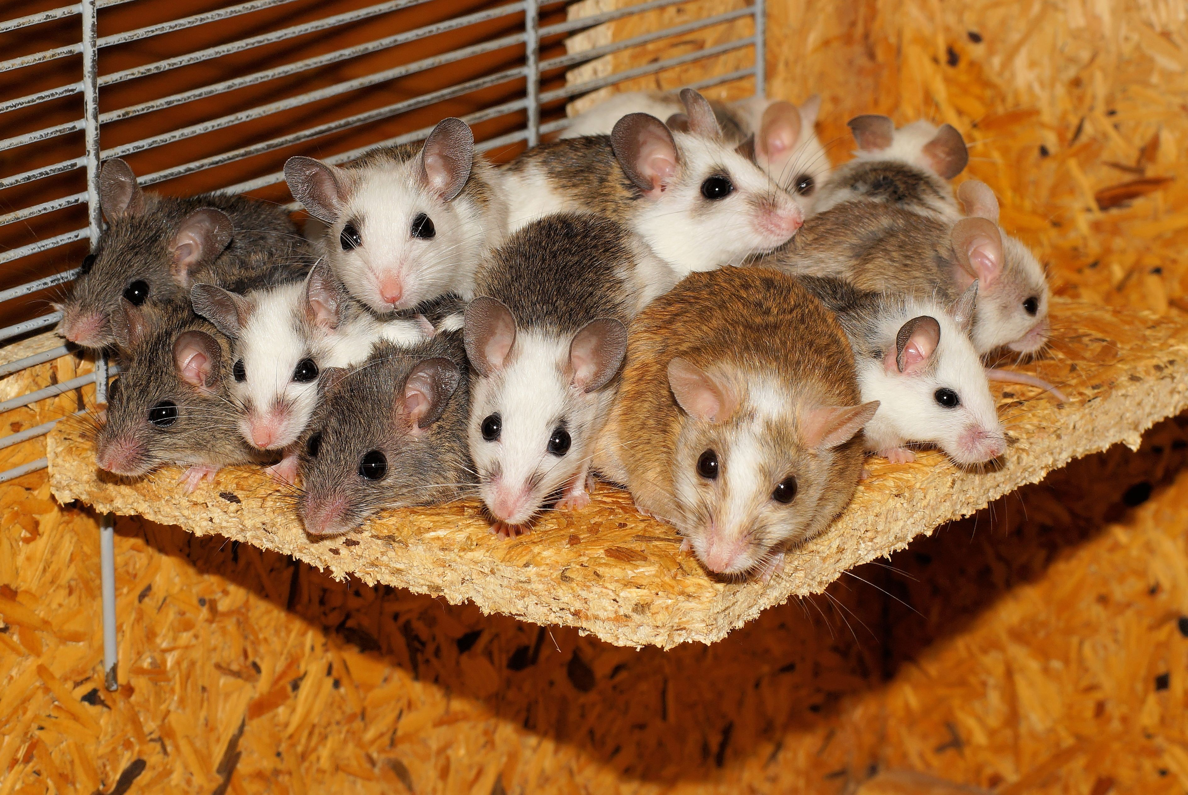
- Simulate 3 litters of 5 baby mice and record your results in the table.
 | - mouse 1 | - mouse 2 | - mouse 3 | - mouse 4 | - mouse 5 | - Do at least 2  have white fur?
- simulation 1
- simulation 2
- simulation 3
- Based on the results from everyone in your group, estimate the probability that the scientist’s experiment will be able to continue.
- How could you improve your estimate?

3 Designing Simulations

Student Task Statement
Your teacher will give your group a paper describing a situation.
- Design a simulation that you could use to estimate a probability. Show your thinking. Organize it so it can be followed by others.
- Explain how you used the simulation to answer the questions posed in the situation.
© CC BY Open Up Resources. Adaptations CC BY IM.

