Lesson 9: Side Length Quotients in Similar Triangles
Let’s find missing side lengths in triangles.

9.1: Two-three-four and Four-five-six
Triangle $A$ has side lengths 2, 3, and 4. Triangle $B$ has side lengths 4, 5, and 6. Is Triangle $A$ similar to Triangle $B$?

9.2: Quotients of Sides Within Similar Triangles
Triangle $ABC$ is similar to triangles $DEF$, $GHI$, and $JKL$. The scale factors for the dilations that show triangle $ABC$ is similar to each triangle are in the table.
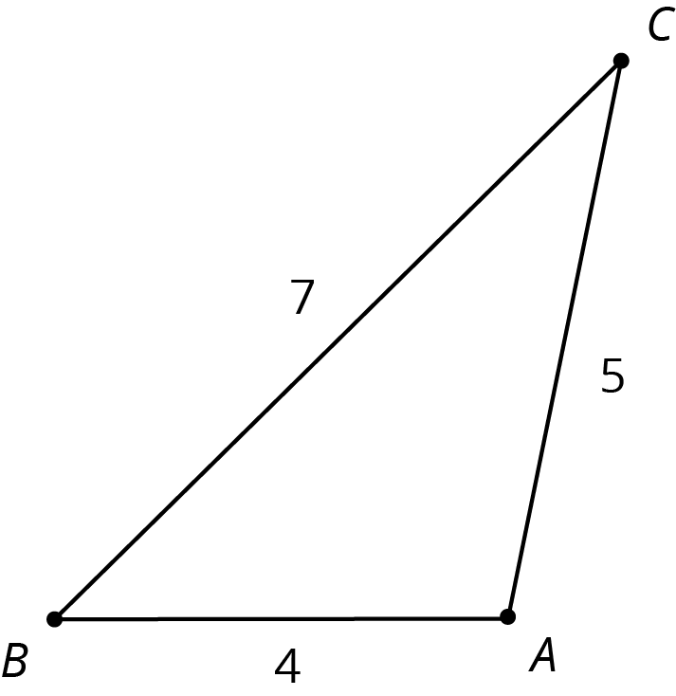
- Find the side lengths of triangles $DEF$, $GHI$, and $JKL$. Record them in the table.
- triangle | - scale factor | - length of  short side | - length of  medium side | - length of  long side
- $ABC$ | - 1 | - 4 | - 5 | - 7
- $DEF$ | - 2
- $GHI$ | - 3
- $JKL$ | - $\frac{1}{2}$
- Your teacher will assign you one of the three columns. For all four triangles, find the quotient of the triangle side lengths assigned to you and record it in the table. What do you notice about the quotients?
- triangle | - (long side) $÷$ (short side) | - (long side) $÷$ (medium side) | - (medium side) $÷$ (short side)
- $ABC$ | - $\frac{7}{4}$ or 1.75
- $DEF$
- $GHI$
- $JKL$
- Compare your results with your partners’ and complete your table.

Are you ready for more?
Triangles $ABC$ and $DEF$ are similar. Explain why $\frac{AB}{BC}=\frac{DE}{EF}$.
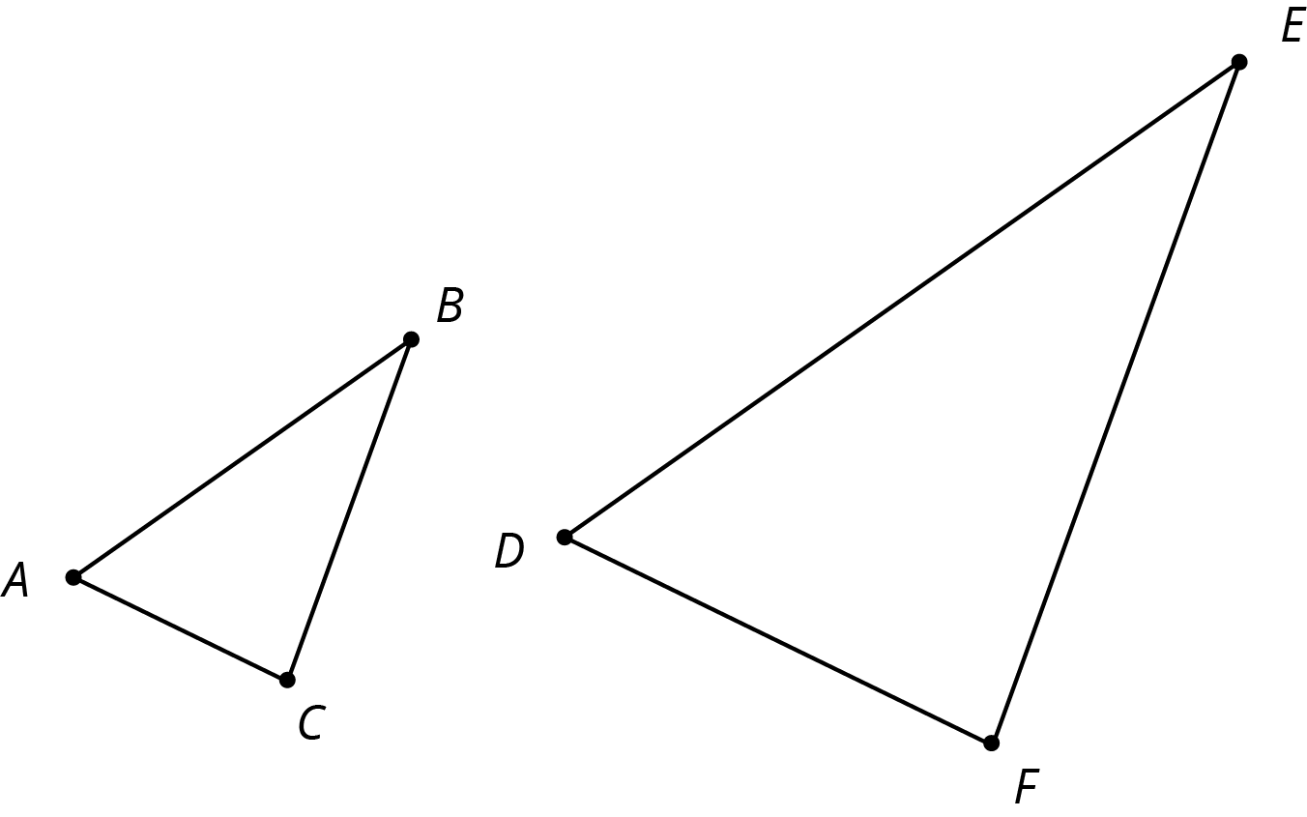

9.3: Using Side Quotients to Find Side Lengths of Similar Triangles
Triangles $ABC$, $EFD$, and $GHI$ are all similar. The side lengths of the triangles all have the same units. Find the unknown side lengths.
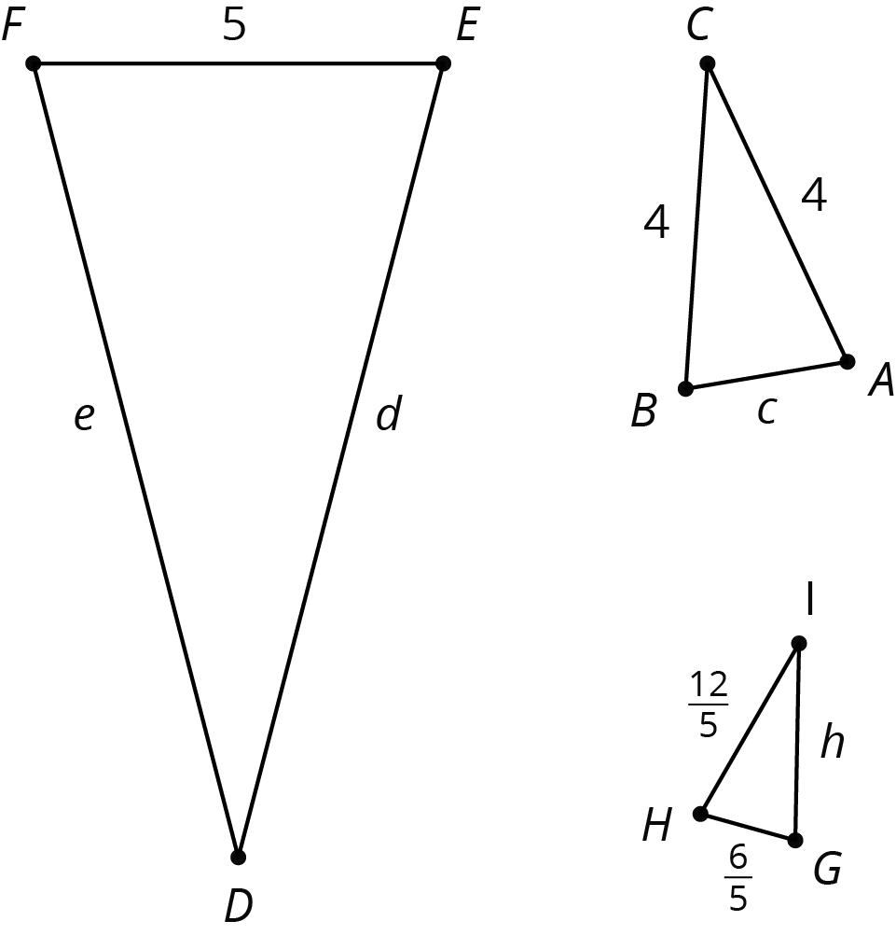

Lesson 9 Summary
If two polygons are similar, then the side lengths in one polygon are multiplied by the same scale factor to give the corresponding side lengths in the other polygon.
For these triangles the scale factor is 2:
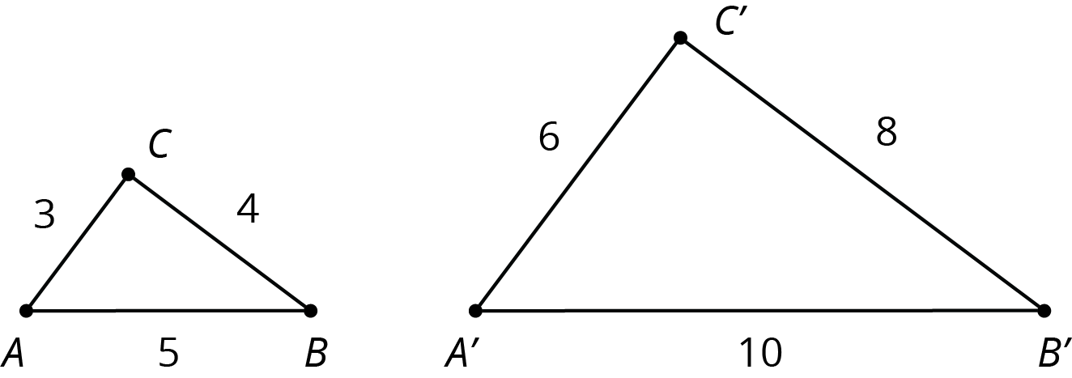
Here is a table that shows relationships between the short and medium length sides of the small and large triangle.
 | small triangle | large triangle
medium side | 4 | 8
short side | 3 | 6
(medium side) $÷$ (short side) | $\frac{4}{3}$ | $\frac{8}{6}=\frac{4}{3}$
The lengths of the medium side and the short side are in a ratio of $4:3$. This means that the medium side in each triangle is $\frac{4}{3}$ as long as the short side. This is true for all similar polygons; the ratio between two sides in one polygon is the same as the ratio of the corresponding sides in a similar polygon.
We can use these facts to calculate missing lengths in similar polygons. For example, triangles $A^{′}B^{′}C^{′}$ and $ABC$ shown here are similar. Let's find the length of segment $B^{′}C^{′}$.
In triangle $ABC$, side $BC$ is twice as long as side $AB$, so this must be true for any triangle that is similar to triangle $ABC$. Since $A^{′}B^{′}$ is 1.2 units long and $2⋅1.2=2.4$, the length of side $B^{′}C^{′}$ is 2.4 units.
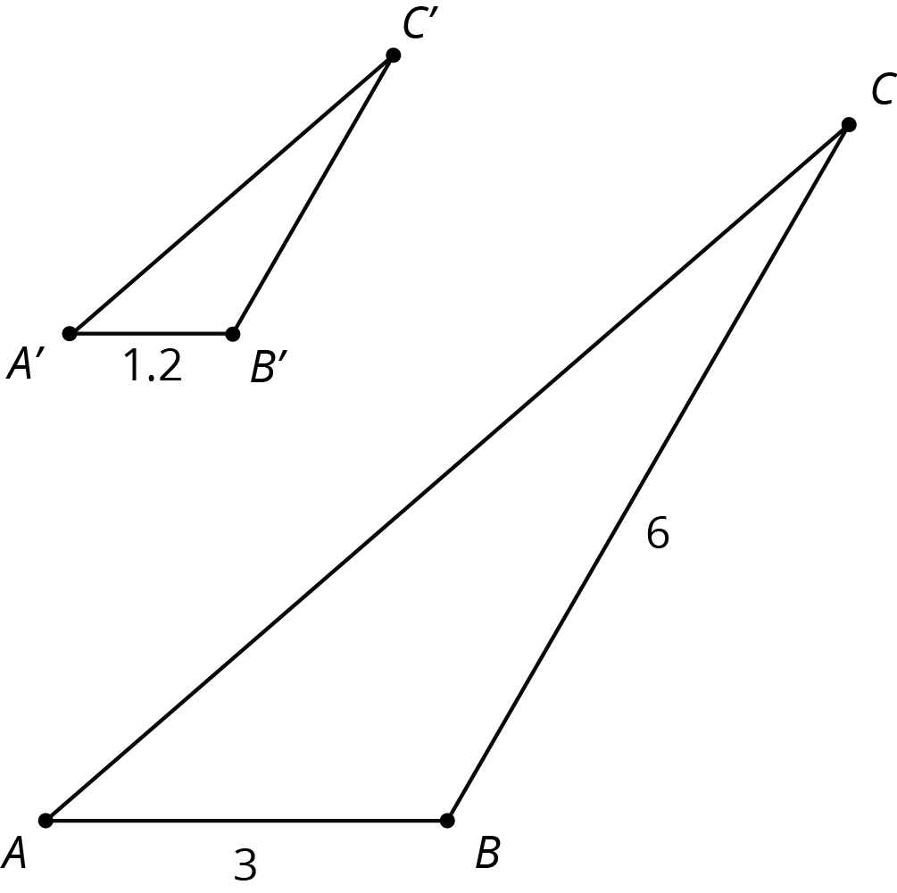
© CC BY Open Up Resources. Adaptations CC BY IM.

