Lesson 12 Practice Problems
- Give each solid a geometric name. Be as precise as you can.

- A
- 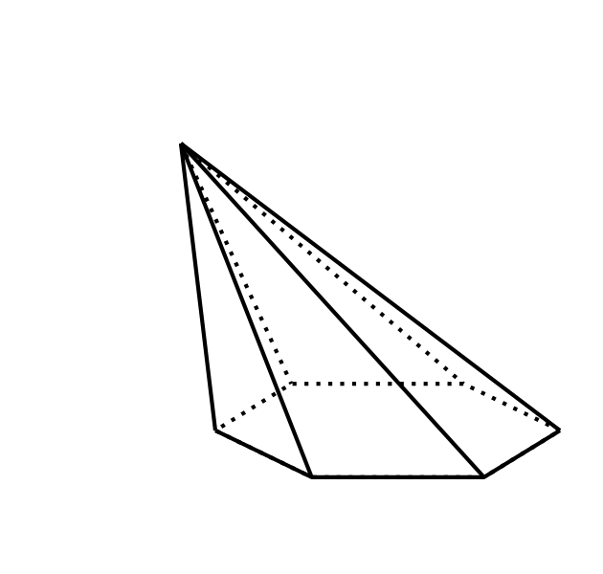

- B
- 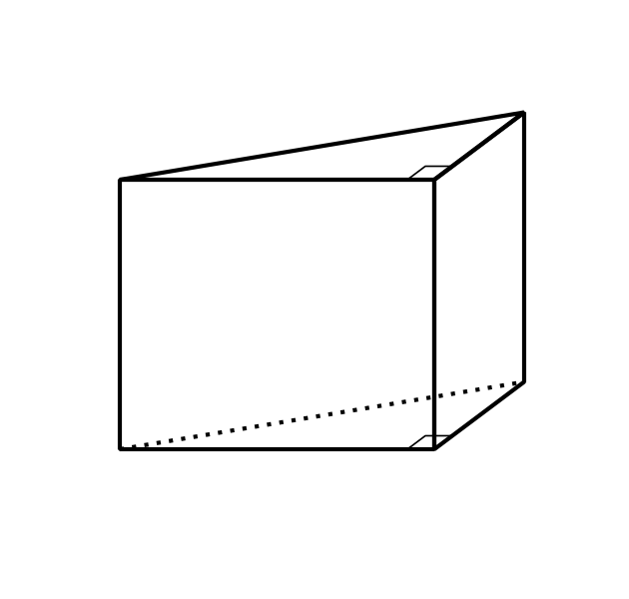

- C
- 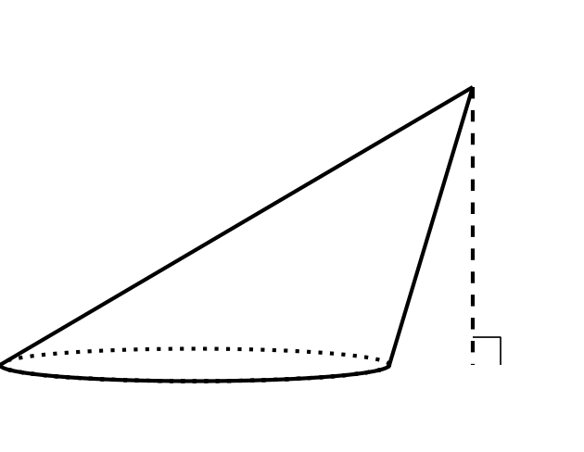
- Each set of two-dimensional shapes is the complete list of faces from a particular solid. Match each set of shapes with the solid they came from.
  - 2 congruent triangles and 3 rectangles
  - 4 triangles and 1 rectangle
  - 2 squares and 4 congruent parallelograms
  - 4 congruent, equilateral triangles
  - right triangular prism
  - oblique square prism
  - right triangular pyramid
  - rectangular pyramid
- These 3 congruent square pyramids can be assembled into a cube with side length 1 foot. What is the volume of each pyramid?
- 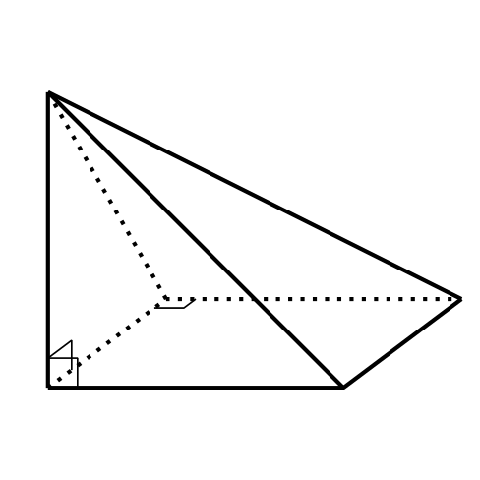
- A prism has a height of 4 inches and a volume of 120 cubic inches. Select all figures that could be the base for this prism.
  - a 5 inch by 6 inch rectangle
  - a square with side length 5 inches
  - a circle with radius 5 inches
  - a star-shaped base with area 30 square inches
  - a right triangle with legs 5 inches and 12 inches
- (From Unit 5, Lesson 11.)
- This prism has a right triangle for a base. The volume of the prism is 54 cubic units. What is the value of $h$?
- 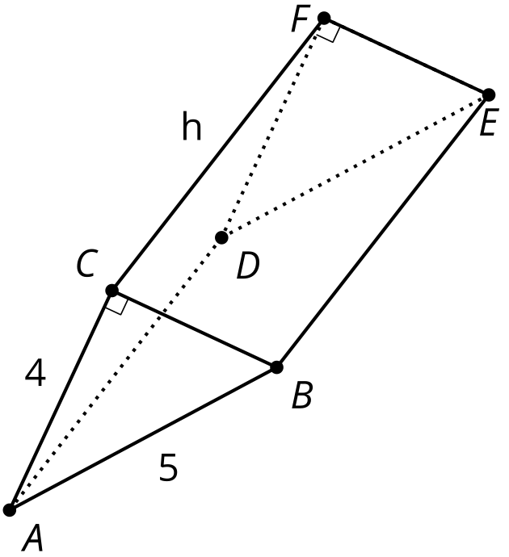
- (From Unit 5, Lesson 11.)
- This solid has curved sides. All cross sections parallel to the base are squares measuring 3 units on each side. The height from the base to the top is 5 units. What is the volume of this solid?
- 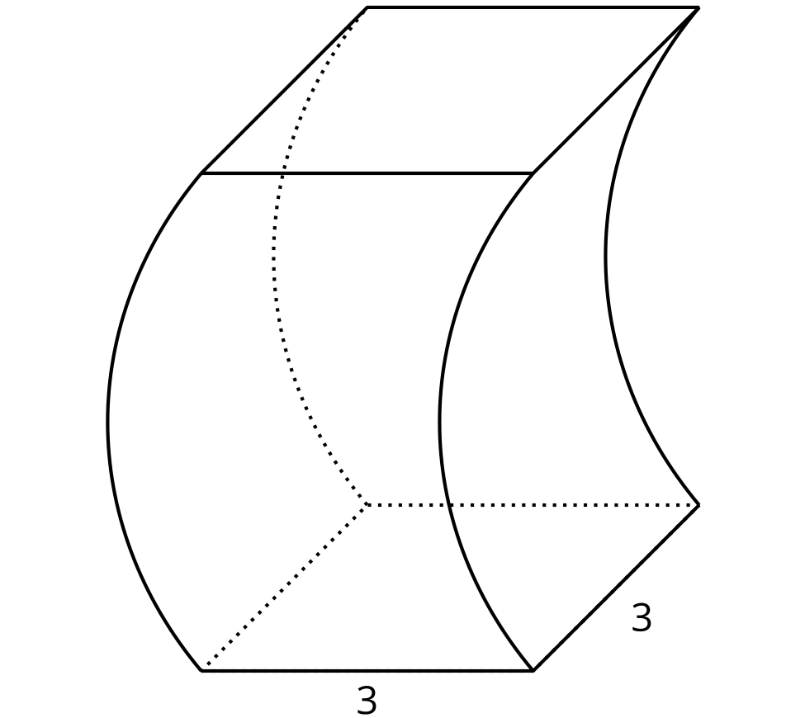
- (From Unit 5, Lesson 10.)
- Find the volume of each solid.
  - a cylinder with radius 3 inches and height 2 inches
  - a hexagonal prism whose base has area 4.5 square centimeters and whose height is 7 centimeters
  - a prism 5 feet tall whose base is a right triangle with leg lengths $\frac{3}{2}$ feet and 9 feet
- (From Unit 5, Lesson 9.)
- A circle with area $π$ square units is dilated using a scale factor of 5. What is the area of the dilated circle?
- (From Unit 5, Lesson 4.)
© CC BY 2019 by Illustrative Mathematics®

