Unit 1 Lesson 1: Human Box Plot

1 Math Talk: Subtraction (Warm up)

Student Task Statement
Evaluate mentally.
$100−20$
$100−25$
$100−73$
$100−38$

2 Human Box Plot

Images for Launch
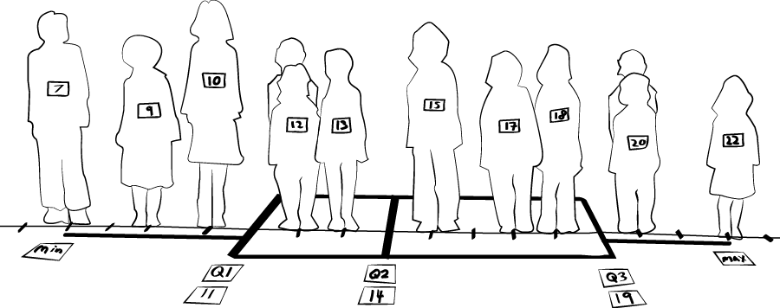

Student Task Statement
Using the list of data, find the lower quartile, median, upper quartile, lowest value, and highest value of the data set. Follow your teacher’s directions to create a human box plot.

3 Creating Box Plots

Student Task Statement
With a partner, calculate the five-number summary and create a box plot of your data set. When you are done, include the name of your data set and display your box plot for the class to see. Then, find the answers to the questions below from your classmates’ box plots.
- Which data set’s greatest value is 10?
- Which data set has the largest range?
- Which data set has a median of 16.5?
- Which data set has the greatest upper quartile value?
- Which data set’s least value is 3?
- Which data set has the smallest range?
© CC BY 2019 by Illustrative Mathematics®

