Unit 1 Lesson 15: Building Polygons

1 Where Is Lin? (Warm up)

Student Task Statement
At a park, the slide is 5 meters east of the swings. Lin is standing 3 meters away from the slide.
- Draw a diagram of the situation including a place where Lin could be.
- How far away from the swings is Lin in your diagram?
- Where are some other places Lin could be?

2 Building Diego’s and Jada’s Shapes

Student Task Statement
- Diego built a quadrilateral using side lengths of 4 in, 5 in, 6 in, and 9 in.
  - Build such a shape.
  - Is your shape an identical copy of Diego’s shape? Explain your reasoning.
- Jada built a triangle using side lengths of 4 in, 5 in, and 8 in.
  - Build such a shape.
  - Is your shape an identical copy of Jada’s shape? Explain your reasoning.

Activity Synthesis
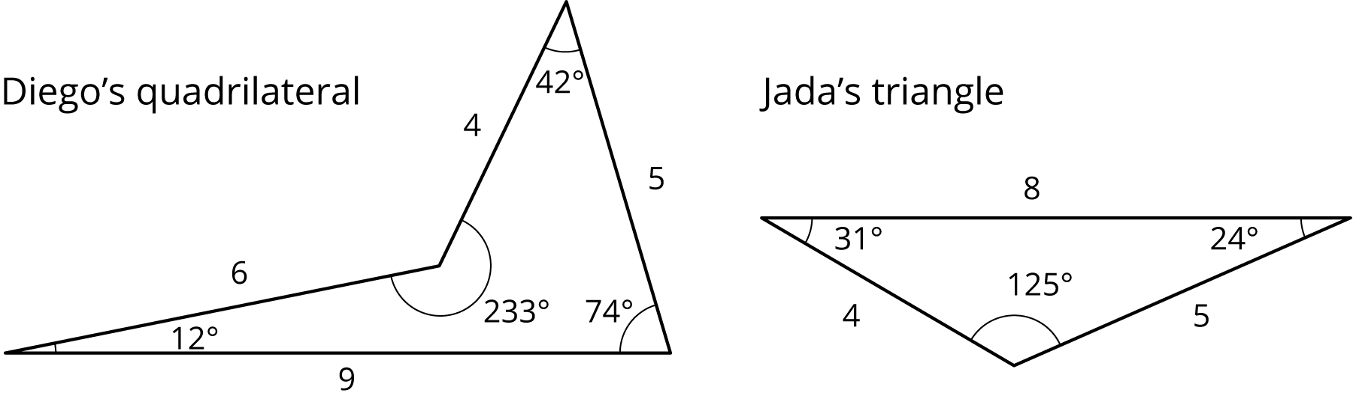

3 Swinging the Sides Around

Images for Launch
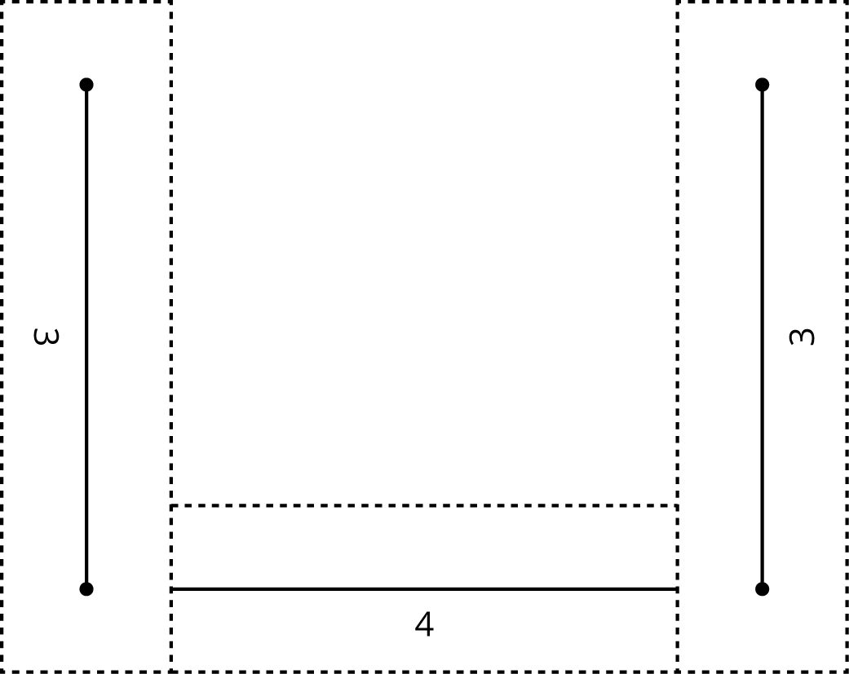

Student Task Statement
We’ll explore a method for drawing a triangle that has three specific side lengths. Your teacher will give you a piece of paper showing a 4-inch segment as well as some instructions for which strips to use and how to connect them.
- Follow these instructions to mark the possible endpoints of one side:
  - Put your 4-inch strip directly on top of the 4-inch segment on the piece of paper. Hold it in place.
  - For now, ignore the 3-inch strip on the left side. Rotate it so that it is out of the way.
  - In the 3-inch strip on the right side, put the tip of your pencil in the hole on the end that is not connected to anything. Use the pencil to move the strip around its hinge, drawing all the places where a 3-inch side could end.
  - Remove the connected strips from your paper.
- What shape have you drawn while moving the 3-inch strip around? Why? Which tool in your geometry toolkit can do something similar?
- Use your drawing to create two unique triangles, each with a base of length 4 inches and a side of length 3 inches. Use a different color to draw each triangle.
- Reposition the strips on the paper so that the 4-inch strip is on top of the 4-inch segment again. In the 3-inch strip on the left side, put the tip of your pencil in the hole on the end that is not connected to anything. Use the pencil to move the strip around its hinge, drawing all the places where another 3-inch side could end.
- Using a third color, draw a point where the two marks intersect. Using this third color, draw a triangle with side lengths of 4 inches, 3 inches, and 3 inches.
© CC BY Open Up Resources. Adaptations CC BY IM.

