Lesson 3: Increasing and Decreasing
Let’s use percentages to describe increases and decreases.

3.1: Improving Their Game
Here are the scores from 3 different sports teams from their last 2 games.
sports team | total points in game 1 | total points in game 2
football team | 22 | 30
basketball team | 100 | 108
baseball team | 4 | 12
- What do you notice about the teams’ scores? What do you wonder?
- Which team improved the most? Explain your reasoning.

3.2: More Cereal and a Discounted Shirt
- ​​
- A cereal box says that now it contains 20% more. Originally, it came with 18.5 ounces of cereal. How much cereal does the box come with now?
- ​​
- The price of a shirt is $18.50, but you have a coupon that lowers the price by 20%. What is the price of the shirt after using the coupon?

3.3: Using Tape Diagrams
- Match each situation to a diagram. Be prepared to explain your reasoning.
  - Compared with last year’s strawberry harvest, this year’s strawberry harvest is a 25% increase.
  - This year’s blueberry harvest is 75% of last year’s.
  - Compared with last year, this year’s peach harvest decreased 25%.
  - This year’s plum harvest is 125% of last year’s plum harvest.
- 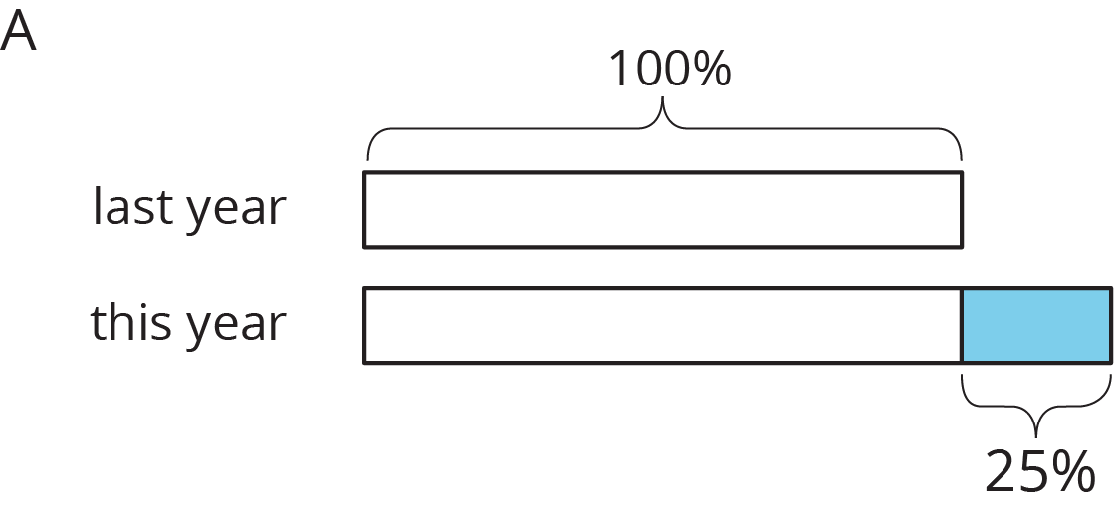
- 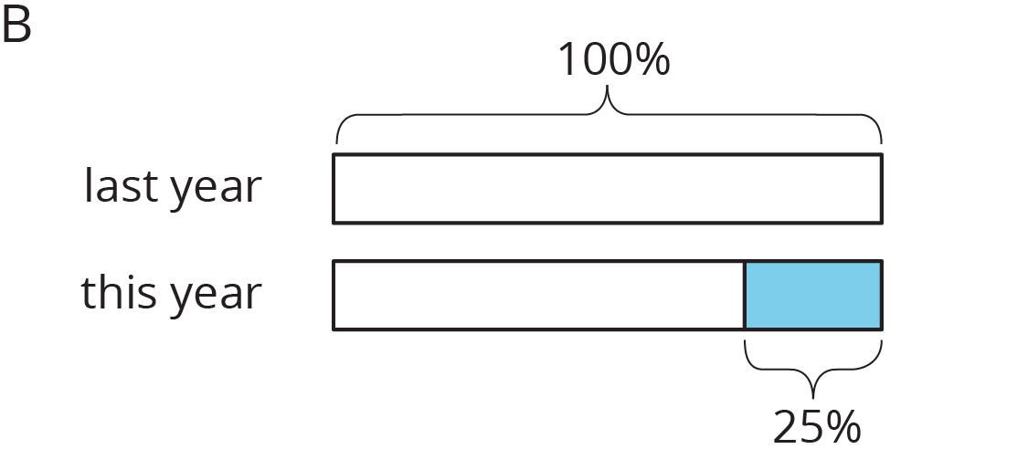
- Draw a diagram to represent these situations.
  - The number of ducks living at the pond increased by 40%.
  - The number of mosquitoes decreased by 80%.

Are you ready for more?
What could it mean to say there is a 100% decrease in a quantity? Give an example of a quantity where this makes sense.

3.4: Agree or Disagree: Percentages
Do you agree or disagree with each statement? Explain your reasoning.
- Employee A gets a pay raise of 50%. Employee B gets a pay raise of 45%. So Employee A gets the bigger pay raise.
- Shirts are on sale for 20% off. You buy two of them. As you pay, the cashier says, “20% off of each shirt means 40% off of the total price.”

Lesson 3 Summary
Imagine that it takes Andre $\frac{3}{4}$ more than the time it takes Jada to get to school. Then we know that Andre’s time is $1\frac{3}{4}$ or 1.75 times Jada’s time. We can also describe this in terms of percentages:
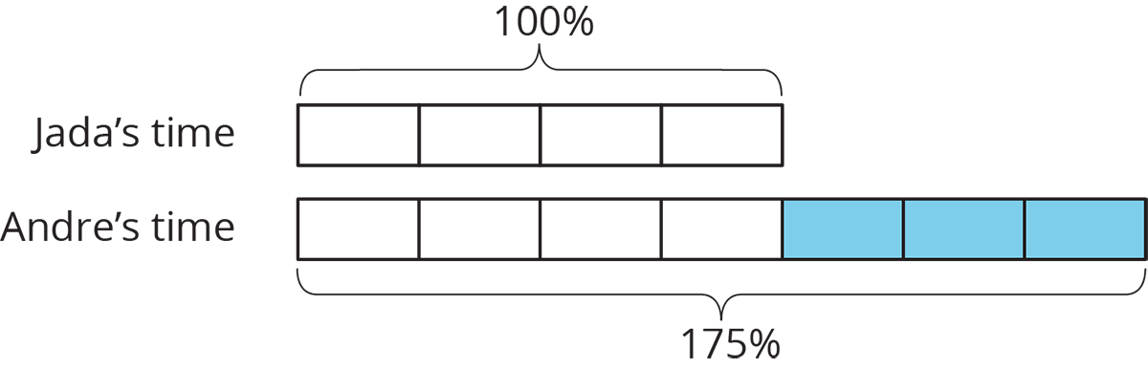
We say that Andre’s time is 75% more than Jada’s time. We can also see that Andre’s time is 175% of Jada’s time. In general, the terms percent increase and percent decrease describe an increase or decrease in a quantity as a percentage of the starting amount.
For example, if there were 500 grams of cereal in the original package, then “20% more” means that 20% of 500 grams has been added to the initial amount, $500+\left(0.2\right)⋅500=600$, so there are 600 grams of cereal in the new package.
We can see that the new amount is 120% of the initial amount because
$500+\left(0.2\right)⋅500=\left(1+0.2\right)500$
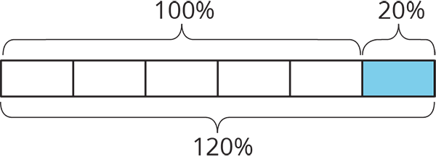
© CC BY Open Up Resources. Adaptations CC BY IM.

