Unit 6 Lesson 9: Equations of Lines

1 Remembering Slope (Warm up)

Student Task Statement
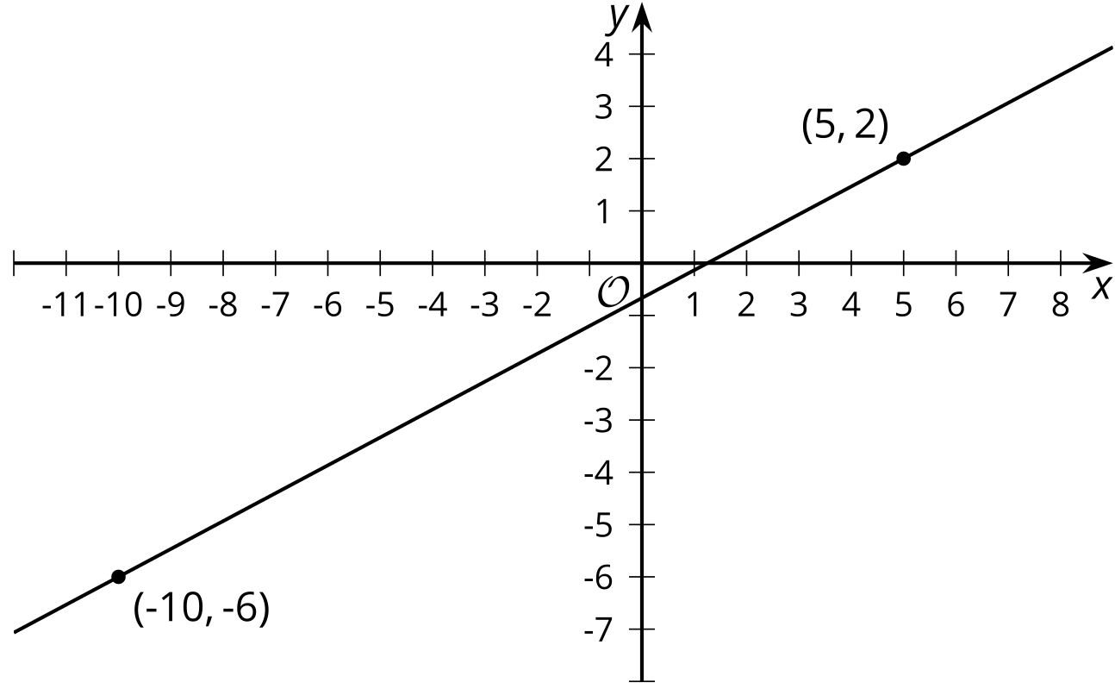
The slope of the line in the image is $\frac{8}{15}$. Explain how you know this is true.

2 Building an Equation for a Line

Student Task Statement
- The image shows a line.
- 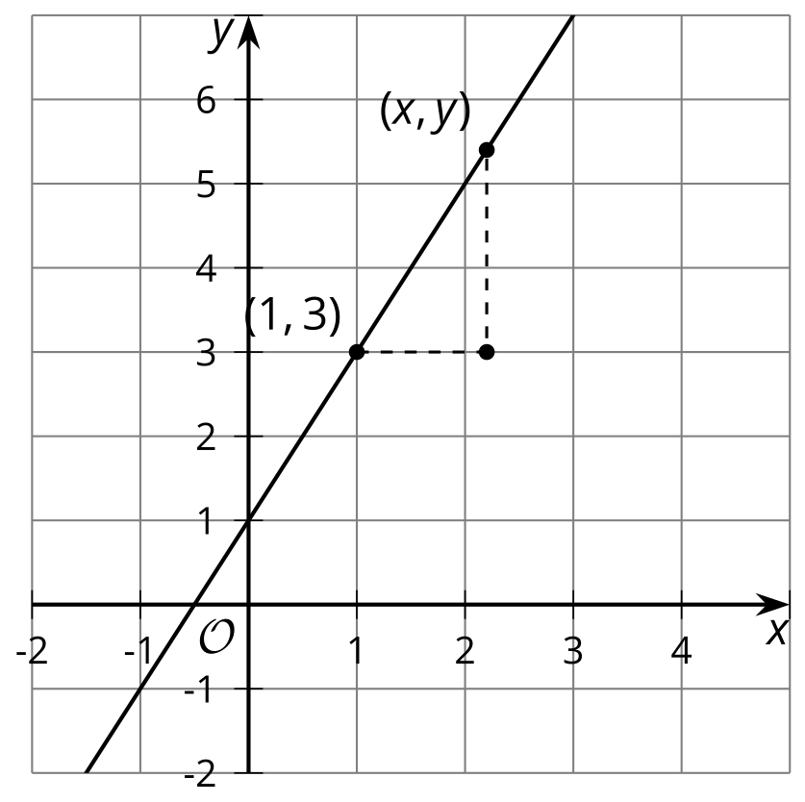
  - Write an equation that says the slope between the points $\left(1,3\right)$ and $\left(x,y\right)$ is 2.
  - Look at this equation: $y−3=2\left(x−1\right)$
How does it relate to the equation you wrote?
- Here is an equation for another line: $y−7=\frac{1}{2}\left(x−5\right)$
  - What point do you know this line passes through?
  - What is the slope of this line?
- Next, let’s write a general equation that we can use for any line. Suppose we know a line passes through a particular point $\left(h,k\right)$.
  - Write an equation that says the slope between point $\left(x,y\right)$ and $\left(h,k\right)$ is $m$.
  - Look at this equation: $y−k=m\left(x−h\right)$. How does it relate to the equation you wrote?

Activity Synthesis
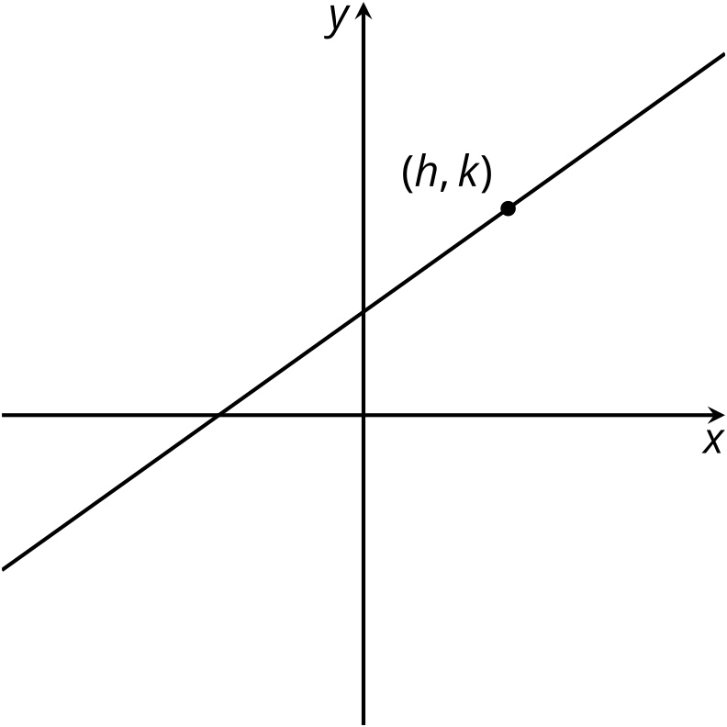

3 Using Point-Slope Form

Student Task Statement
- Write an equation that describes each line.
  - the line passing through point $\left(\text{-}2,8\right)$ with slope $\frac{4}{5}$
  - the line passing through point $\left(0,7\right)$ with slope $\text{-}\frac{7}{3}$
  - the line passing through point $\left(\frac{1}{2},0\right)$ with slope -1
  - the line in the image
  - 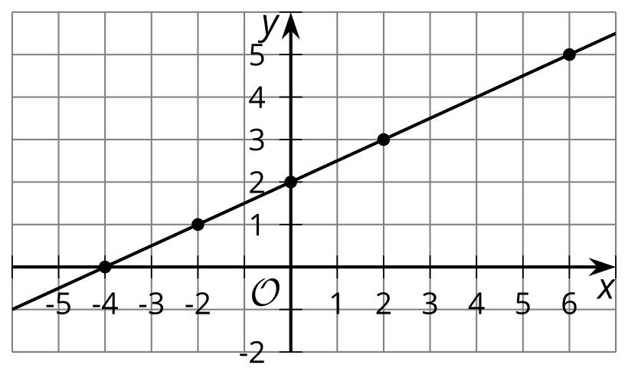
- Using the structure of the equation, what point do you know each line passes through? What’s the line’s slope?
  - $y−5=\frac{3}{2}\left(x+4\right)$
  - $y+2=5x$
  - $y=\text{-}2\left(x−\frac{5}{8}\right)$

Images for Activity Synthesis
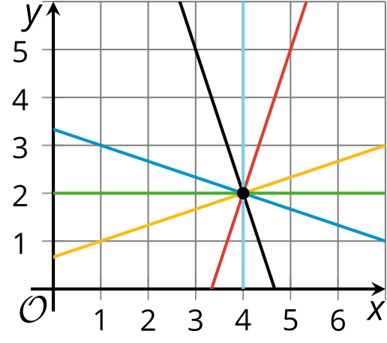
© CC BY 2019 by Illustrative Mathematics®

