Unit 8 Lesson 6: The Median

1 The Plot of the Story (Warm up)

Student Task Statement
- Here are two dot plots and two stories. Match each story with a dot plot that could represent it. Be prepared to explain your reasoning.
- 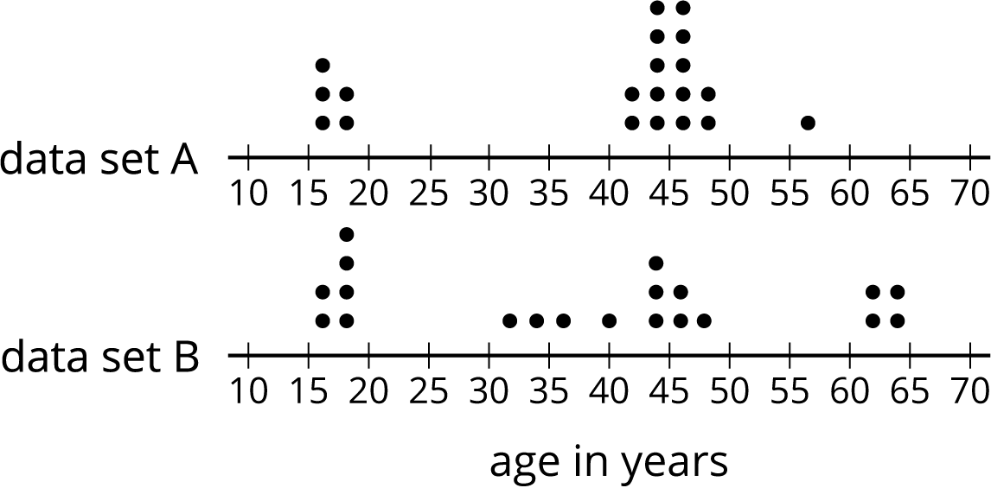

  - Twenty people—high school students, teachers, and invited guests—attended a rehearsal for a high school musical. The mean age was 38.5 years and the MAD was 16.5 years.
  - High school soccer team practice is usually watched by supporters of the players. One evening, twenty people watched the team practice. The mean age was 38.5 years and the MAD was 12.7 years.
- Another evening, twenty people watched the soccer team practice. The mean age was similar to that from the first evening, but the MAD was greater (about 20 years).
- Make a dot plot that could illustrate the distribution of ages in this story.
- 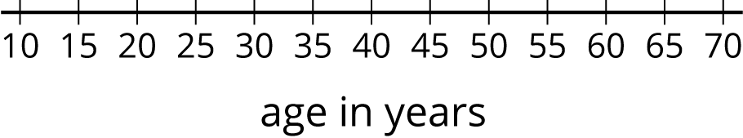

2 Finding the Middle

Student Task Statement
- Your teacher will give you an index card. Write your first and last names on the card. Then record the total number of letters in your name. After that, pause for additional instructions from your teacher.
- Here is the data set on numbers of siblings from an earlier activity.
- 1
- 0
- 2
- 1
- 7
- 0
- 2
- 0
- 1
- 10
  - Sort the data from least to greatest, and then find the median.
  - In this situation, do you think the median is a good measure of a typical number of siblings for this group? Explain your reasoning.
- Here is the dot plot showing the travel time, in minutes, of Elena’s bus rides to school.
- 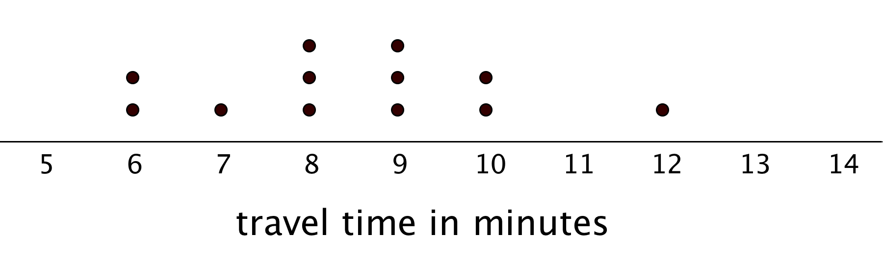
  - Find the median travel time. Be prepared to explain your reasoning.
  - What does the median tell us in this context?

3 Mean or Median?

Student Task Statement
- Your teacher will give you six cards. Each has either a dot plot or a histogram. Sort the cards into two piles based on the distributions shown. Be prepared to explain your reasoning.
- Discuss your sorting decisions with another group. Did you have the same cards in each pile? If so, did you use the same sorting categories? If not, how are your categories different?
- Pause here for a class discussion.
- Use the information on the cards to answer the following questions.
  - Card A: What is a typical age of the dogs being treated at the animal clinic?
  - Card B: What is a typical number of people in the Irish households?
  - Card C: What is a typical travel time for the New Zealand students?
  - Card D: Would 15 years old be a good description of a typical age of the people who attended the birthday party?
  - Card E: Is 15 minutes or 24 minutes a better description of a typical time it takes the students in South Africa to get to school?
  - Card F: Would 21.3 years old be a good description of a typical age of the people who went on a field trip to Washington, D.C.?
- How did you decide which measure of center to use for the dot plots on Cards A–C? What about for those on Cards D–F?
© CC BY Open Up Resources. Adaptations CC BY IM.

