Unit 8 Lesson 5: Variability and MAD

1 Shooting Hoops (Part 1) (Warm up)

Student Task Statement
Elena, Jada, and Lin enjoy playing basketball during recess. Lately, they have been practicing free throws. They record the number of baskets they make out of 10 attempts. Here are their data sets for 12 school days.
Elena
4
5
1
6
9
7
2
8
3
3
5
7
Jada
2
4
5
4
6
6
4
7
3
4
8
7
Lin
3
6
6
4
5
5
3
5
4
6
6
7
- Calculate the mean number of baskets each player made, and compare the means. What do you notice?
- What do the means tell us in this context?

2 Shooting Hoops (Part 3)

Student Task Statement
The tables show Elena, Jada, and Lin’s basketball data from an earlier activity. Recall that the mean of Elena’s data, as well as that of Jada and Lin’s data, was 5.
- Record the distance between each of Elena’s scores and the mean.
- Elena | - 4 | - 5 | - 1 | - 6 | - 9 | - 7 | - 2 | - 8 | - 3 | - 3 | - 5 | - 7
- distance from 5 | - 1 |  |  | - 1
- Now find the average of the distances in the table. Show your reasoning and round your answer to the nearest tenth.
- This value is the mean absolute deviation (MAD) of Elena’s data.
- Elena’s MAD: _________
- Find the mean absolute deviation of Jada’s data. Round it to the nearest tenth.
- Jada | - 2 | - 4 | - 5 | - 4 | - 6 | - 6 | - 4 | - 7 | - 3 | - 4 | - 8 | - 7
- distance from 5
- Jada’s MAD: _________
- Find the mean absolute deviation of Lin’s data. Round it to the nearest tenth.
- Lin | - 3 | - 6 | - 6 | - 4 | - 5 | - 5 | - 3 | - 5 | - 4 | - 6 | - 6 | - 7
- distance from 5
- Lin’s MAD: _________
- Compare the MADs and dot plots of the three students’ data. Do you see a relationship between each student’s MAD and the distribution on her dot plot? Explain your reasoning.
- 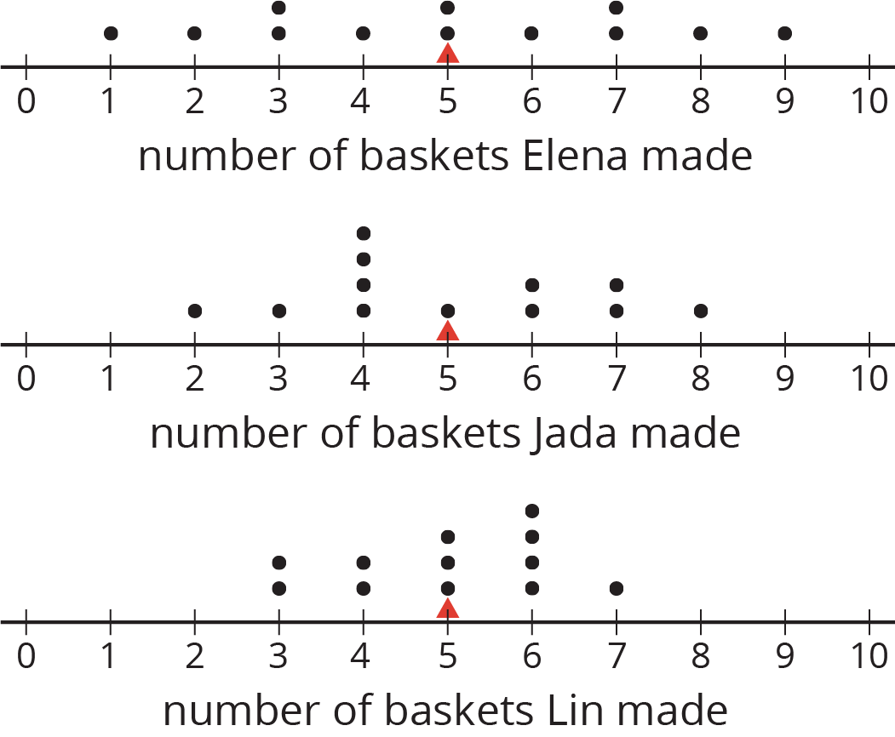

3 Which Player Would You Choose?

Images for Launch
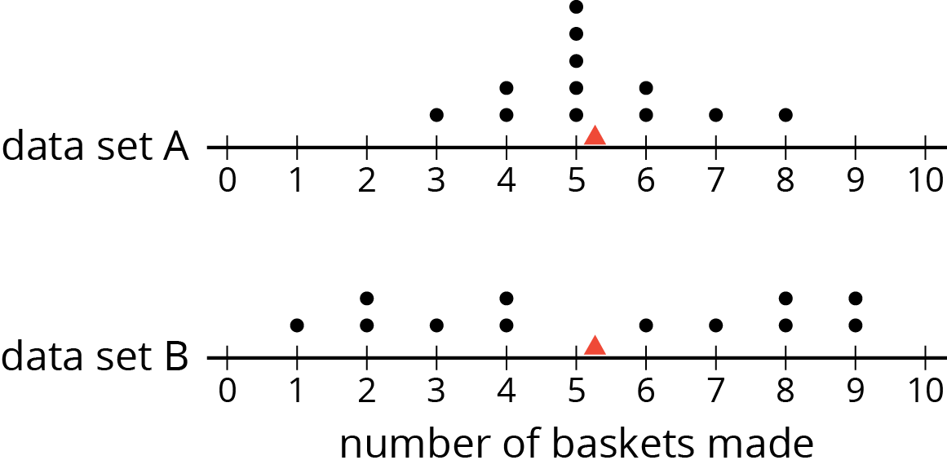

Student Task Statement
- Andre and Noah joined Elena, Jada, and Lin in recording their basketball scores. They all recorded their scores in the same way: the number of baskets made out of 10 attempts. Each collected 12 data points.
  - Andre’s mean number of baskets was 5.25, and his MAD was 2.6.
  - Noah’s mean number of baskets was also 5.25, but his MAD was 1.
- Here are two dot plots that represent the two data sets. The triangle indicates the location of the mean.
  - Without calculating, decide which dot plot represents Andre’s data and which represents Noah’s. Explain how you know.
  - If you were the captain of a basketball team and could use one more player on your team, would you choose Andre or Noah? Explain your reasoning.
- An eighth-grade student decided to join Andre and Noah and kept track of his scores. His data set is shown here. The mean number of baskets he made is 6.
- eighth‐grade student | - 6 | - 5 | - 4 | - 7 | - 6 | - 5 | - 7 | - 8 | - 5 | - 6 | - 5 | - 8
- distance from 6
  - Calculate the MAD. Show your reasoning.
  - Draw a dot plot to represent his data and mark the location of the mean with a triangle ($Δ$).
  - Compare the eighth-grade student’s mean and MAD to Noah’s mean and MAD. What do you notice?
  - Compare their dot plots. What do you notice about the distributions?
  - What can you say about the two players’ shooting accuracy and consistency?

Activity Synthesis
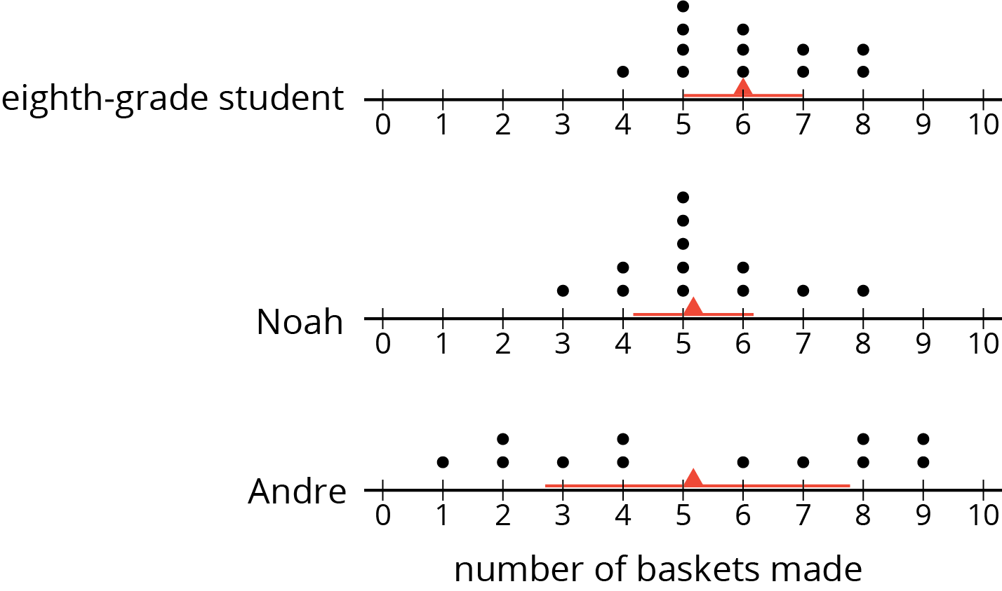

4 Swimmers Over the Years

Student Task Statement
In 1984, the mean age of swimmers on the U.S. women’s swimming team was 18.2 years and the MAD was 2.2 years. In 2016, the mean age of the swimmers was 22.8 years, and the MAD was 3 years.
- How has the average age of the women on the U.S. swimming team changed from 1984 to 2016? Explain your reasoning.
- Are the swimmers on the 1984 team closer in age to one another than the swimmers on the 2016 team are to one another? Explain your reasoning.
- Here are dot plots showing the ages of the women on the U.S. swimming team in 1984 and in 2016. Use them to make two other comments about how the women’s swimming team has changed over the years.
- 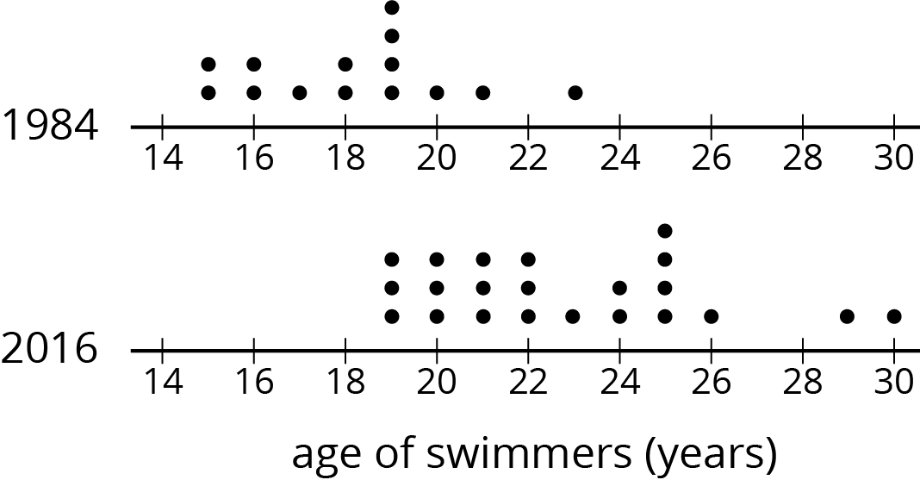
© CC BY Open Up Resources. Adaptations CC BY IM.

