Lesson 10 Practice Problems
- The cost for an upcoming field trip is $30 per student. The cost of the field trip $C$, in dollars, is a function of the number of students $x$.
- Select all the possible outputs for the function defined by $C\left(x\right)=30x$.
  - 20
  - 30
  - 50
  - 90
  - 100
- A rectangle has an area of 24 cm². Function $f$ gives the length of the rectangle, in centimeters, when the width is $w$ cm.
- Determine if each value, in centimeters, is a possible input of the function.
- 3 | - 0.5 | - 48 | - -6 | - 0

- Select all the possible input-output pairs for the function $y=x^{3}$.
  - $\left(\text{-}1,\text{-}1\right)$
  - $\left(\text{-}2,8\right)$
  - $\left(3,9\right)$
  - $\left(\frac{1}{2},\frac{1}{8}\right)$
  - $\left(4,64\right)$
  - $\left(1,\text{-}1\right)$
- A small bus charges $3.50 per person for a ride from the train station to a concert. The bus will run if at least 3 people take it, and it cannot fit more than 10 people.
- Function $B$ gives the amount of money that the bus operator earns when $n$ people ride the bus.
  - Identify all numbers that make sense as inputs and outputs for this function.
  - Sketch a graph of $B$.
- 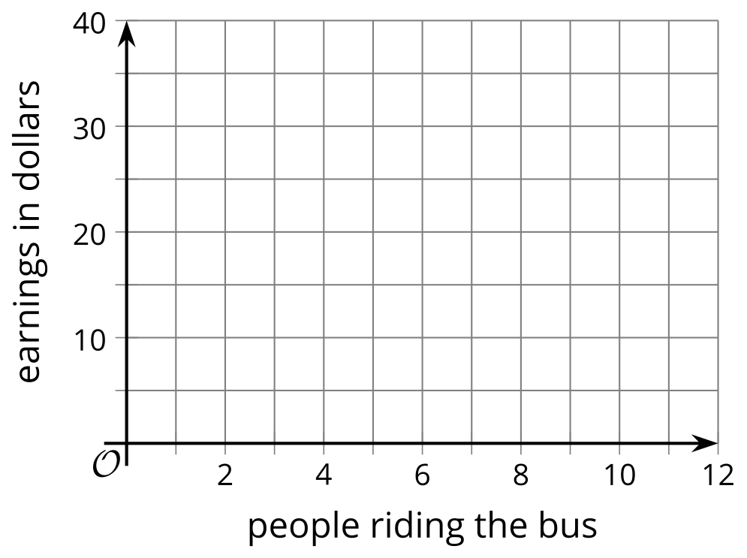
- Two functions are defined by the equations $f\left(x\right)=5−0.2x$ and $g\left(x\right)=0.2\left(x+5\right)$.
Select all statements that are true about the functions.
  - $f\left(3\right)>0$
  - $f\left(3\right)>5$
  - $g\left(\text{-}1\right)=0.8$
  - $g\left(\text{-}1\right)<f\left(\text{-}1\right)$
  - $f\left(0\right)=g\left(0\right)$
- (From Unit 4, Lesson 5.)
- The graph of function $f$ passes through the coordinate points $\left(0,3\right)$ and $\left(4,6\right)$.
- Use function notation to write the information each point gives us about function $f$.
- (From Unit 4, Lesson 3.)
- Match each feature of the graph with the corresponding coordinate point.
- If the feature does not exist, choose “none”.
- 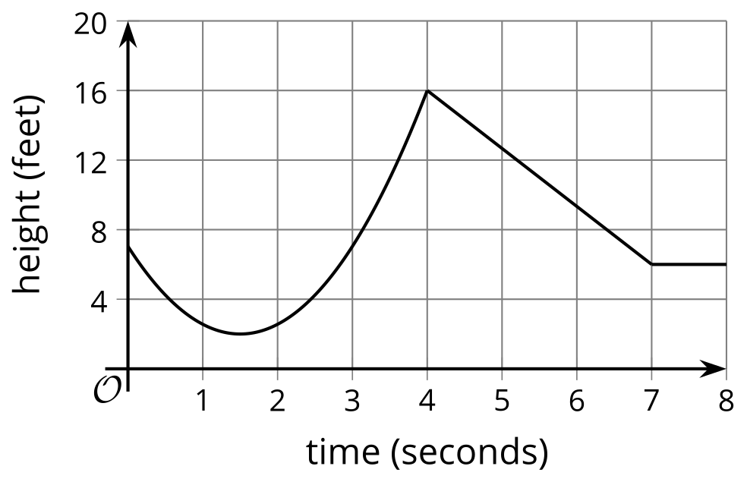
- ​​​​​
  - maximum
  - minimum
  - vertical intercept
  - horizontal intercept
  - $\left(0,7\right)$
  - $\left(1.5,2\right)$
  - $\left(4,16\right)$
  - none
- (From Unit 4, Lesson 6.)
- The graphs show the audience, in millions, of two TV shows as a function of the episode number.

- Show A
- 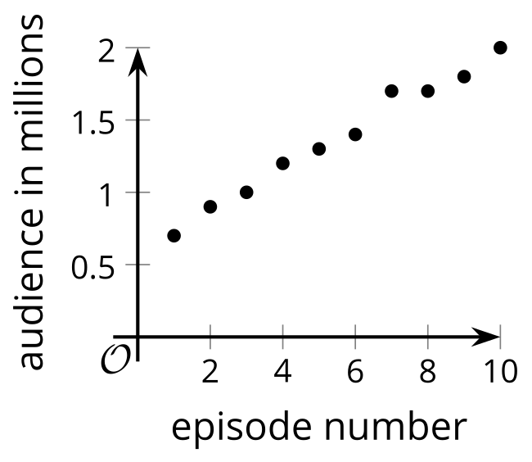

- Show C
- 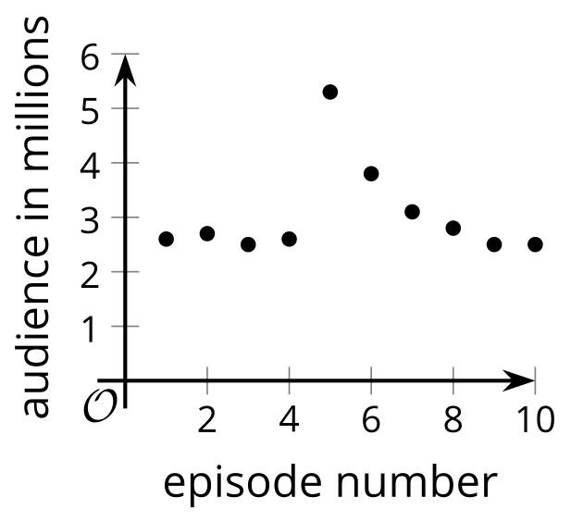
- For each show, pick two episode numbers between which the function has a negative average rate of change, if possible. Estimate the average rate of change, or explain why it is not possible.
- (From Unit 4, Lesson 9.)
© CC BY 2019 by Illustrative Mathematics®

