Lesson 11 Practice Problems
- If two rectangles have the same perimeter, do they have to be congruent? Explain how you know.
- Draw two rectangles that have the same area, but are not congruent.
- For each pair of shapes, decide whether or not the two shapes are congruent. Explain your reasoning.

  - 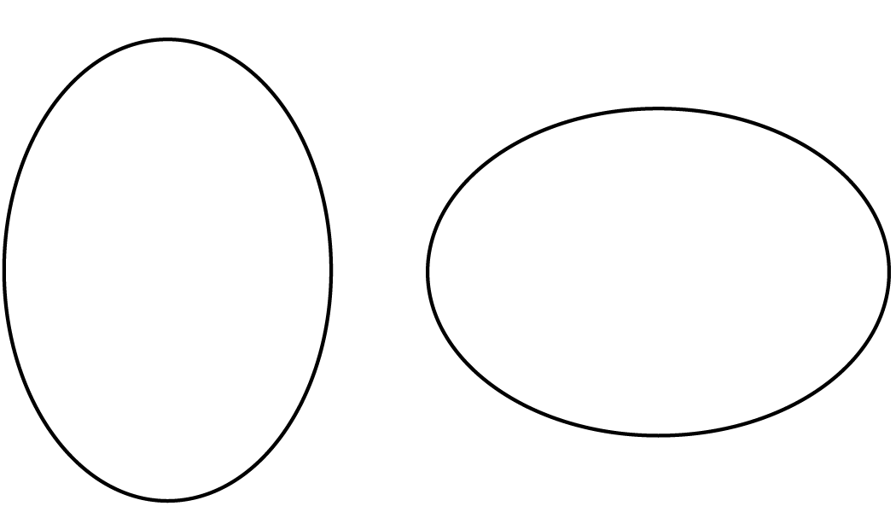

  - 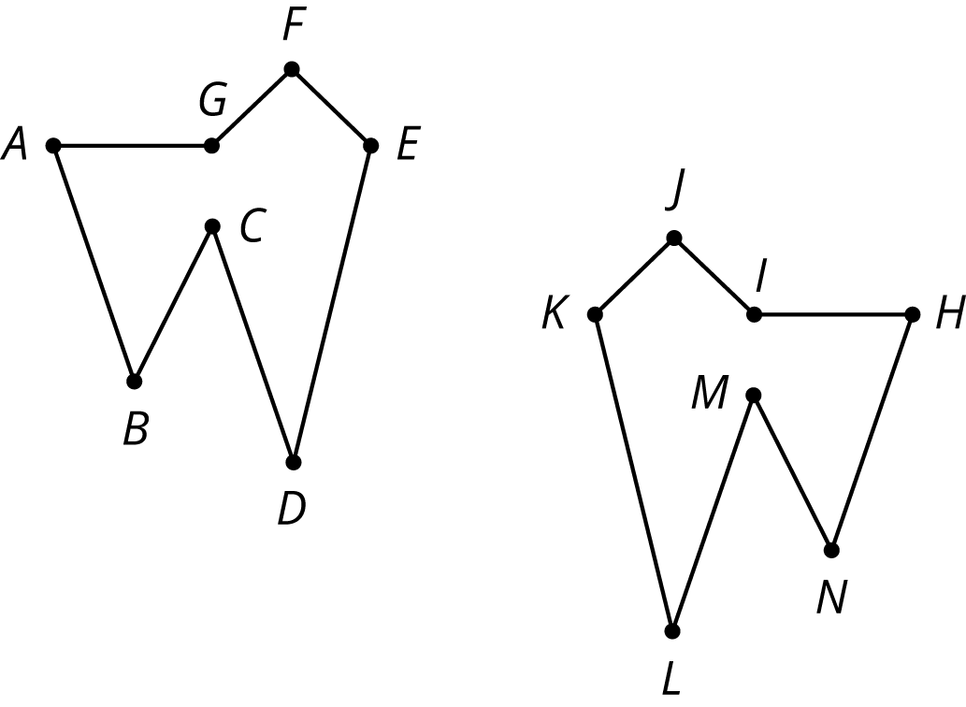

  - Reflect Quadrilateral A over the $x$-axis. Label the image quadrilateral B. Reflect Quadrilateral B over the $y$-axis. Label the image C.
  - 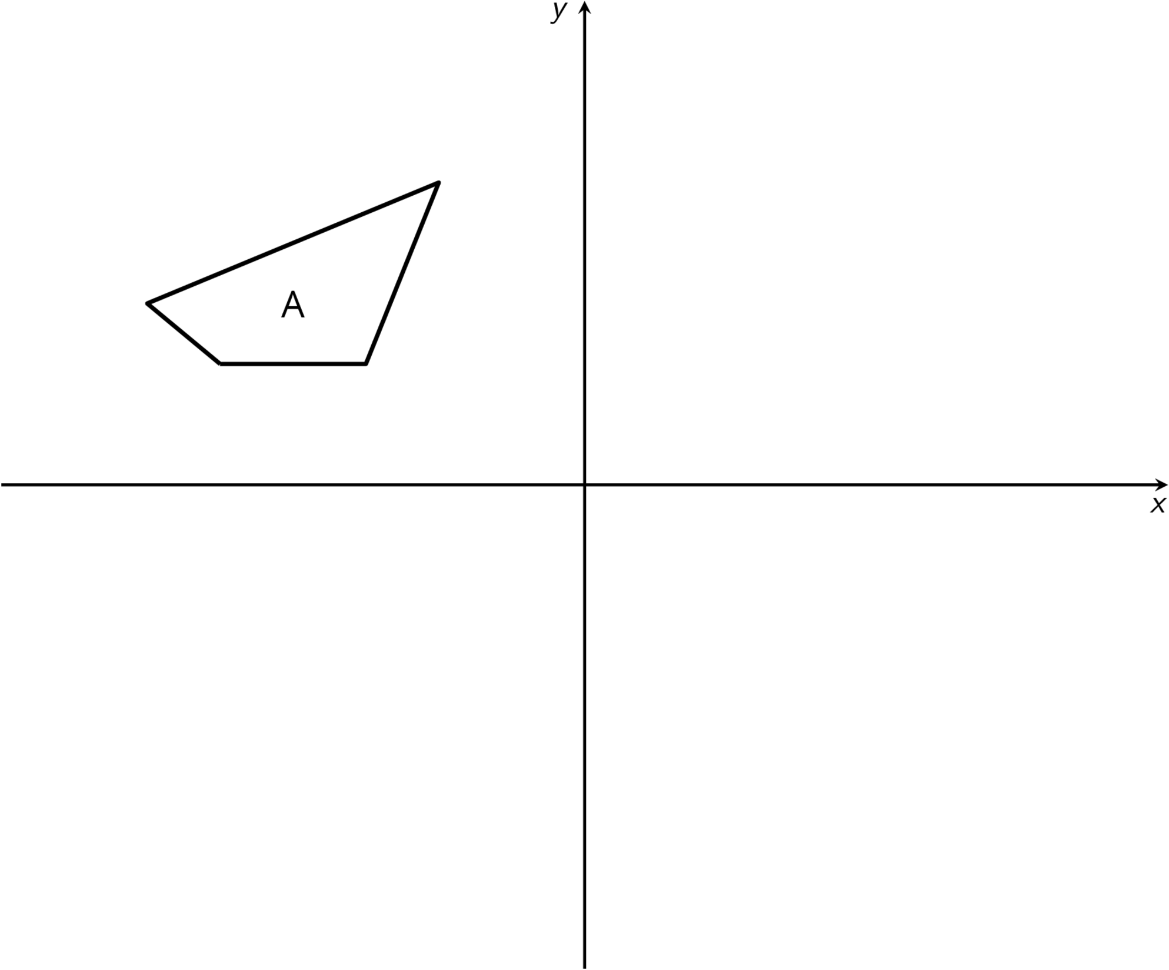
  - Are Quadrilaterals A and C congruent? Explain how you know.
- The point $\left(\text{-}2,\text{-}3\right)$ is rotated 90 degrees counterclockwise using center $\left(0,0\right)$. What are the coordinates of the image?
  - $\left(\text{-}3,\text{-}2\right)$
  - $\left(\text{-}3,2\right)$
  - $\left(3,\text{-}2\right)$
  - $\left(3,2\right)$
- (From Unit 1, Lesson 6.)
- Describe a rigid transformation that takes Polygon A to Polygon B.
- 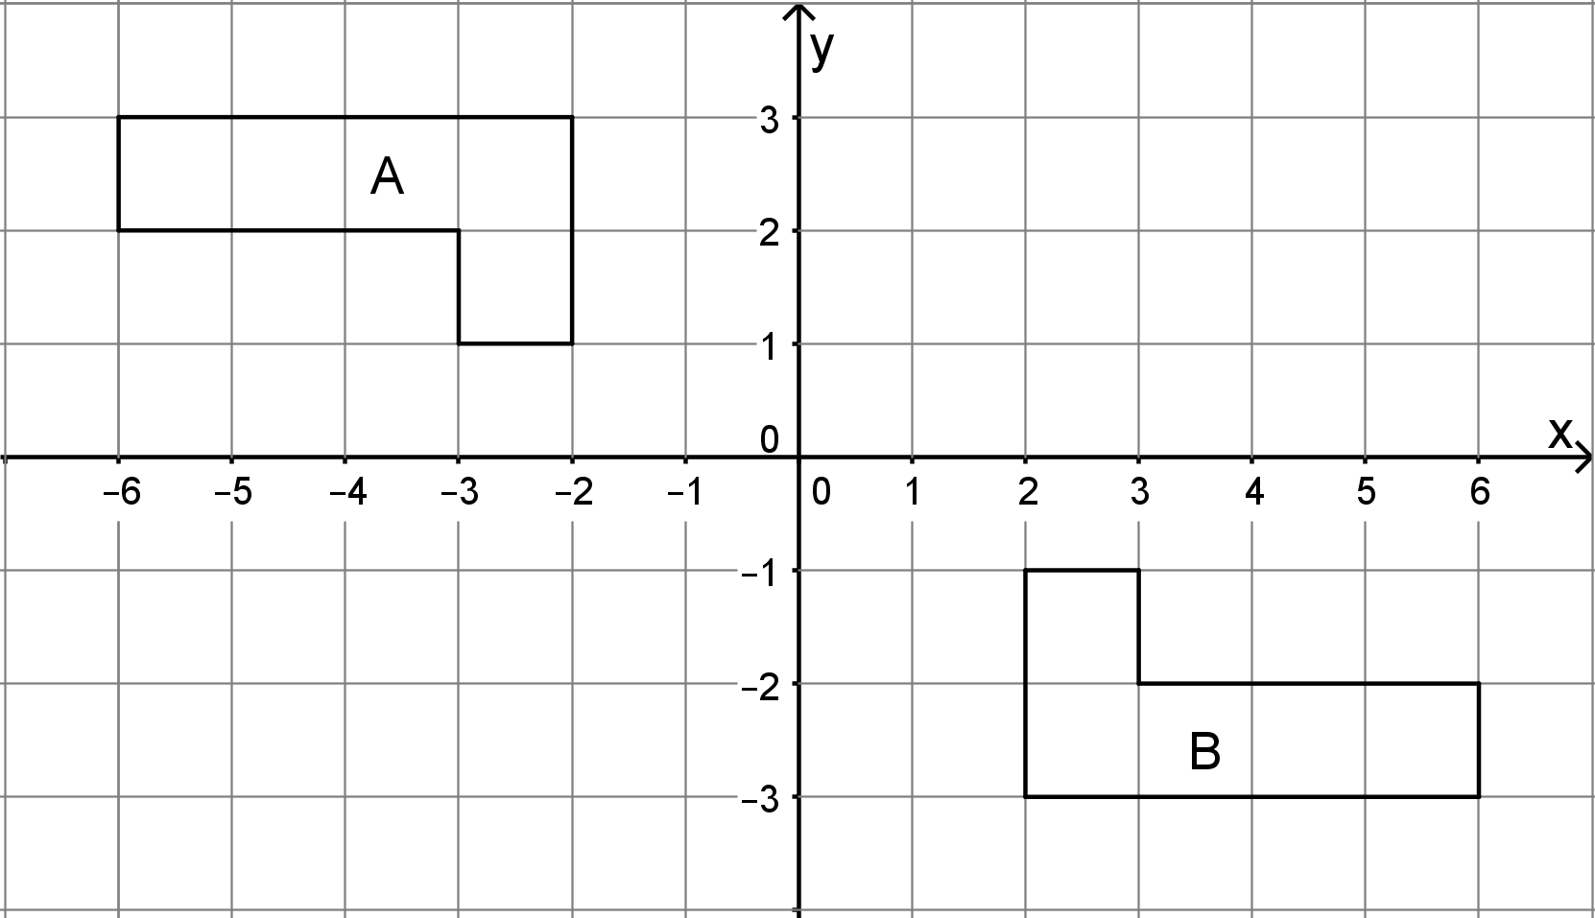
- (From Unit 1, Lesson 7.)
© CC BY Open Up Resources. Adaptations CC BY IM.

