Unit 4 Lesson 6: Writing Equations for Exponential Functions

1 All Equivalent? (Warm up)

Student Task Statement
- Discuss with a partner why the following expressions are equivalent.
  - ${64}^{\frac{1}{3}}$
  - ${\left(8^{2}\right)}^{\frac{1}{3}}$
  - ${\left(2^{3}\right)}^{\frac{2}{3}}$
  - ${\left(8^{\frac{1}{3}}\right)}^{2}$
  - $8^{\frac{2}{3}}$
- What is another expression equivalent to these?

2 Info Gap: Two Points

Student Task Statement
Your teacher will give you either a problem card or a data card. Do not show or read your card to your partner.
If your teacher gives you the data card:
- Silently read the information on your card.
- Ask your partner “What specific information do you need?” and wait for your partner to ask for information. Only give information that is on your card. (Do not figure out anything for your partner!)
- Before telling your partner the information, ask “Why do you need to know (that piece of information)?”
- Read the problem card, and solve the problem independently.
- Share the data card, and discuss your reasoning.
If your teacher gives you the problem card:
- Silently read your card and think about what information you need to answer the question.
- Ask your partner for the specific information that you need.
- Explain to your partner how you are using the information to solve the problem.
- When you have enough information, share the problem card with your partner, and solve the problem independently.
- Read the data card, and discuss your reasoning.
Pause here so your teacher can review your work. Ask your teacher for a new set of cards and repeat the activity, trading roles with your partner.

3 Bacteria Growth Expressions (Optional)

Student Task Statement
A bacteria population starts at 1000 and doubles every 10 hours.
- Explain why the expressions $1000⋅{\left(2^{\frac{1}{10}}\right)}^{h}$ and $1000⋅2^{\frac{h}{10}}$ both represent the bacteria population after $h$ hours.
- By what factor does the bacteria population grow each hour? Explain how you know.

Images for Activity Synthesis
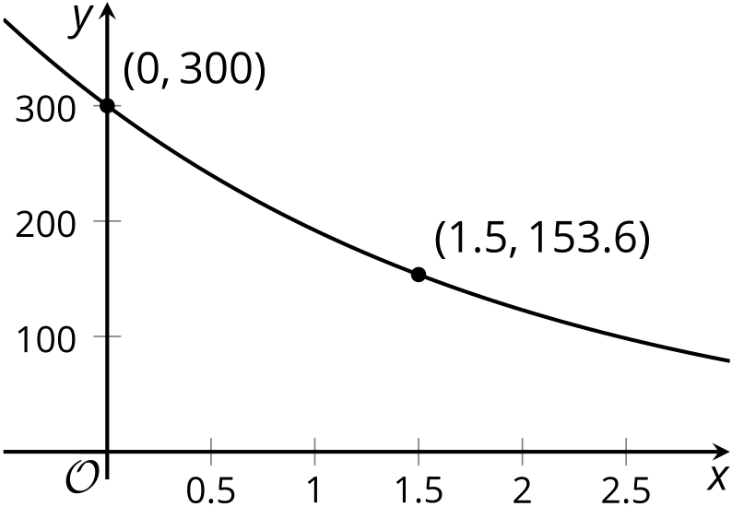
© CC BY 2019 by Illustrative Mathematics®

