Lesson 13 Practice Problems
- The double number line shows how much water and how much lemonade powder to mix to make different amounts of lemonade.
- 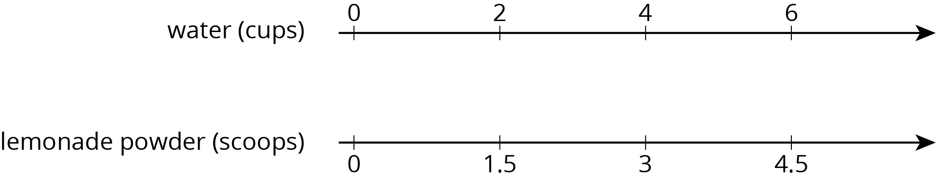
- Make a table that represents the same situation.
- A bread recipe uses 3 tablespoons of olive oil for every 2 cloves of crushed garlic.
  - Complete the table to show different-sized batches of bread that taste the same as the recipe.
  - Draw a double number line that represents the same situation.
  - Which representation do you think works better in this situation? Explain why.
- olive oil (tablespoons) | - crushed garlic (cloves)
- 3 | - 2
- 1
- 2
- 5
- 10
- Clare travels at a constant speed, as shown on the double number line.
- 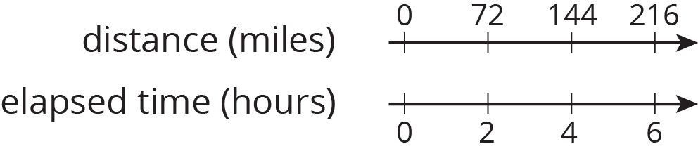
- At this rate, how far does she travel in each of these intervals of time? Explain or show your reasoning. If you get stuck, consider using a table.
  - 1 hour
  - 3 hours
  - 6.5 hours
- Lin and Diego travel in cars on the highway at constant speeds. In each case, decide who was traveling faster and explain how you know.
  - During the first half hour, Lin travels 23 miles while Diego travels 25 miles.
  - After stopping for lunch, they travel at different speeds. To travel the next 60 miles, it takes Lin 65 minutes and it takes Diego 70 minutes.
- (From Unit 2, Lesson 9.)
- A sports drink recipe calls for $\frac{5}{3}$ tablespoons of powdered drink mix for every 12 ounces of water. How many batches can you make with 5 tablespoons of drink mix and 36 ounces of water? Explain your reasoning.
- (From Unit 2, Lesson 3.)
- In this cube, each small square has side length 1 unit.
  - What is the surface area of this cube?
  - What is the volume of this cube?
- (From Unit 1, Lesson 18.)
© CC BY Open Up Resources. Adaptations CC BY IM.

