Unit 3 Lesson 9: Applying Area of Circles

1 Still Irrigating the Field (Warm up)

Student Task Statement
The area of this field is about 500,000 m². What is the field’s area to the nearest square meter? Assume that the side lengths of the square are exactly 800 m.
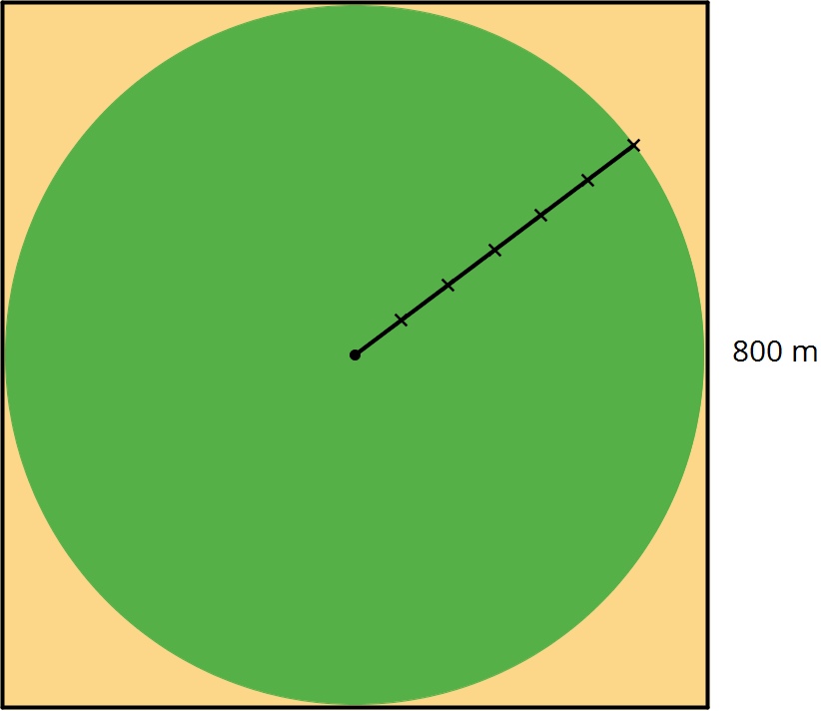
- 502,400 m²
- 502,640 m²
- 502,655 m²
- 502,656 m²
- 502,857 m²

2 Comparing Areas Made of Circles

Student Task Statement
- Each square has a side length of 12 units. Compare the areas of the shaded regions in the 3 figures. Which figure has the largest shaded region? Explain or show your reasoning.
- 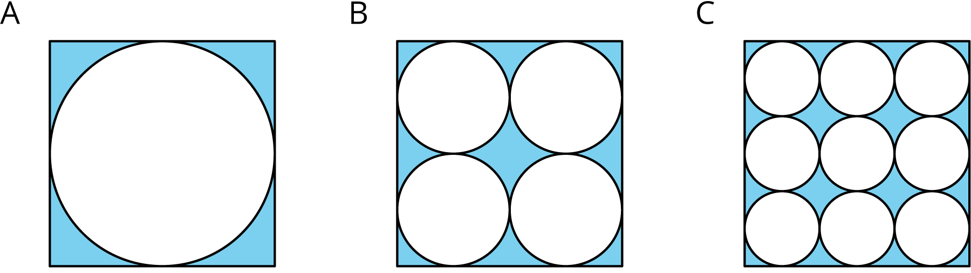
- Each square in Figures D and E has a side length of 1 unit. Compare the area of the two figures. Which figure has more area? How much more? Explain or show your reasoning.
- 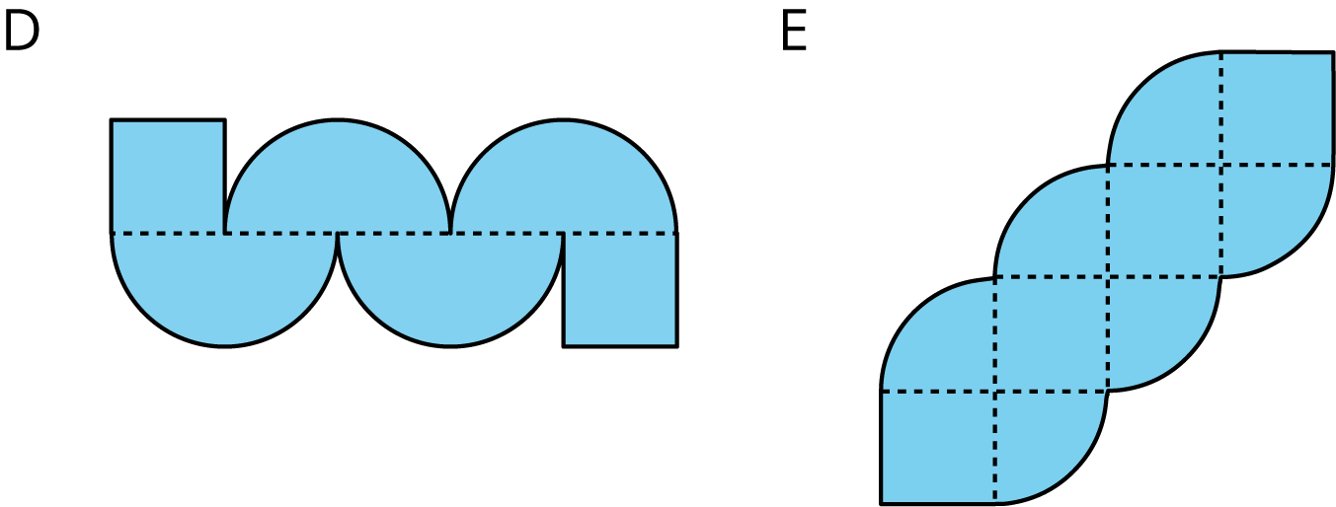

Activity Synthesis
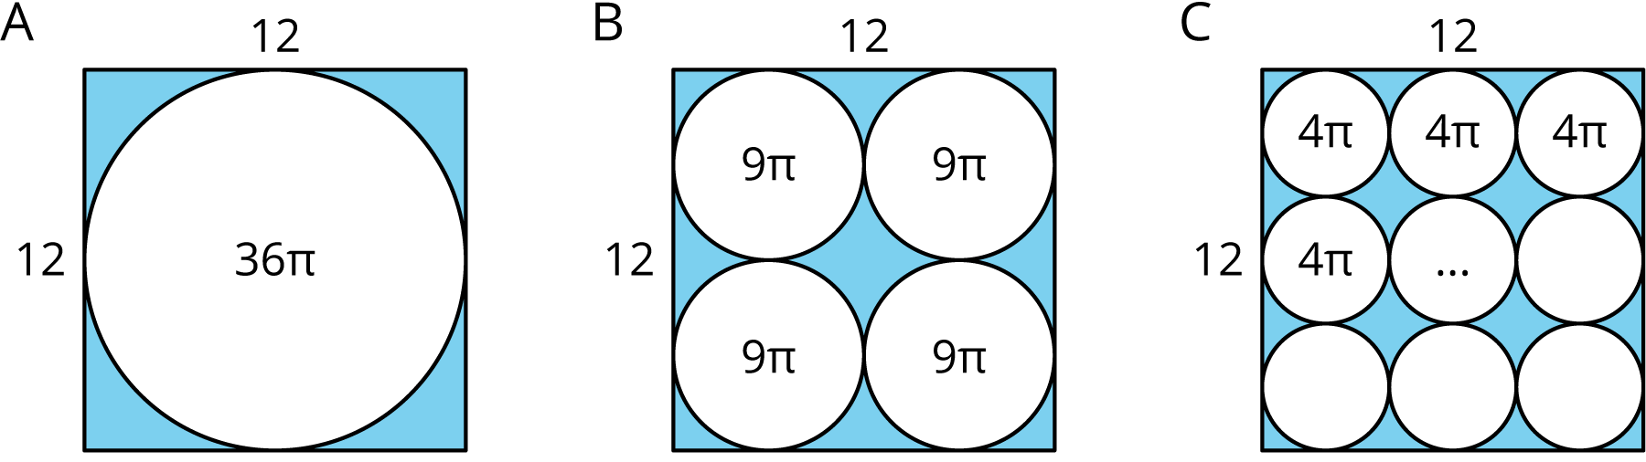

3 The Running Track Revisited (Optional)

Student Task Statement
The field inside a running track is made up of a rectangle 84.39 m long and 73 m wide, together with a half-circle at each end. The running lanes are 9.76 m wide all the way around.
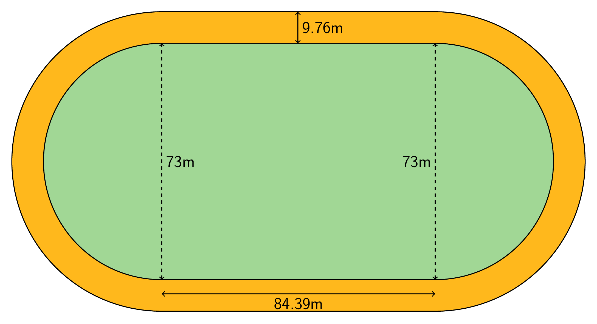
What is the area of the running track that goes around the field? Explain or show your reasoning.
© CC BY Open Up Resources. Adaptations CC BY IM.

