Lesson 16 Practice Problems
- Describe a situation that could be represented with this tape diagram.
- 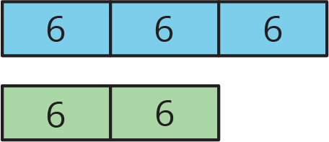
- There are some nickels, dimes, and quarters in a large piggy bank. For every 2 nickels there are 3 dimes. For every 2 dimes there are 5 quarters. There are 500 coins total.
  - How many nickels, dimes, and quarters are in the piggy bank? Explain your reasoning.
  - How much are the coins in the piggy bank worth?
- Two horses start a race at the same time. Horse A gallops at a steady rate of 32 feet per second and Horse B gallops at a steady rate of 28 feet per second. After 5 seconds, how much farther will Horse A have traveled? Explain or show your reasoning.
- Andre paid $13 for 3 books. Diego bought 12 books priced at the same rate. How much did Diego pay for the 12 books? Explain your reasoning.
- (From Unit 2, Lesson 10.)
- Which polyhedron can be assembled from this net?
- 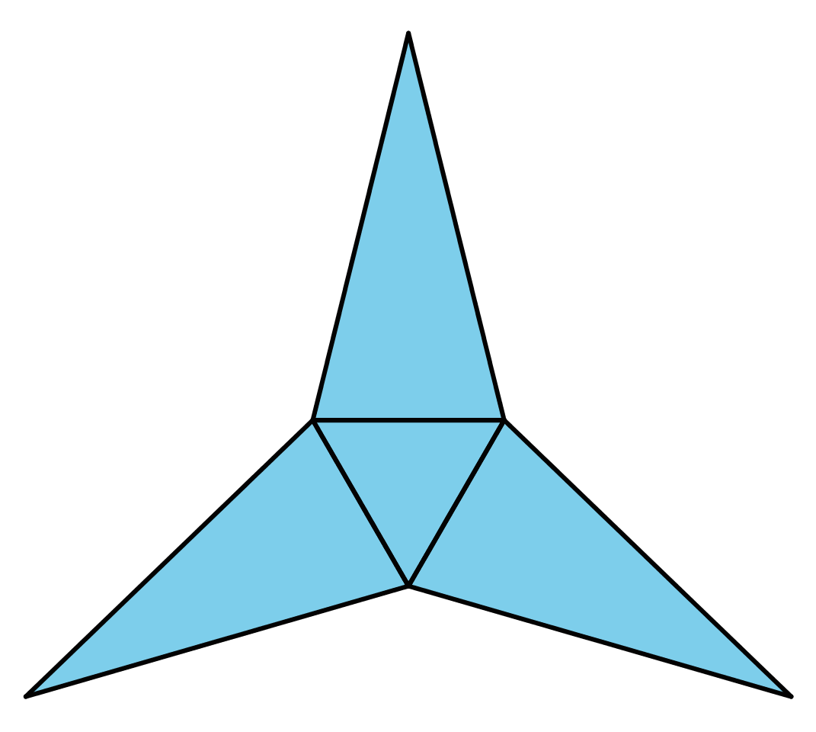
  - A triangular pyramid
  - A trapezoidal prism
  - A rectangular pyramid
  - A triangular prism
- (From Unit 1, Lesson 15.)
- Find the area of the triangle. Show your reasoning. If you get stuck, consider drawing a rectangle around the triangle.
- 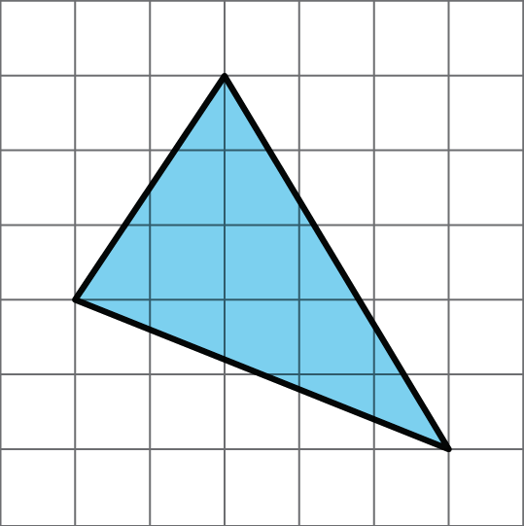
- (From Unit 1, Lesson 10.)
© CC BY Open Up Resources. Adaptations CC BY IM.

