Unit 4 Lesson 8: Unknown Exponents

1 A Bunch of $x$’s (Warm up)

Student Task Statement
Solve each equation. Be prepared to explain your reasoning.
- $\frac{x}{3}=12$
- $3x^{2}=12$
- $x^{3}=12$
- $\sqrt[3]{x}=12$
- $\sqrt{3x}=12$
- $\frac{3}{x}=12$

2 A Tessellated Trapezoid

Student Task Statement
Here is a pattern showing a trapezoid being successively decomposed into four similar trapezoids at each step.
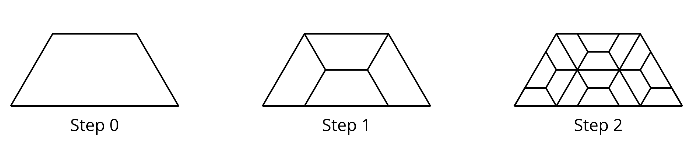
- If $n$ is the step number, how many of the smallest trapezoids are there when $n$ is 4? What about when $n$ is 10?
- At a certain step, there are 262,144 smallest trapezoids.
  - Write an equation to represent the relationship between $n$ and the number of trapezoids in that step.
  - Explain to a partner how you might find the value of that step number.

3 Successive Splitting

Student Task Statement
In a lab, a colony of 100 bacteria is placed on a petri dish. The population triples every hour.
- How would you estimate or find the population of bacteria in:
  - 4 hours?
  - 90 minutes?
  - $\frac{1}{2}$ hour?
- How would you estimate or find the number of hours it would take the population to grow to:
  - 1,000 bacteria?
  - double the initial population?

4 Missing Values (Optional)

Student Task Statement
Complete the tables.
$x$ |  |  | -1 | 0 | $\frac{1}{2}$ | 1 |  |  | 5
$2^{x}$ | $\frac{1}{32}$ | $\frac{1}{4}$ | $\frac{1}{2}$ |  |  |  | 4 | 16 |  | 256 | 1,024

$x$ |  |  |  | $\frac{1}{3}$ | $\frac{1}{2}$
$5^{x}$ | $\frac{1}{25}$ | $\frac{1}{5}$ | 1 |  |  | 5 | 125 | 625 | 3,125
Be prepared to explain how you found the missing values.
© CC BY 2019 by Illustrative Mathematics®

