Unit 8 Lesson 2: Using Dot Plots to Answer Statistical Questions

1 Packs on Backs (Warm up)

Student Task Statement
This dot plot shows the weights of backpacks, in kilograms, of 50 sixth-grade students at a school in New Zealand.
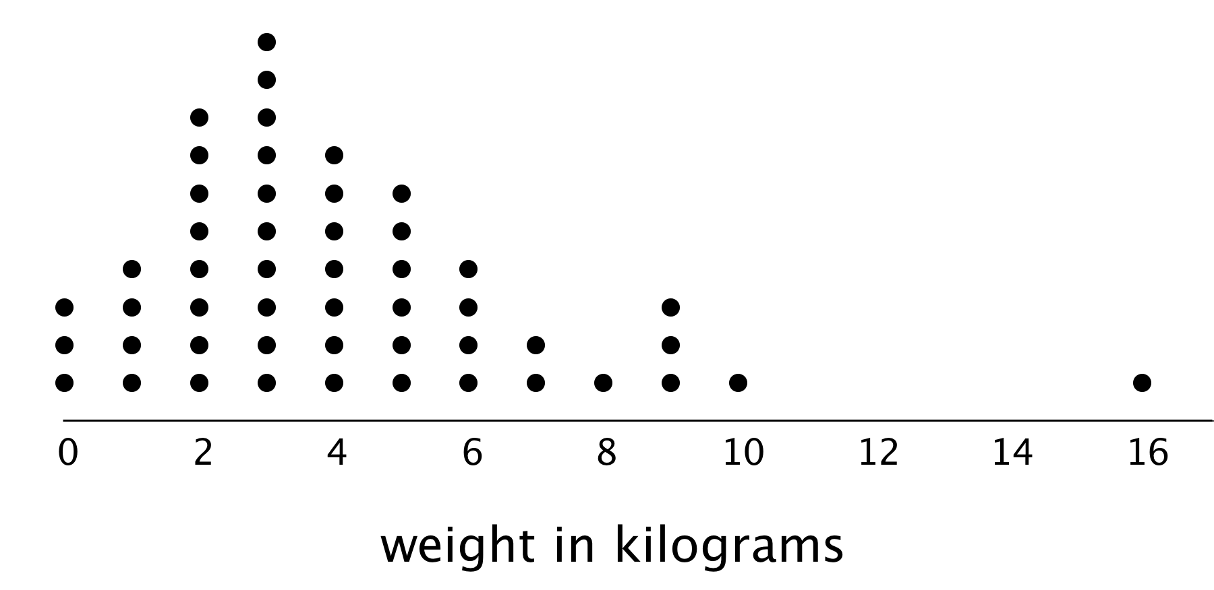
- The dot plot shows several dots at 0 kilograms. What could a value of 0 mean in this context?
- Clare and Tyler studied the dot plot.
  - Clare said, “I think we can use 3 kilograms to describe a typical backpack weight of the group because it represents 20%—or the largest portion—of the data.”
  - Tyler disagreed and said, “I think 3 kilograms is too low to describe a typical weight. Half of the dots are for backpacks that are heavier than 3 kilograms, so I would use a larger value.”
- Do you agree with either of them? Explain your reasoning.

2 On the Phone

Student Task Statement
Twenty-five sixth-grade students were asked to estimate how many hours a week they spend talking on the phone. This dot plot represents their reported number of hours of phone usage per week.
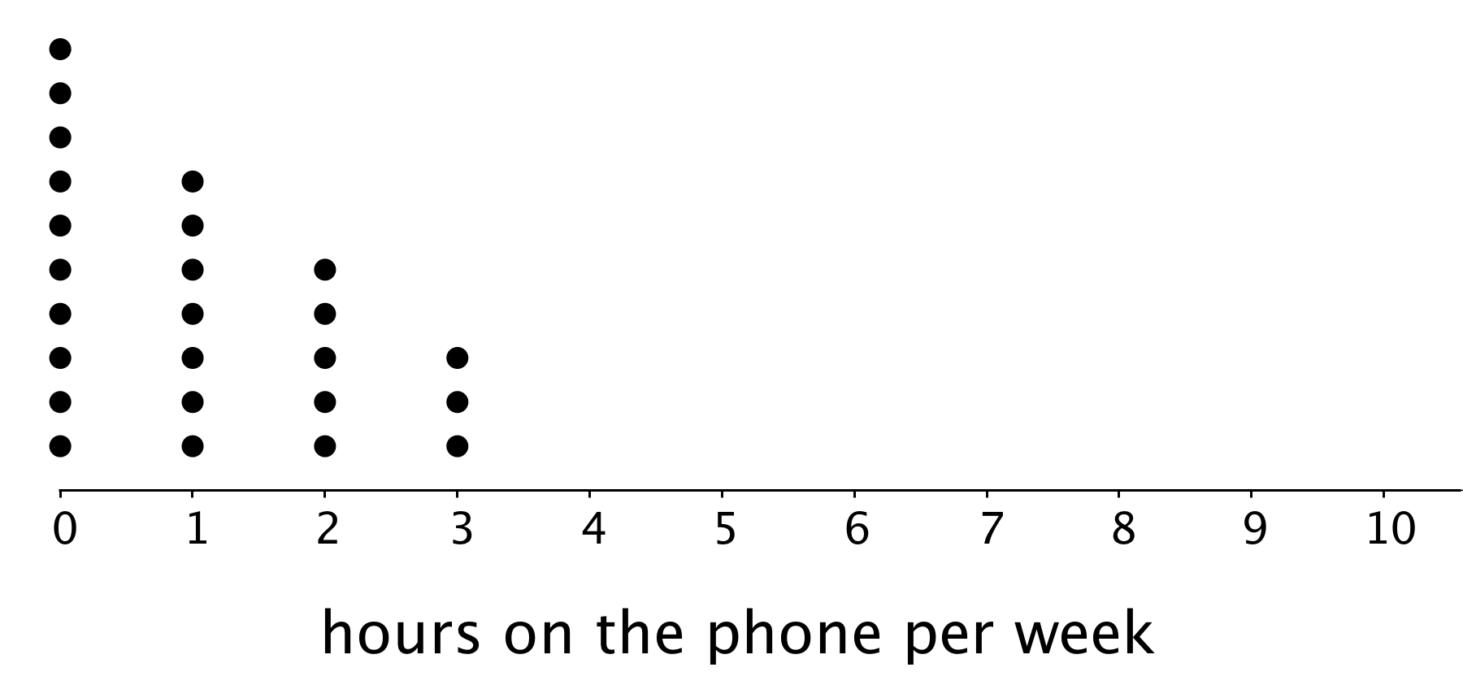

  - How many of the students reported not talking on the phone during the week? Explain how you know.
  - What percentage of the students reported not talking on the phone?

  - What is the largest number of hours a student spent talking on the phone per week?
  - What percentage of the group reported talking on the phone for this amount of time?

  - How many hours would you say that these students typically spend talking on the phone?
  - How many minutes per day would that be?

  - How would you describe the spread of the data? Would you consider these students’ amounts of time on the phone to be alike or different? Explain your reasoning.
  - Here is the dot plot from an earlier activity. It shows the number of hours per week the same group of 25 sixth-grade students reported spending on homework.
  - 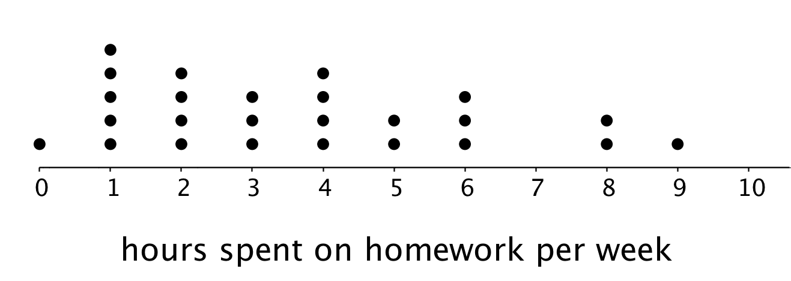
  - Overall, are these students more alike in the amount of time they spend talking on the phone or in the amount of time they spend on homework? Explain your reasoning.
- Suppose someone claimed that these sixth-grade students spend too much time on the phone. Do you agree? Use your analysis of the dot plot to support your answer.

3 Click-Clack

Student Task Statement
- A keyboarding teacher wondered: “Do typing speeds of students improve after taking a keyboarding course?” Explain why her question is a statistical question.
- The teacher recorded the number of words that her students could type per minute at the beginning of a course and again at the end. The two dot plots show the two data sets.
- 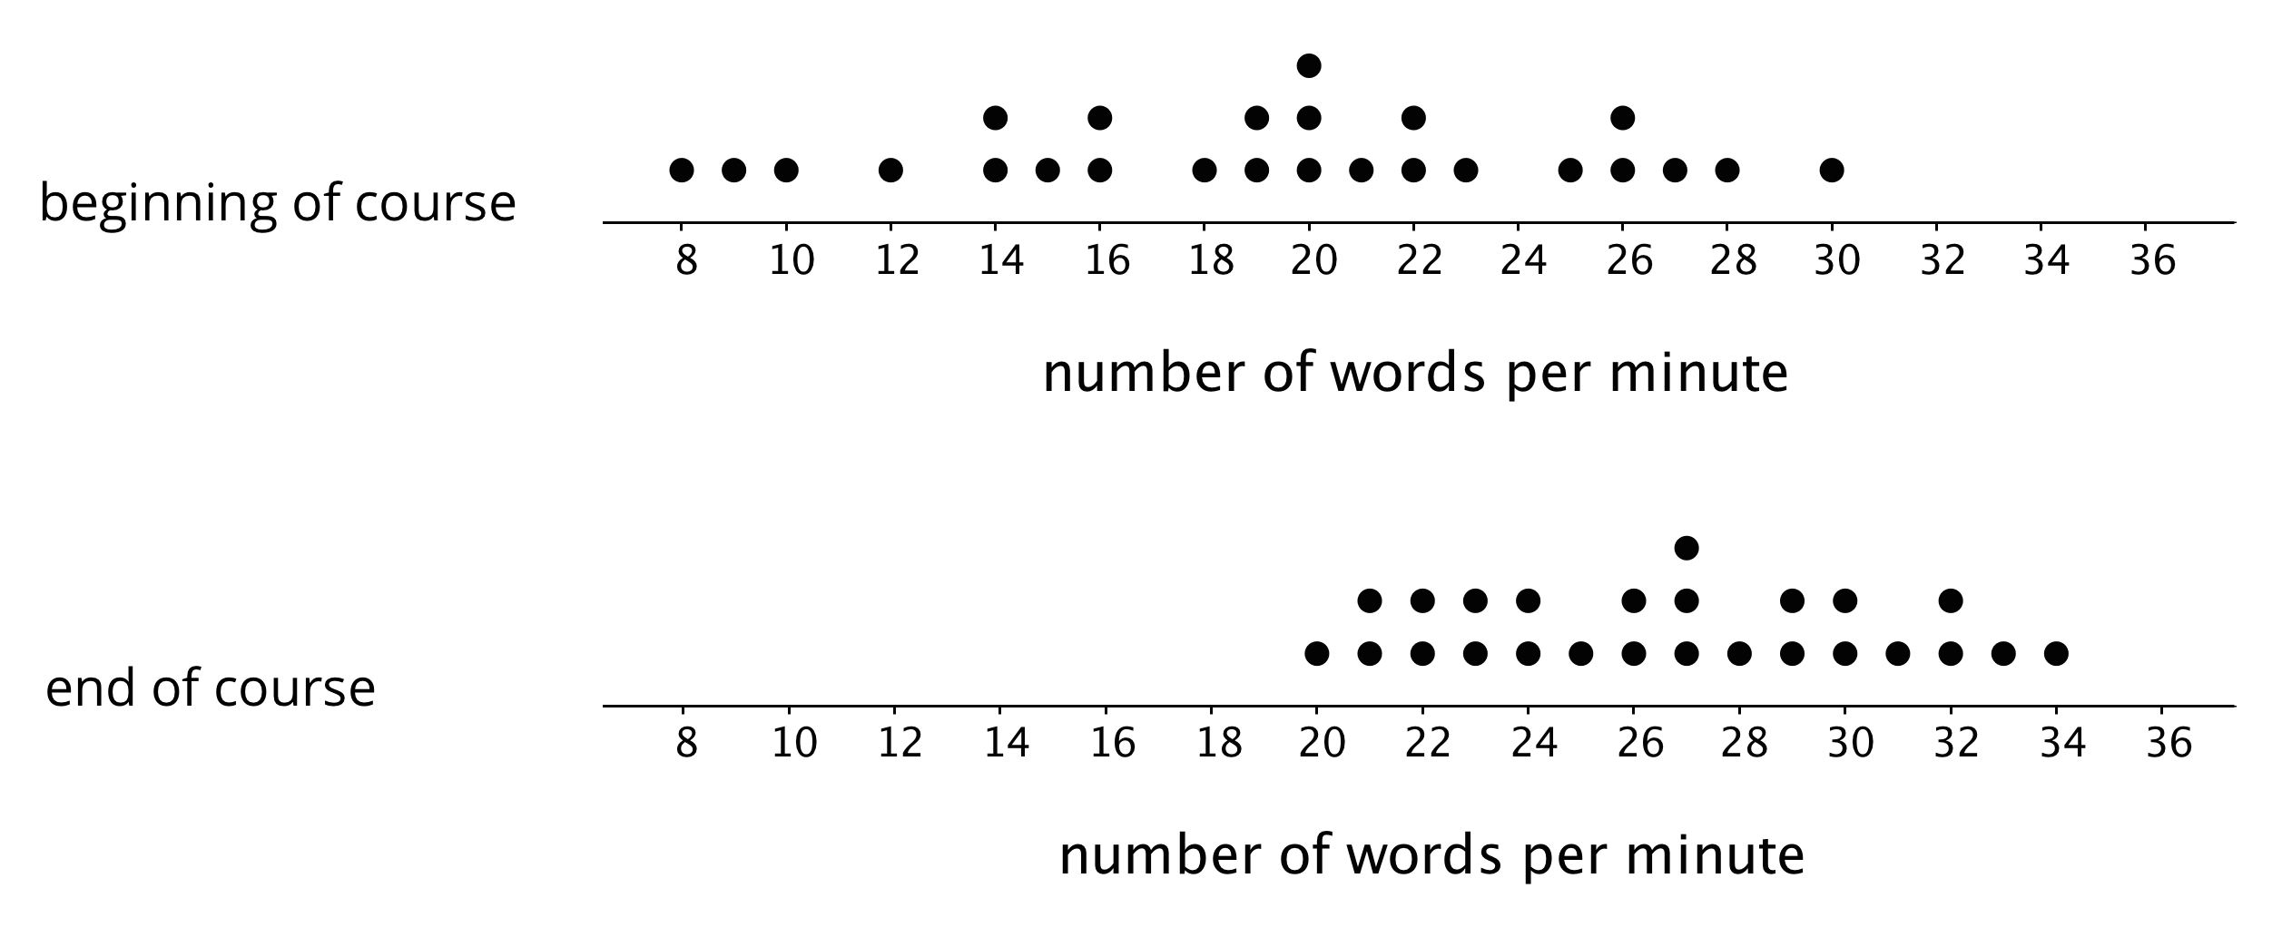
- Based on the dot plots, do you agree with each of the following statements about this group of students? Be prepared to explain your reasoning.
  - Overall, the students’ typing speed did not improve. They typed at the same speed at the end of the course as they did at the beginning.
  - 20 words per minute is a good estimate for how fast, in general, the students typed at the beginning of the course.
  - 20 words per minute is a good description of the center of the data set at the end of the course.
  - There was more variability in the typing speeds at the beginning of the course than at the end, so the students’ typing speeds were more alike at the end.
- Overall, how fast would you say that the students typed after completing the course? What would you consider the center of the end-of-course data?

Images for Activity Synthesis
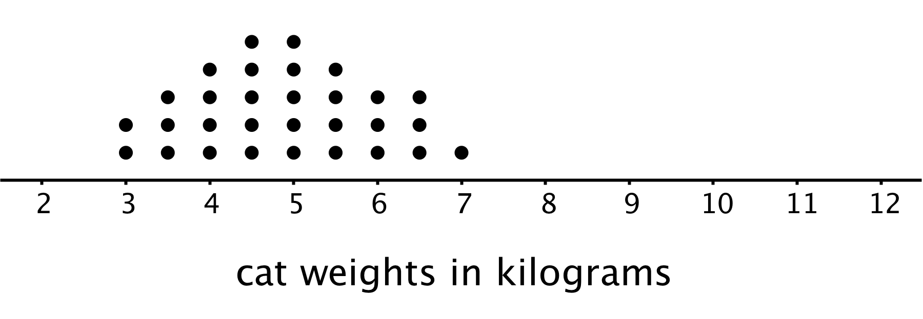
© CC BY Open Up Resources. Adaptations CC BY IM.

