Lesson 7 Practice Problems
- The temperature was recorded at several times during the day. Function $T$ gives the temperature in degrees Fahrenheit, $n$ hours since midnight.
- Here is a graph for this function.
- For each time interval, decide if the average rate of change is positive, negative, or zero:
  - From $n=1$ to $n=5$
  - From $n=5$ to $n=7$
  - From $n=10$ to $n=20$
  - From $n=15$ to $n=18$
  - From $n=20$ to $n=24$
- 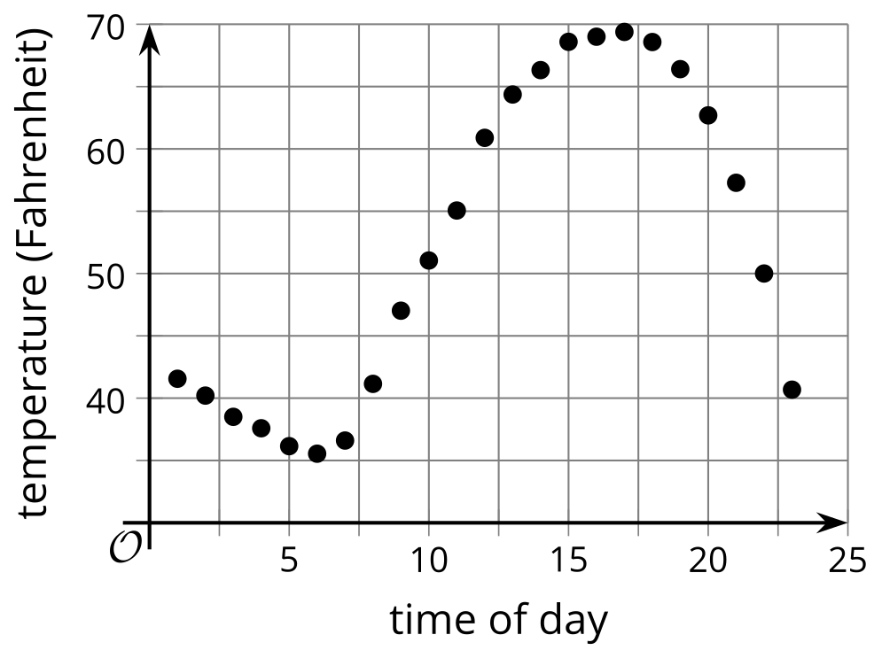
- The graph shows the total distance, in feet, walked by a person as a function of time, in seconds.
- 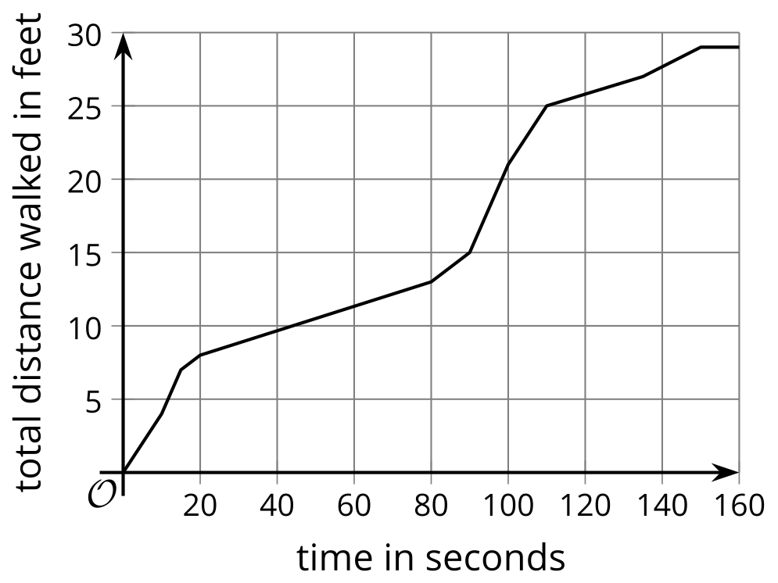
  - ​​​​​​Was the person walking faster between 20 and 40 seconds or between 80 and 100 seconds?
  - Was the person walking faster between 0 and 40 seconds or between 40 and 100 seconds?
- The height, in feet, of a squirrel running up and down a tree is a function of time, in seconds.
- Here are statements describing the squirrel’s movement during four intervals of time. Match each description with a statement about the average rate of change of the function for that interval.
  - The squirrel runs up the tree very fast.
  - The squirrel starts and ends at the same height.
  - The squirrel runs down the tree.
  - The squirrel runs up the tree slowly.
  - The average rate of change is negative.
  - The average rate of change is zero.
  - The average rate of change is small and positive.
  - The average rate of change is large and positive.
- The percent of voters between the ages of 18 and 29 that participated in each United States presidential election between the years 1988 to 2016 are shown in the table.
- year | - 1988 | - 1992 | - 1996 | - 2000 | - 2004 | - 2008 | - 2012 | - 2016
- percentage of voters ages 18-29 | - 35.7 | - 42.7 | - 33.1 | - 34.5 | - 45.0 | - 48.4 | - 40.9 | - 43.4
- The function $P$ gives the percent of voters between 18 and 29 years old that participated in the election in year $t$.
  - Determine the average rate of change for $P$ between 1992 and 2000.
  - Pick two different values of $t$ so that the function has a negative average rate of change between the two values. Determine the average rate of change.
  - Pick two values of $t$ so that the function has a positive average rate of change between the two values. Determine the average rate of change.
- Jada walks to school. The function $D$ gives her distance from school, in meters, as a function of time, in minutes, since she left home.
- What does $D\left(10\right)=0$ represent in this situation?
- (From Unit 4, Lesson 2.)
- Jada walks to school. The function $D$ gives her distance from school, in meters, $t$ minutes since she left home.
- Which equation tells us “Jada is 600 meters from school after 5 minutes”?
  - $D\left(5\right)=600$
  - $D\left(600\right)=5$
  - $t\left(5\right)=600$
  - $t\left(600\right)=5$
- (From Unit 4, Lesson 2.)
- A news website shows a scatter plot with a positive relationship between the number of vending machines in a school and the percentage of students who are absent from school on average. The headline reads, “Vending machines are causing our youth to miss school!”
  - What is wrong with this claim?
  - What is a better headline for this information?
- (From Unit 3, Lesson 9.)
© CC BY 2019 by Illustrative Mathematics®

