Unit 8 Lesson 1: Representing Data Graphically

1 Curious about Caps (Warm up)

Student Task Statement
Clare collects bottle caps and keeps them in plastic containers.
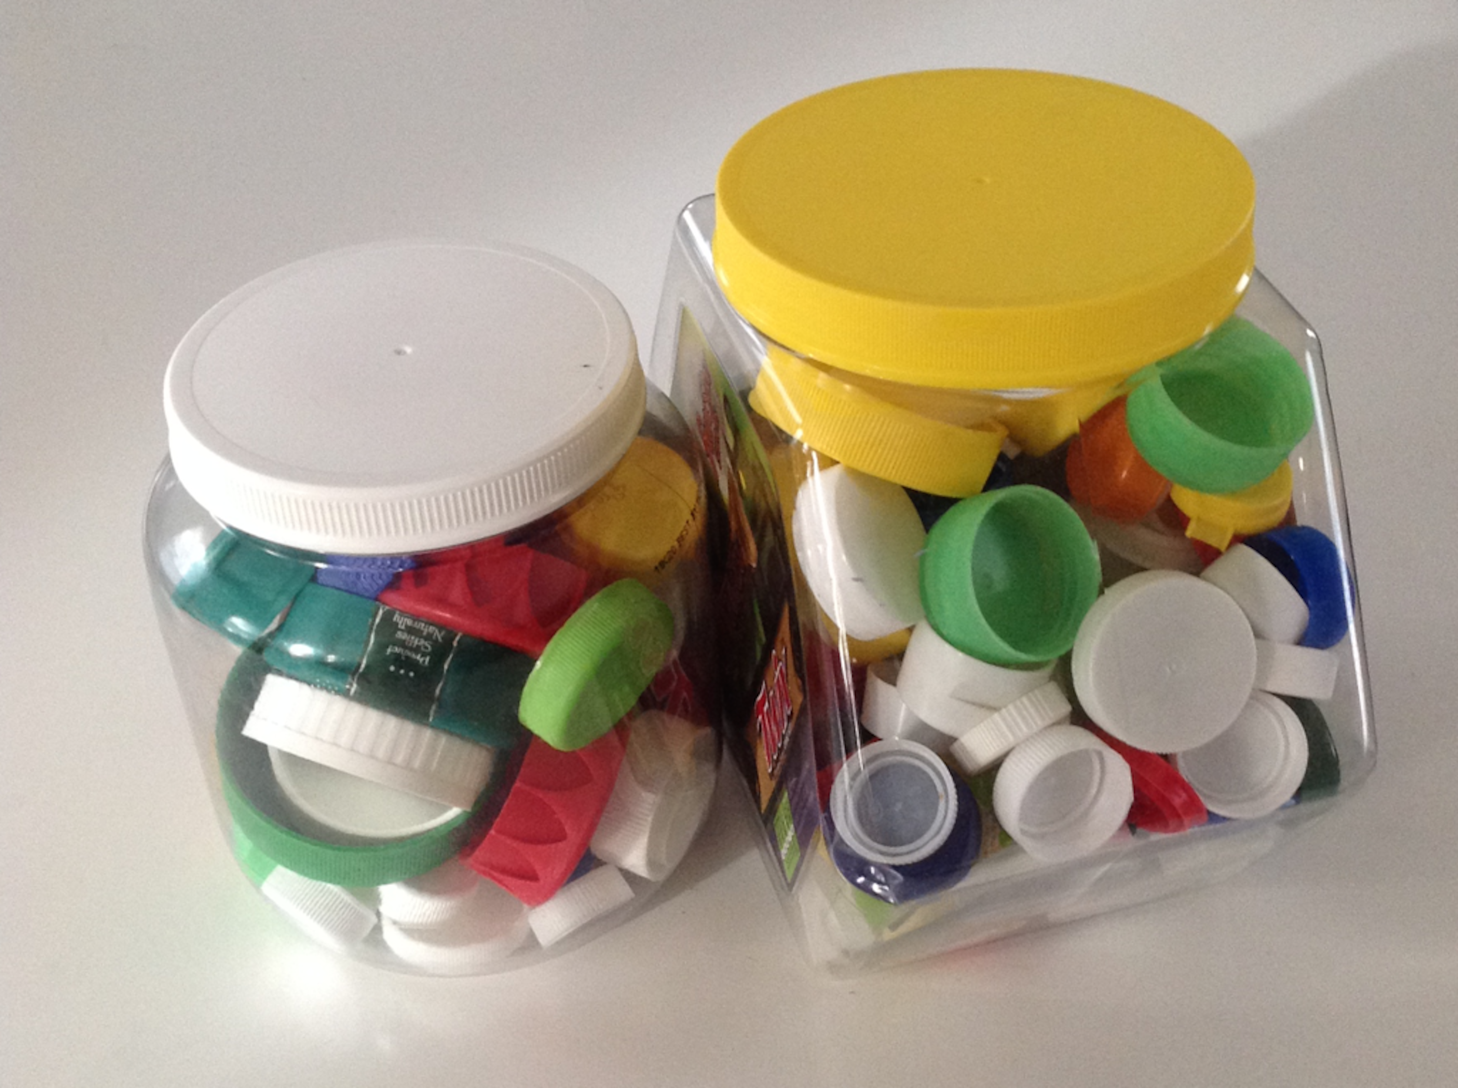
Write one statistical question that someone could ask Clare about her collection. Be prepared to explain your reasoning.

2 Estimating Caps

Images for Launch
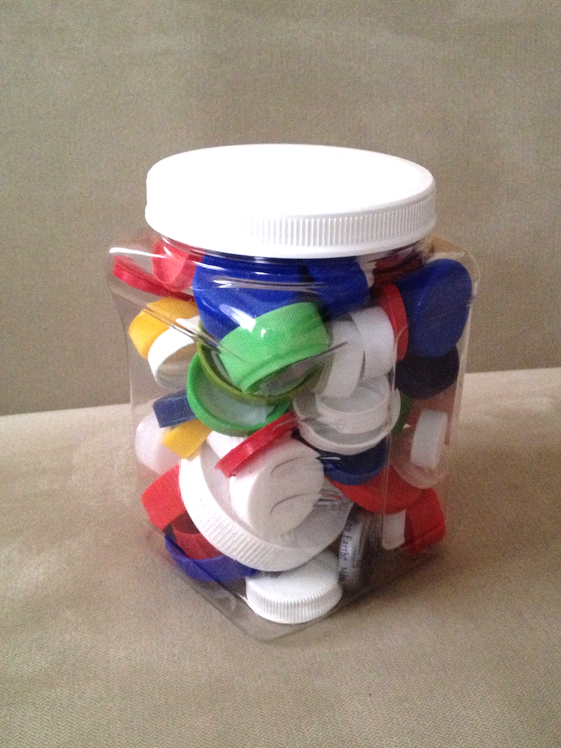

Student Task Statement
- Write down the statistical question your class is trying to answer.
- Look at the dot plot that shows the data from your class. Write down one thing you notice and one thing you wonder about the dot plot.
- Use the dot plot to answer the statistical question. Be prepared to explain your reasoning.

3 Been There, Done That!

Student Task Statement
Priya wants to know if basketball players on a men’s team and a women’s team have had prior experience in international competitions. She gathered data on the number of times the players were on a team before 2016.
men's team
3
0
0
0
0
1
0
0
0
0
0
0
women's team
2
3
3
1
0
2
0
1
1
0
3
1
- Did Priya collect categorical or numerical data?
- Organize the information on the two basketball teams into these tables.
- Men’s Basketball Team Players
- number of prior  competitions | - frequency  (number)
- 0
- 1
- 2
- 3
- 4
- Women’s Basketball Team Players
- number of prior  competitions | - frequency  (number)
- 0
- 1
- 2
- 3
- 4
- Make a dot plot for each table.
- Men’s Basketball Team Players
- 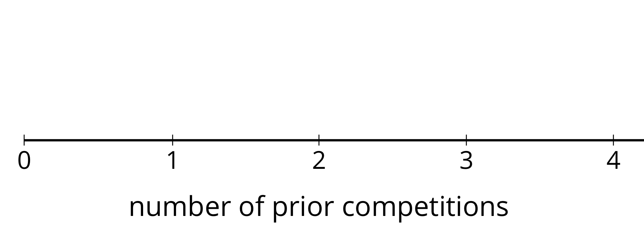
- Women’s Basketball Team Players
- Study your dot plots. What do they tell you about the competition participation of:
  - the players on the men’s basketball team?
  - the players on the women’s basketball team?
- Explain why a dot plot is an appropriate representation for Priya’s data.

4 Favorite Summer Sports (Optional)

Student Task Statement
Kiran wants to know which three summer sports are most popular in his class. He surveyed his classmates on their favorite summer sport. Here are their responses.
swimming
gymnastics
track and field
volleyball
swimming
swimming
diving
track and field
gymnastics
basketball
basketball
volleyball
track and field
track and field
volleyball
gymnastics
diving
gymnastics
volleyball
rowing
track and field
track and field
soccer
swimming
gymnastics
track and field
swimming
rowing
diving
soccer
- Did Kiran collect categorical or numerical data?
- Organize the responses in a table to help him find which summer sports are most popular in his class.
- sport | - frequency
- Represent the information in the table as a bar graph.

  - How can you use the bar graph to find how many classmates Kiran surveyed?
  - Which three summer sports are most popular in Kiran’s class?
  - Use your bar graph to describe at least one observation about Kiran’s classmates’ preferred summer sports.
- Could a dot plot be used to represent Kiran’s data? Explain your reasoning.
© CC BY Open Up Resources. Adaptations CC BY IM.

