Lesson 11 Practice Problems
- Complete the table to show the amounts of yellow and red paint needed for different-sized batches of the same shade of orange paint.
- yellow paint (quarts) | - red paint (quarts)
- 5 | - 6
- Explain how you know that these amounts of yellow paint and red paint will make the same shade of orange as the mixture in the first row of the table.
- A car travels at a constant speed, as shown on the double number line.
- 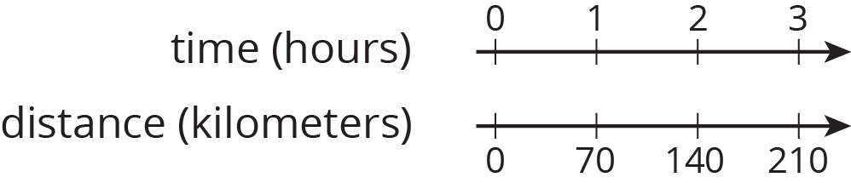
- How far does the car travel in 14 hours? Explain or show your reasoning.

- The olive trees in an orchard produce 3,000 pounds of olives a year. It takes 20 pounds of olives to make 3 liters of olive oil. How many liters of olive oil can this orchard produce in a year? If you get stuck, consider using the table.
- olives (pounds) | - olive oil (liters)
- 20 | - 3
- 100
- 3,000
- At a school recess, there needs to be a ratio of 2 adults for every 24 children on the playground. The double number line represents the number of adults and children on the playground at recess.
- 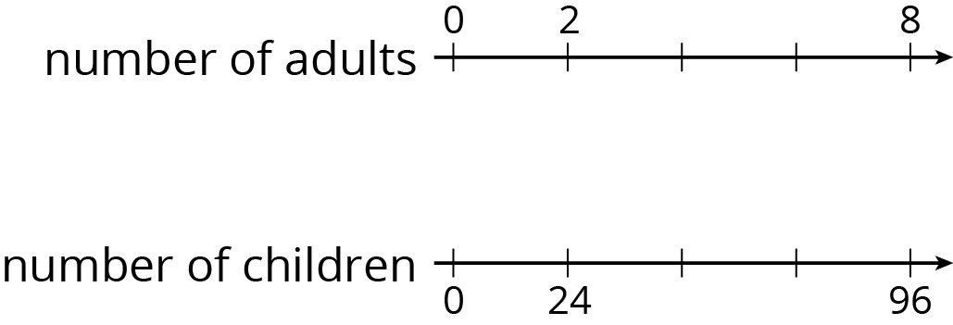
  - Label each remaining tick mark with its value.
  - How many adults are needed if there are 72 children? Circle your answer on the double number line.
- (From Unit 2, Lesson 6.)
- While playing basketball, Jada’s heart rate goes up to 160 beats per minute. While jogging, her heart beats 25 times in 10 seconds. Assuming her heart beats at a constant rate while jogging, which of these activities resulted in a higher heart rate? Explain your reasoning.
- (From Unit 2, Lesson 10.)
- A shopper bought the following items at the farmer’s market:
  - 6 ears of corn for $1.80. What was the cost per ear?
  - 12 apples for $2.88. What was the cost per apple?
  - 5 tomatoes for $3.10. What was the cost per tomato?
- (From Unit 2, Lesson 8.)
© CC BY Open Up Resources. Adaptations CC BY IM.

