Unit 4 Lesson 3: Understanding Rational Inputs

1 Keeping Equations True (Warm up)

Student Task Statement
- Select all solutions to $x⋅x=5$. Be prepared to explain your reasoning.
  - $\frac{1}{25}$
  - $\sqrt{5}$
  - $\frac{5}{2}$
  - $5^{\frac{1}{2}}$
  - $\frac{\sqrt{5}}{2}$
  - $\sqrt{25}$
- Select all solutions to $p⋅p⋅p=10$. Be prepared to explain your reasoning.
  - ${10}^{\frac{1}{3}}$
  - $\sqrt{10}$
  - $\frac{10}{3}$
  - $\frac{\sqrt{10}}{3}$
  - $\sqrt[3]{10}$
  - $\frac{1}{3}\sqrt{10}$

2 Florida in the 1800’s

Student Task Statement
In 1840, the population of Florida was about 54,500. Between 1840 and 1860, the population grew exponentially, increasing by about 60% each decade.
- Find the population of Florida in 1850 and in 1860 according to this model.
- The population is a function $f$ of the number of decades $d$ after 1840. Write an equation for $f$.

  - Explain what $f\left(0.5\right)$ means in this situation.
  - Graph your function using graphing technology and estimate the value of $f\left(0.5\right)$.
  - Explain why we can find the value of $f\left(0.5\right)$ by multiplying 54,500 by $\sqrt{1.6}$. Find that value.
- Based on the model, what was the population of Florida in 1858? Show your reasoning.

3 Disappearing Medicine

Student Task Statement
The amount of a medicine in the bloodstream of a patient decreases roughly exponentially. Here is a graph representing $f$, an exponential function that models the medicine in the body of a patient, $t$ hours after an injection is given.
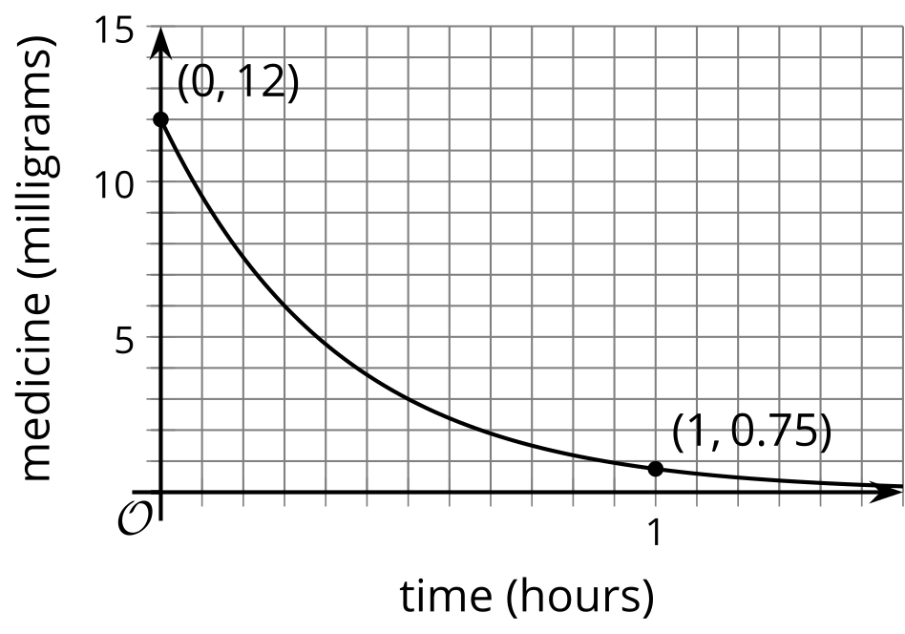
- Use the graph to estimate $f\left(\frac{1}{3}\right)$ and explain what it tells us in this situation.
- After one hour, 0.75 mg of medicine remains in the bloodstream. Find an equation that defines $f$.

Images for Activity Synthesis
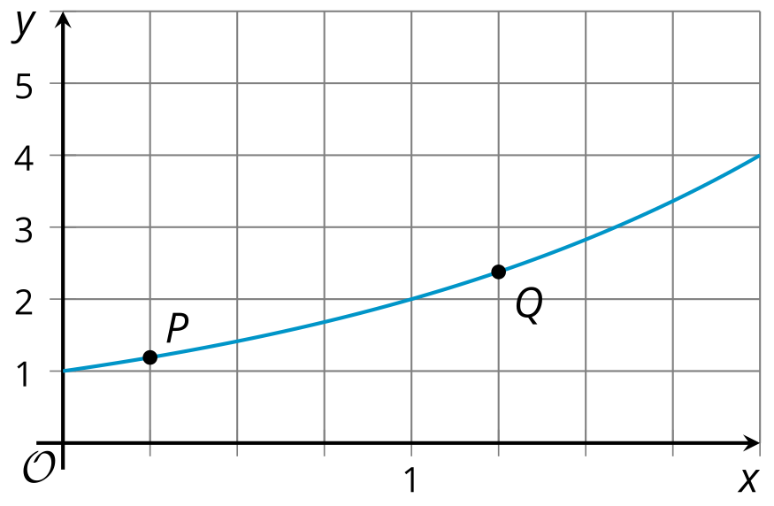
© CC BY 2019 by Illustrative Mathematics®

