Lesson 3 Practice Problems
- Apply each transformation described to Figure A. If you get stuck, try using tracing paper.
- 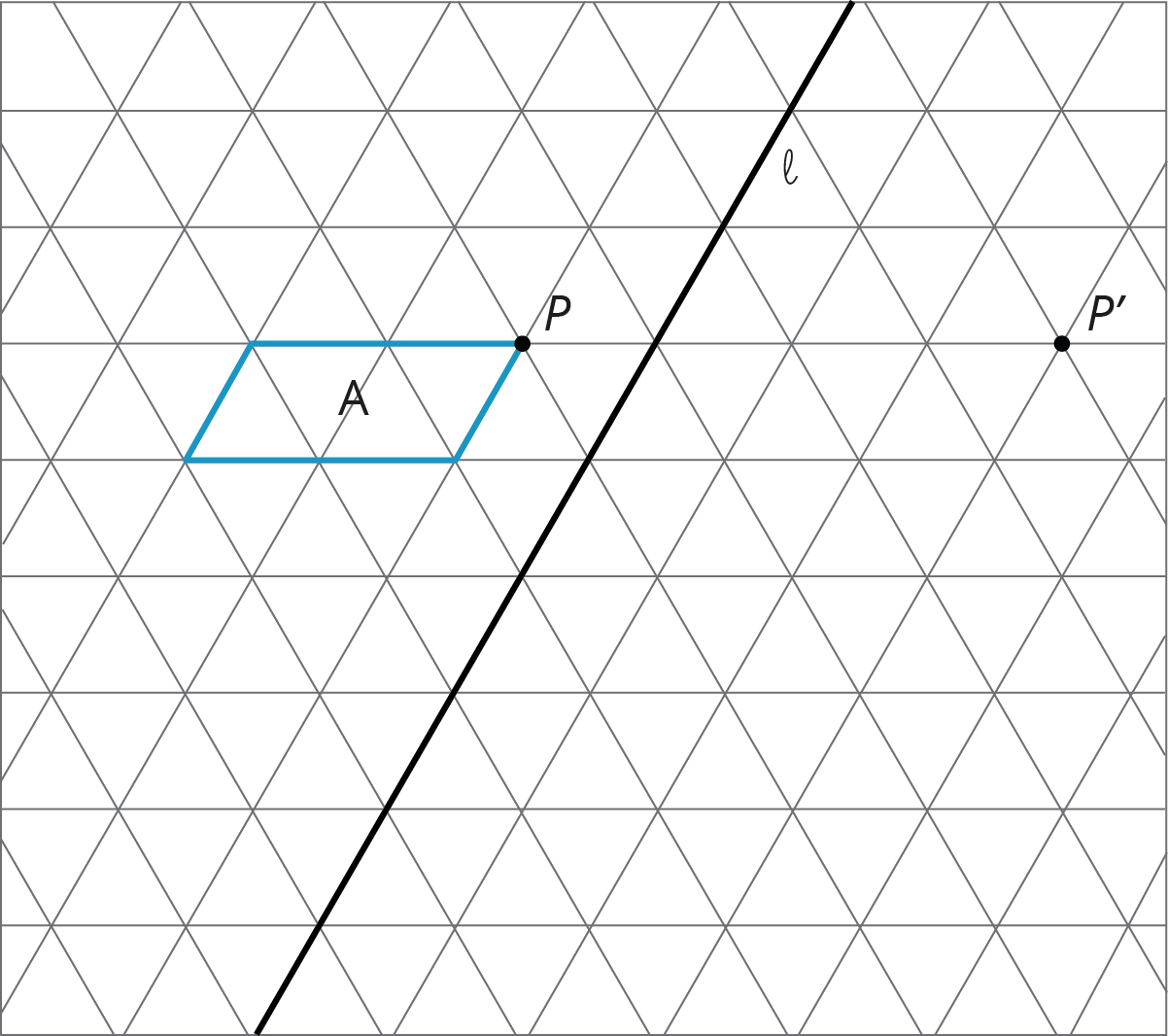
  - A translation which takes $P$ to $P^{′}$
  - A counterclockwise rotation of A, using center $P$, of 60 degrees
  - A reflection of A across line $ℓ$
- Here is triangle $ABC$ drawn on a grid.
- 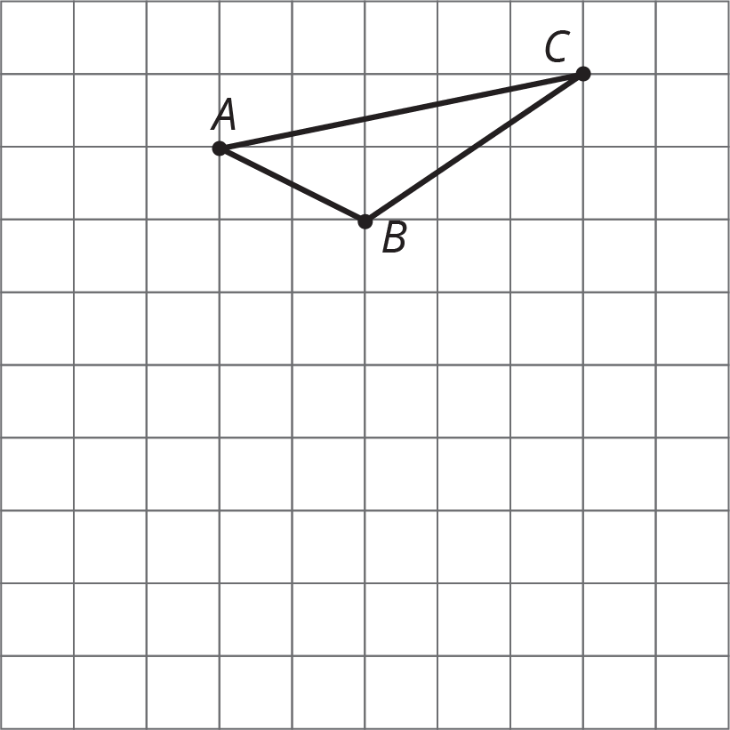
- On the grid, draw a rotation of triangle $ABC$, a translation of triangle $ABC$, and a reflection of triangle $ABC$. Describe clearly how each was done.

  - Draw the translated image of $ABCDE$ so that vertex $C$ moves to $C^{′}$. Tracing paper may be useful.
  - 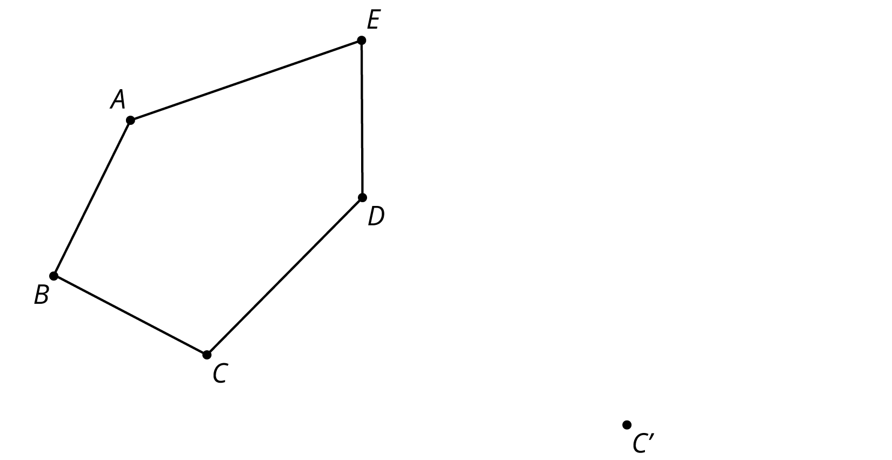
  - Draw the reflected image of Pentagon $ABCDE$ with line of reflection $ℓ$. Tracing paper may be useful.
  - 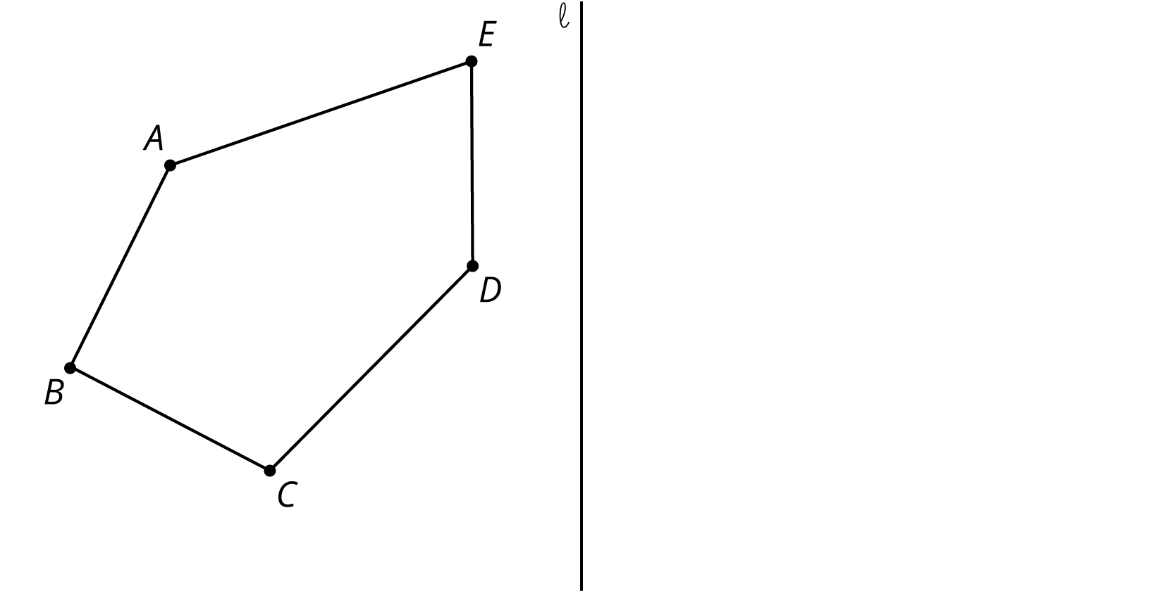
  - Draw the rotation of Pentagon $ABCDE$ around $C$ clockwise by an angle of 150 degrees. Tracing paper and a protractor may be useful.
  - 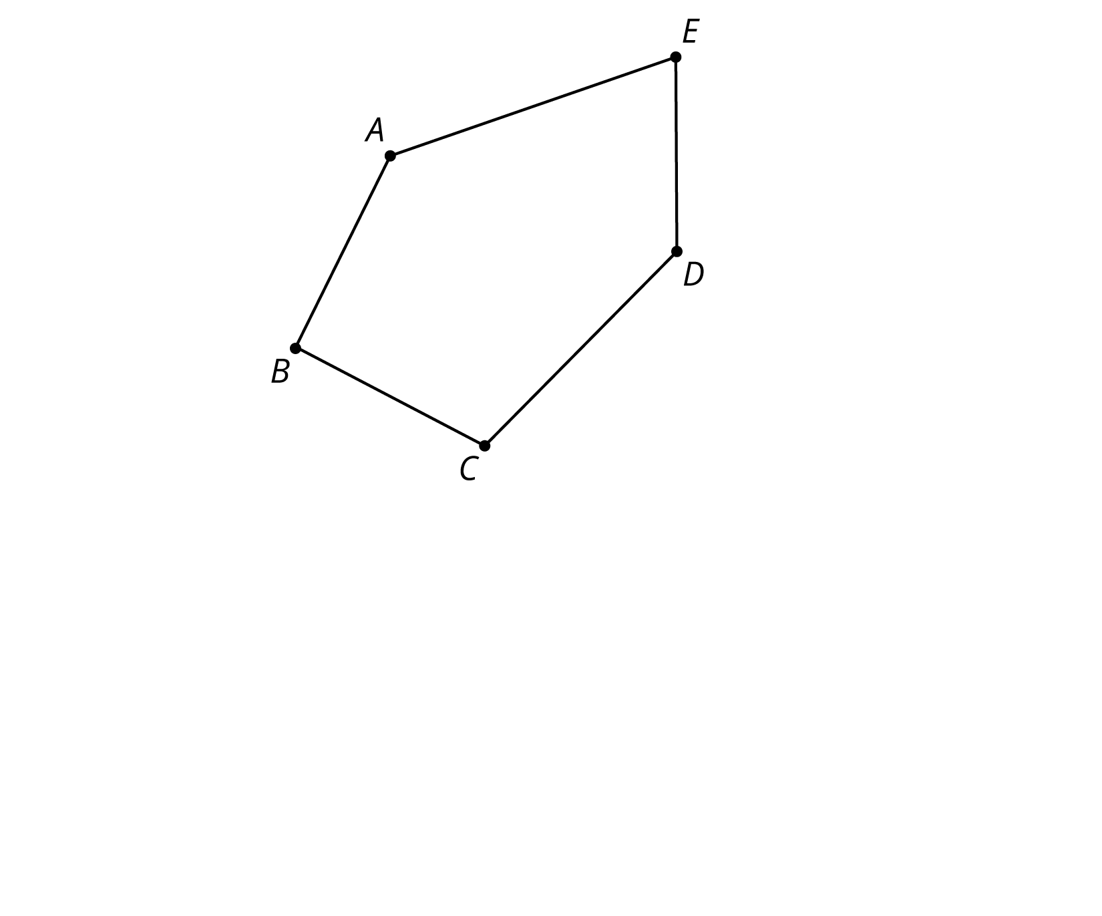
- (From Unit 1, Lesson 2.)
© CC BY Open Up Resources. Adaptations CC BY IM.

