Lesson 4 Practice Problems
- The table shows five transactions and the resulting account balance in a bank account, except some numbers are missing. Fill in the missing numbers.
 | - transaction amount | - account balance
- transaction 1 | - 200 | - 200
- transaction 2 | - -147 | - 53
- transaction 3 | - 90
- transaction 4 | - -229
- transaction 5 |  | - 0

  - Clare has $54 in her bank account. A store credits her account with a $10 refund. How much does she now have in the bank?
  - Mai's bank account is overdrawn by $60, which means her balance is -$60. She gets $85 for her birthday and deposits it into her account. How much does she now have in the bank?
  - Tyler is overdrawn at the bank by $180. He gets $70 for his birthday and deposits it. What is his account balance now?
  - Andre has $37 in his bank account and writes a check for $87. After the check has been cashed, what will the bank balance show?
- Last week, it rained $g$ inches. This week, the amount of rain decreased by 5%. Which expressions represent the amount of rain that fell this week? Select all that apply.
  - $g−0.05$
  - $g−0.05g$
  - $0.95g$
  - $0.05g$
  - $\left(1−0.05\right)g$
- (From Unit 4, Lesson 8.)
- Decide whether or not each equation represents a proportional relationship.
  - Volume measured in cups ($c$) vs. the same volume measured in ounces ($z$): $c=\frac{1}{8}z$
  - Area of a square ($A$) vs. the side length of the square ($s$): $A=s^{2}$
  - Perimeter of an equilateral triangle ($P$) vs. the side length of the triangle ($s$): $3s=P$
  - Length ($L$) vs. width ($w$) for a rectangle whose area is 60 square units: $L=\frac{60}{w}$
- (From Unit 2, Lesson 8.)
- Add.
  - $5\frac{3}{4}+\left(\text{-}\frac{1}{4}\right)$
  - $\text{-}\frac{2}{3}+\frac{1}{6}$
  - $\text{-}\frac{8}{5}+\left(\text{-}\frac{3}{4}\right)$
- (From Unit 5, Lesson 3.)
- In each diagram, $x$ represents a different value.
- 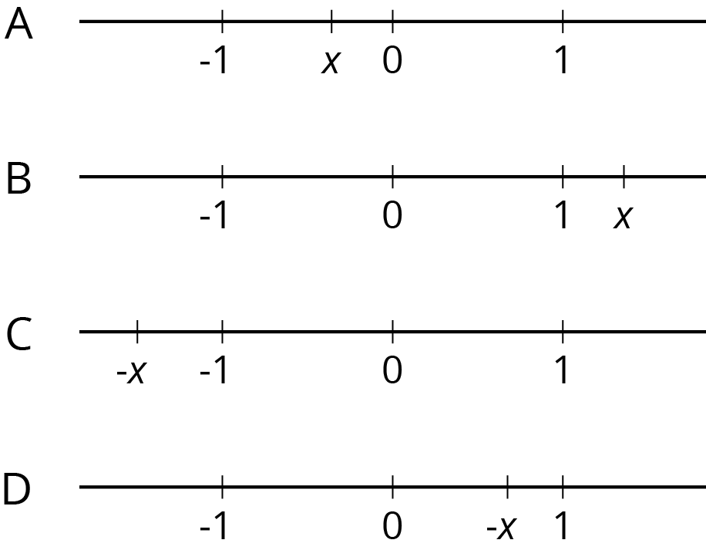
- For each diagram,
  - What is something that is definitely true about the value of $x$?
  - What is something that could be true about the value of $x$?
- (From Unit 5, Lesson 1.)
© CC BY Open Up Resources. Adaptations CC BY IM.

