Lesson 6 Practice Problems
- It takes 2 ounces of paint to completely cover all 6 sides of a rectangular prism box which holds 15 cups of sugar. Double the dimensions of the box. Approximately how much paint would the new box need? How much sugar would it hold?
- A solid with volume 12 cubic units is dilated by a scale factor of $k$. Find the volume of the image for each given value of $k$.
  - $k=\frac{1}{4}$
  - $k=0.4$
  - $k=1$
  - $k=1.2$
  - $k=\frac{5}{3}$
- A solid’s volume is 10 cubic inches. The solid is dilated by a scale factor of 3.5. Kiran says, “I calculated the volume of the image as 35 cubic inches, but I don’t think that’s right.”
  - What might Kiran have done wrong?
  - What is the volume of the image?
- A parallelogram has an area of 10 square feet.
  - Complete the table that shows the relationship between the dilated area ($x$) and the scale factor ($y$).
- dilated area in square feet | - scale factor
  - 0
  - 40
  - 160
  - 360
  - 640
  - Plot the points in the table on coordinate axes and connect them to create a smooth curve.
- (From Unit 5, Lesson 5.)
- A figure has an area of 4 square units. The equation $y=\sqrt{\frac{x}{4}}$ represents the scale factor of $y$ by which the solid must be dilated to obtain an image with area $x$ square units. Select all points which are on the graph representing this equation.
  - $\left(0,0\right)$
  - $\left(1,\frac{1}{2}\right)$
  - $\left(1,1\right)$
  - $\left(4,1\right)$
  - $\left(8,2\right)$
- (From Unit 5, Lesson 5.)
- Tyler is designing a banner that will welcome people to a festival. The design for the banner has an area of 1.5 square feet. The actual banner will be a dilation of the design by a factor of 5. What will the area of the actual banner be?
- (From Unit 5, Lesson 4.)
- The horizontal cross sections of this figure are dilations of the bottom rectangle using a point above the rectangle as a center and scale factors from $\frac{1}{2}$ to 1. Sketch an example of a cross section that is created from using a scale factor of $\frac{3}{4}$. Label the dimensions of the cross section that you sketch.
- 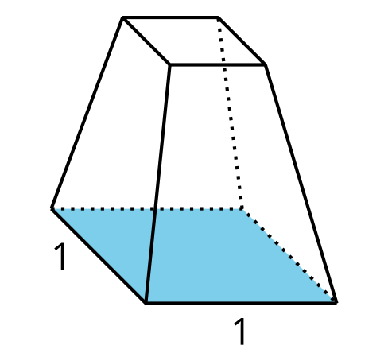
- (From Unit 5, Lesson 3.)
- Technology required. A regular hexagon is inscribed in a circle of radius 1 inch. What is the area of the shaded region?
- 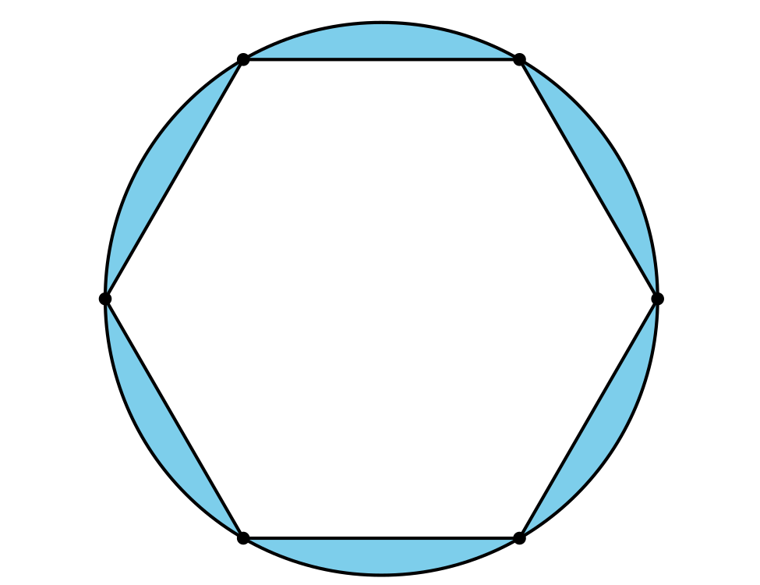
- (From Unit 4, Lesson 10.)
- Two distinct lines, $ℓ$ and $m$, are each perpendicular to the same line $n$. Explain why $ℓ$ and $m$ are parallel lines.
- (From Unit 1, Lesson 6.)
© CC BY 2019 by Illustrative Mathematics®

