Unit 4 Lesson 12: The Number $e$

1 Matching Situations and Equations (Warm up)

Student Task Statement
Match each equation to a situation it represents. Be prepared to explain how you know. Not all equations have a match.
$f\left(t\right)=400⋅{\left(0.5\right)}^{0.1t}$
$g\left(t\right)=400⋅{\left(1.25\right)}^{0.1t}$
$h\left(t\right)=400⋅{\left(0.75\right)}^{0.1t}$
$j\left(t\right)=400⋅{\left(2\right)}^{10t}$
$k\left(t\right)=400⋅{\left(2\right)}^{0.1t}$
- A scientist begins an experiment with 400 bacteria in a petri dish. The population doubles every 10 hours. The function gives the number of bacteria $t$ hours since the experiment began.
- A patient takes 400 mg of a medicine. The amount of medicine in her bloodstream decreases by 25% every 10 hours. The function gives the amount of medicine left in her bloodstream after $t$ hours of taking the medicine.
- The half-life of a radioactive element is 10 years. There are 400 g of the element in a sample when it is first studied. The function gives the amount of the element remaining $t$ years later.
- In a lake, the population of a species of fish is 400. The population is expected to grow by 25% in the next decade. The function gives the number of fish in the lake $t$ years after it was 400.

2 Notice and Wonder: Moldy Growth

Student Task Statement
A spot of mold is found on a basement wall. Its area is about 10 square centimeters. Here are three representations of a function that models how the mold is growing.
time (weeks) | area of mold (sq cm)
0 | 10
1 | 27
2 | 74
3 | 201
4 | 546
$a\left(t\right)=10⋅e^{t}$
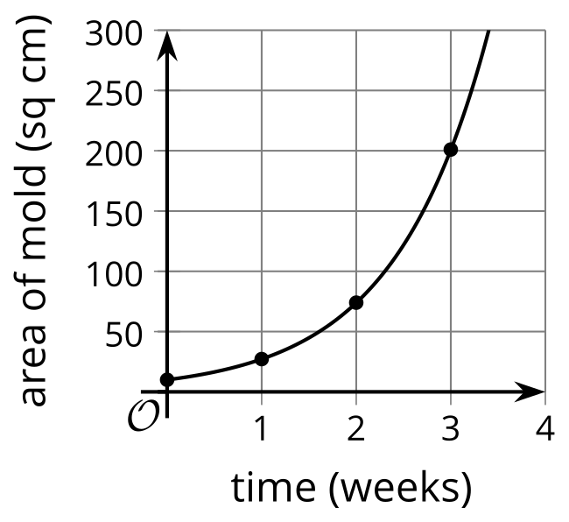
What do you notice? What do you wonder?

3 ${\left(1+\text{tiny}\right)}^{\text{huge}}$

Student Task Statement
- Here are some functions. For each function, describe, in words, the outputs for very tiny, positive values of $x$ and for very large values of $x$.
- $a\left(x\right)=1^{x}$
- $b\left(x\right)=\text{-}x$
- $d\left(x\right)=\frac{1}{x}$
- $f\left(x\right)={\left(\frac{1}{x}\right)}^{x}$
- $g\left(x\right)={\left(1+\frac{1}{x}\right)}^{x}$
- $h\left(x\right)=e^{x}$
- $k\left(x\right)=1+x$

- Remember that $e≈2.718$. What does the function $g$ have to do with the number $e$?
- What do you notice about the relationship between $h$ and $k$ for very small, positive values of $x$?

Activity Synthesis
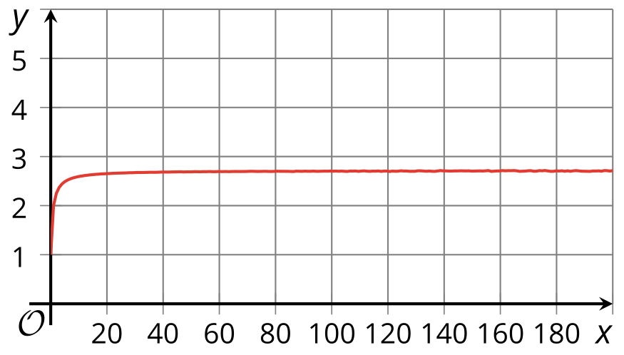
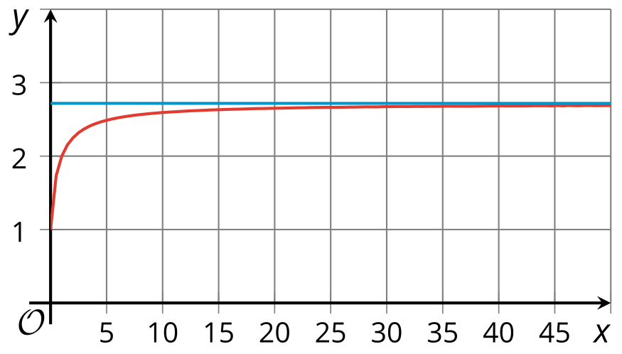
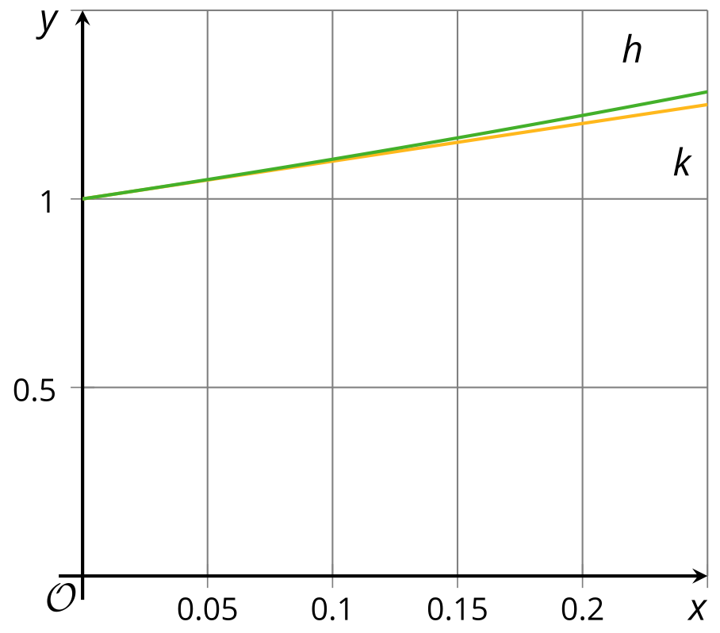
© CC BY 2019 by Illustrative Mathematics®

