Unit 1 Lesson 11: Congruence

1 Translated Images (Warm up)

Student Task Statement
All of these triangles are congruent. Sometimes we can take one figure to another with a translation. Shade the triangles that are images of triangle $ABC$ under a translation.
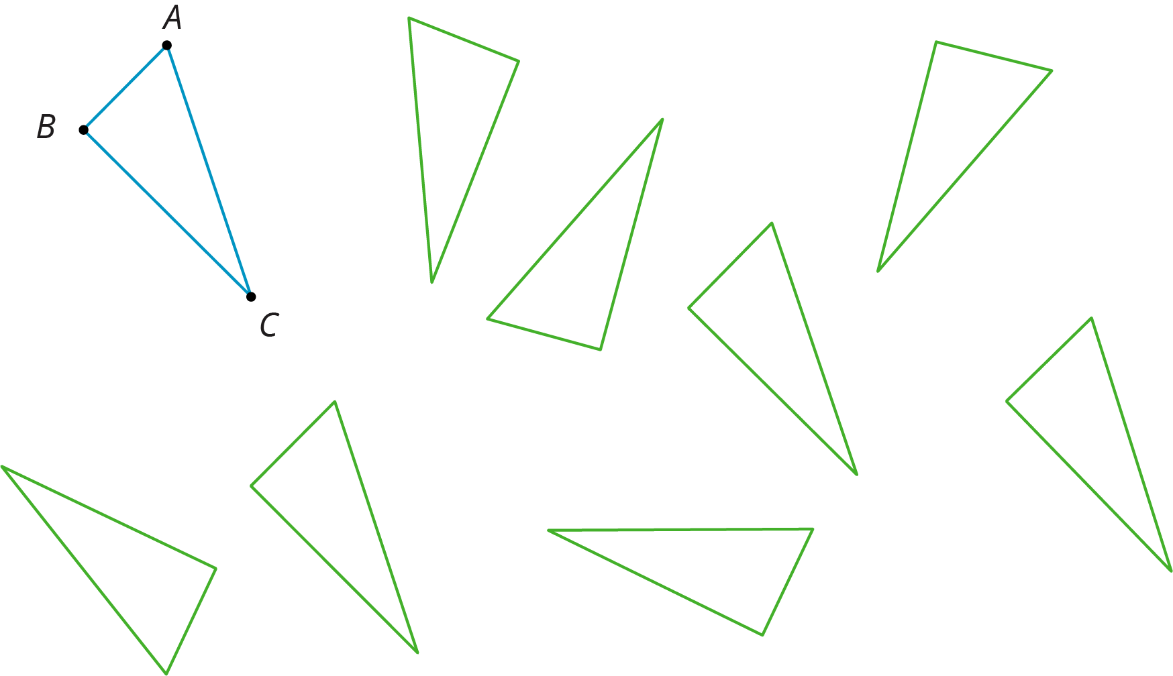

2 Congruent Pairs

Student Task Statement
For each of the following pairs of shapes, decide whether or not they are congruent. Explain your reasoning.

- 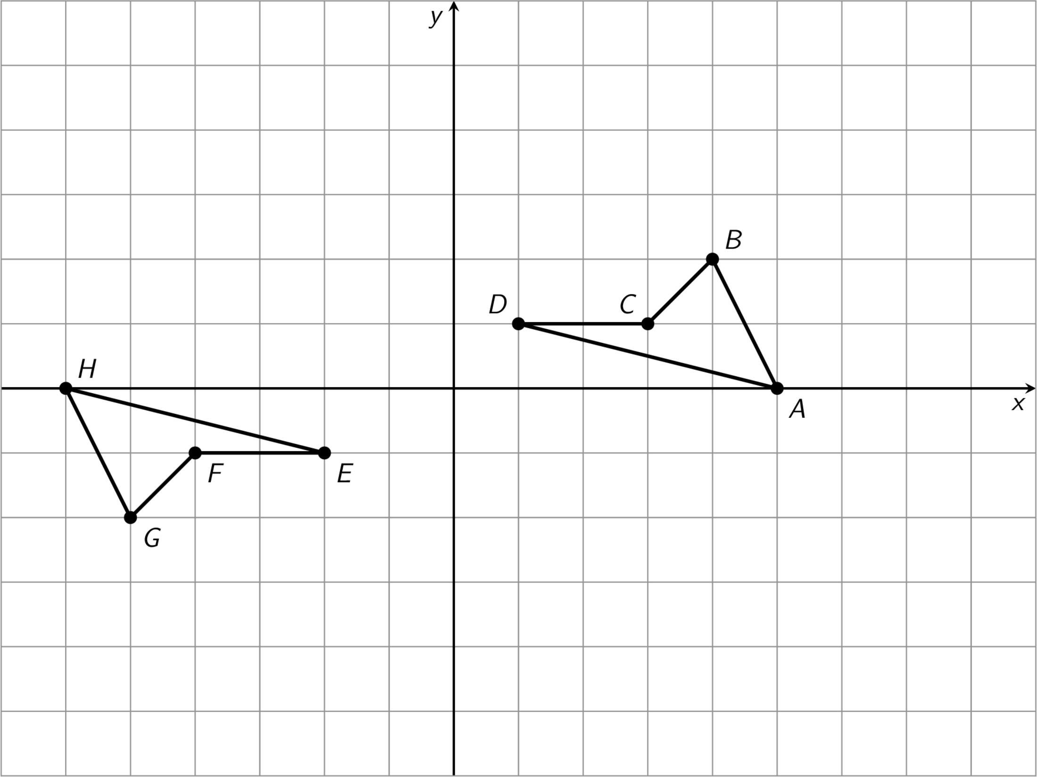

- 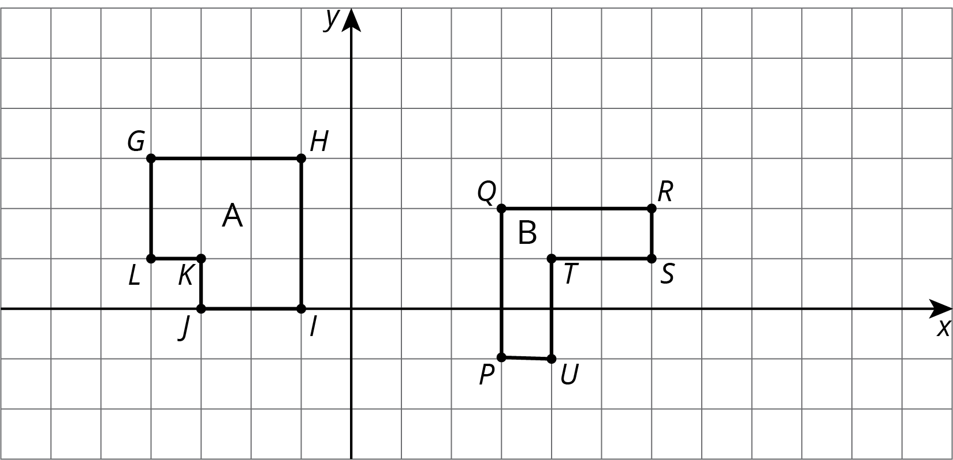

- 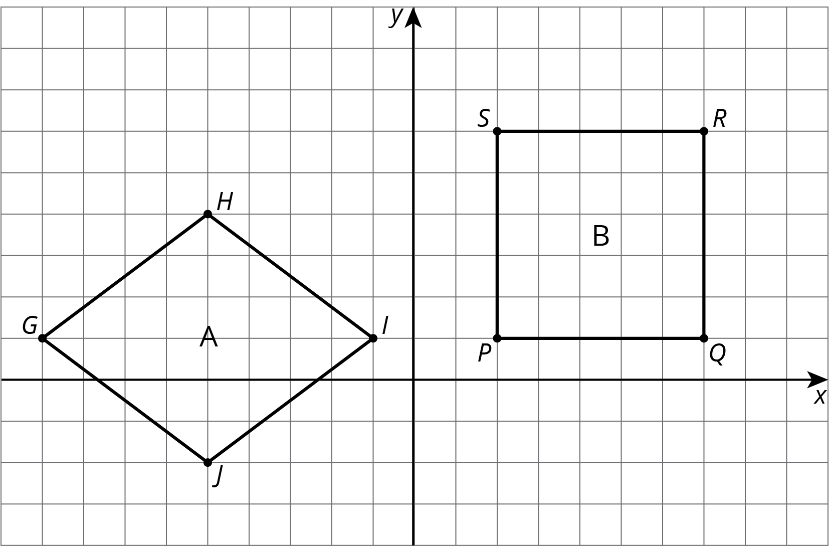

- 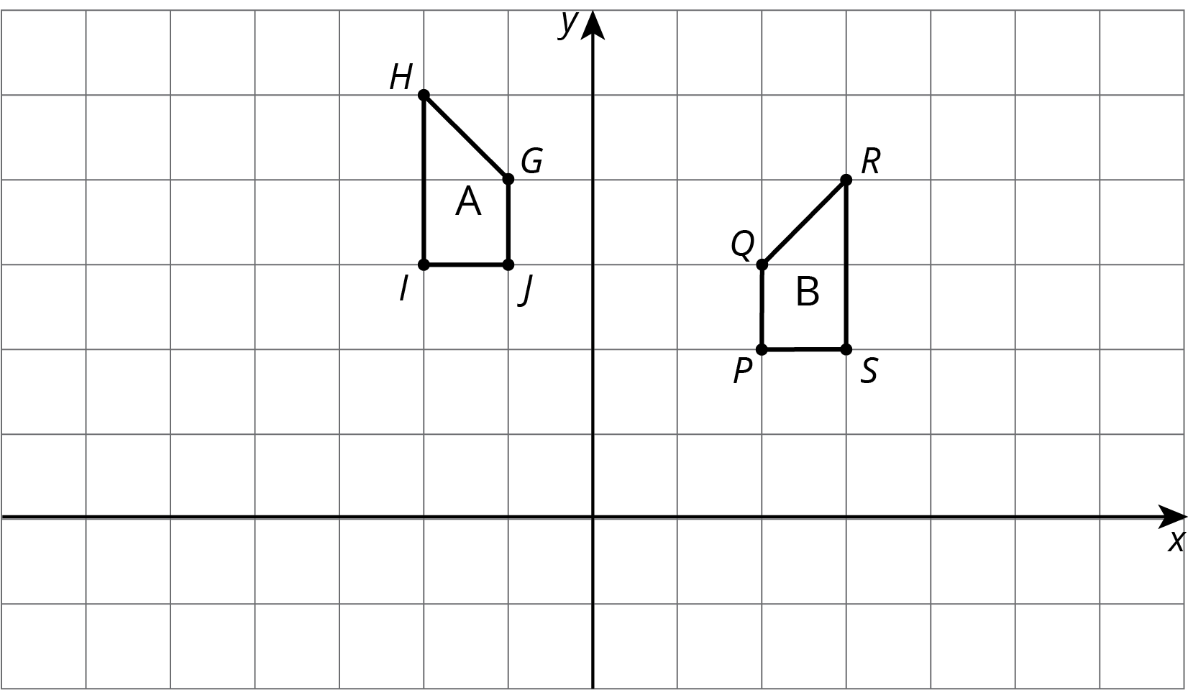

- 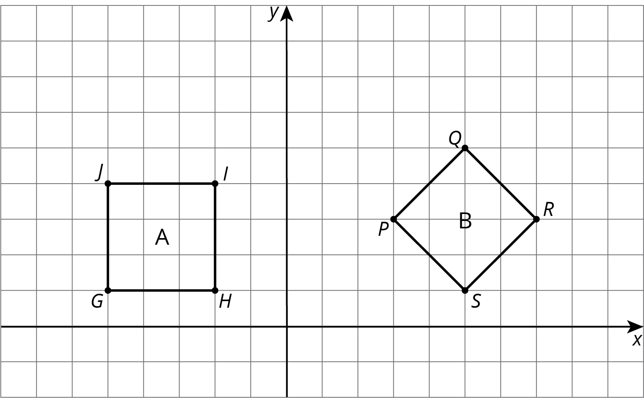

3 Corresponding Points in Congruent Figures

Student Task Statement
Here are two congruent shapes with some corresponding points labeled.
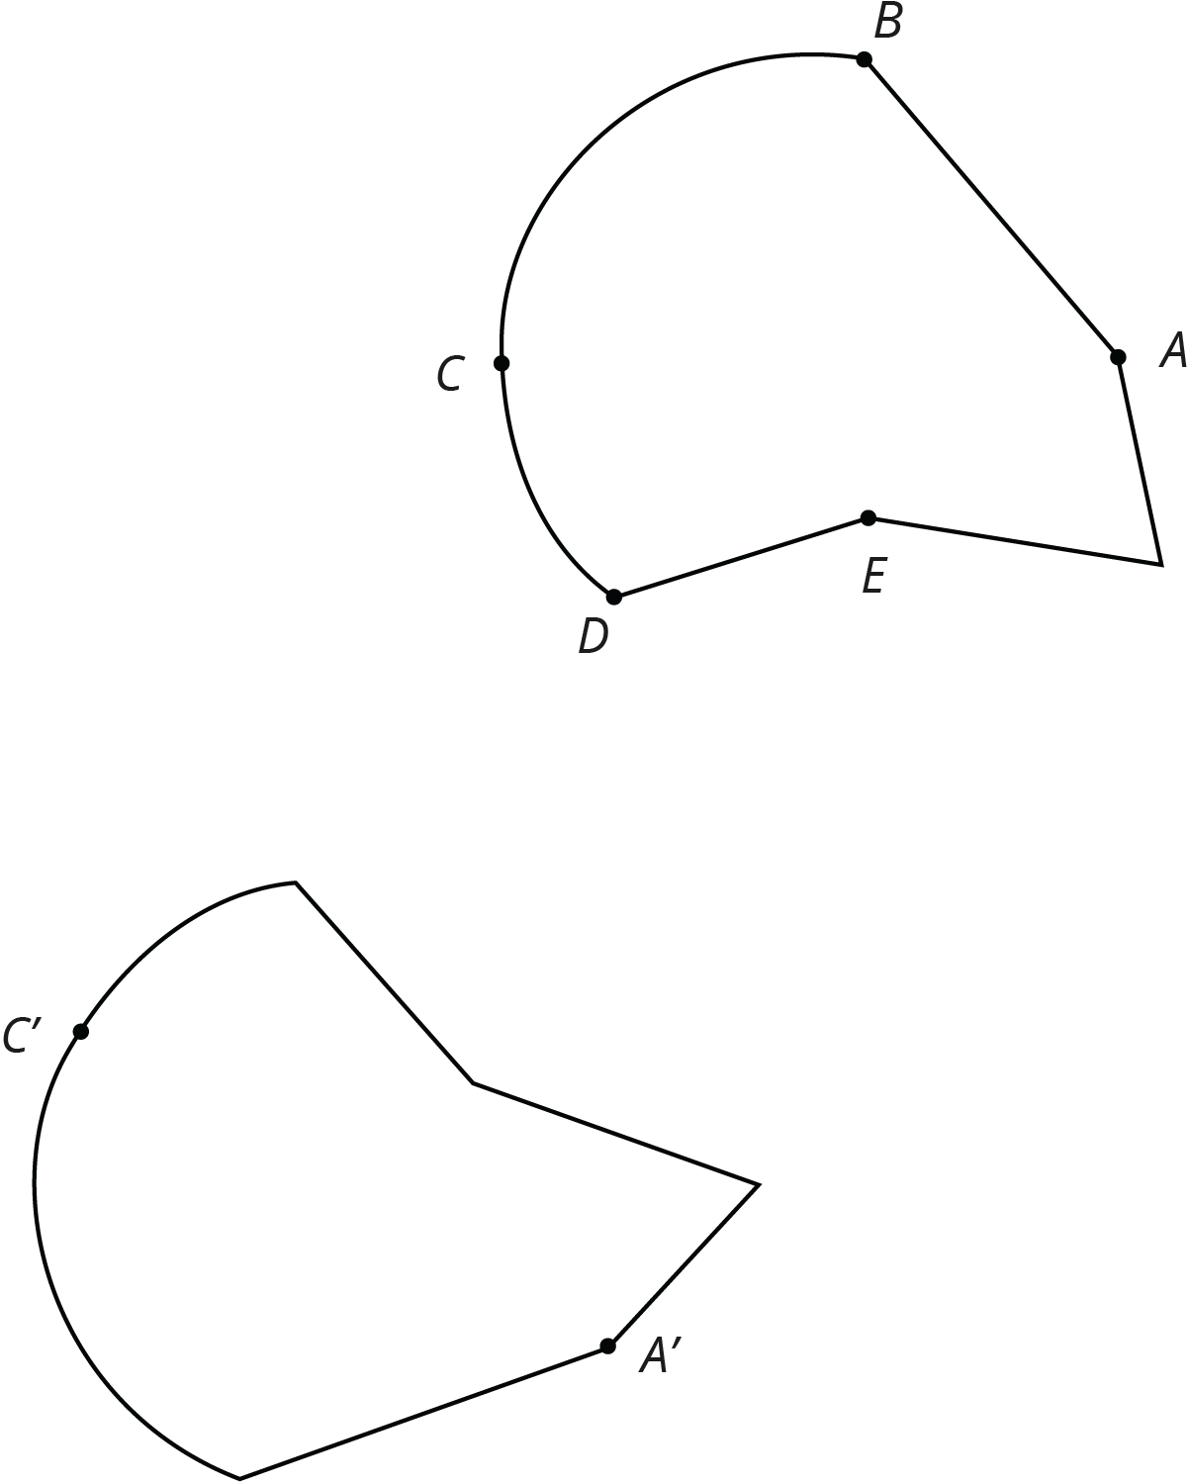
- Draw the points corresponding to $B$, $D$, and $E$, and label them $B^{′}$, $D^{′}$, and $E^{′}$.
- Draw line segments $AD$ and $A^{′}D^{′}$ and measure them. Do the same for segments $BC$ and $B^{′}C^{′}$ and for segments $AE$ and $A^{′}E^{′}$. What do you notice?
- Do you think there could be a pair of corresponding segments with different lengths? Explain.
© CC BY Open Up Resources. Adaptations CC BY IM.

