Lesson 17 Practice Problems

  - The table shows the value of a car, in thousands of dollars, each year after it was purchased. Plot the data values, and find a line that fits the data.
- age (years) | - value (thousands  of dollars)
- 0 | - 30.0
- 1 | - 22.5
- 2 | - 19.0
- 3 | - 16.0
- 4 | - 13.5
- 5 | - 11.4
  - 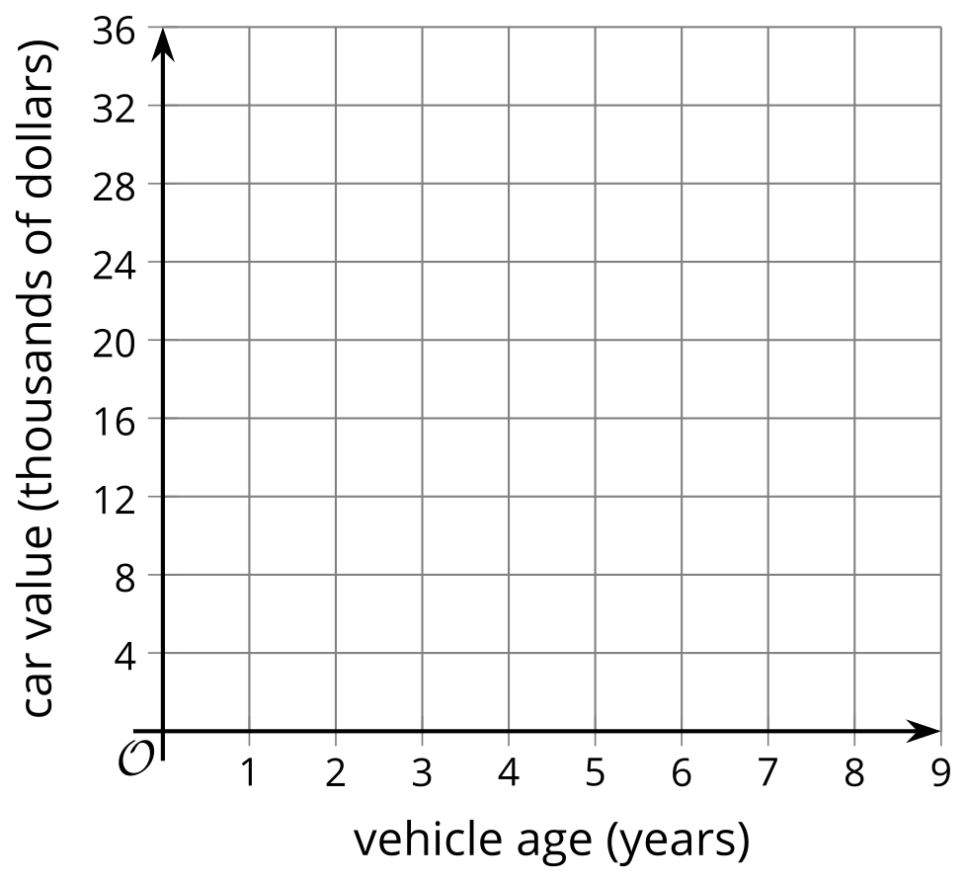
  - Write an equation for the linear function, $C$, that gives the value of the car, in thousands of dollars, when its age is $t$ years.
  - What does $C\left(6\right)$ mean in this situation? What is the value of $C\left(6\right)$?
  - In this situation, what does the solution to the equation $C\left(t\right)=2$ tell us? Find that solution.
  - Write an equation that would allow us to find the age of the car when we know $C\left(t\right)$.
  - Use your equation to estimate the vehicle age when the value of the car will be $500.
- The distance $d$, in kilometers, that a car travels at a speed of 80 km per hour, for $t$ hours, is given by the equation $d=80t$.
  - If the car has gone 120 kilometers, how long has it been traveling?
  - Rewrite the equation to represent time, $t$, as a function of distance, $d$.
- Match each function to its inverse.
  - $y=2x−3$
  - $y=3x$
  - $y=3x−2$
  - $y=x−2$
  - $y=x+2$
  - $y=\frac{x−2}{3}$
  - $x=\frac{y+2}{3}$
  - $x=\frac{y+3}{2}$
  - $x=3y+2$
  - $x=y+2$
  - $x=\frac{y}{3}$
  - $x=y−2$
- Functions $h$ and $j$ are inverses. When $x$ is -10, the value of $h\left(x\right)$ is 7, or $h\left(\text{-}10\right)=7$.
  - What is the value of $j\left(7\right)$?
  - Determine if each point is on the graph of $h$, on the graph of $j$, or neither. Explain your reasoning.
    - $\left(\text{-}10,7\right)$
    - $\left(7,\text{-}10\right)$
- Crickets make chirping sounds by rubbing their wings together. The number of chirps they make is closely related to the temperature of their environment. When the temperature is between 55 and 100 degrees Fahrenheit, we can tell the temperature by counting the number of chirps!
- 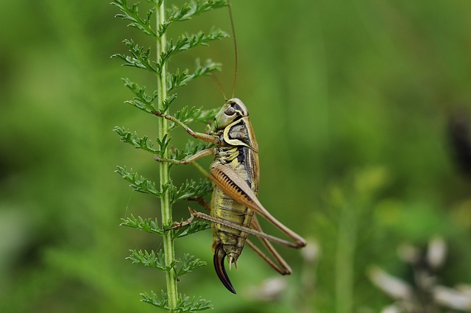
- A formula that is commonly used to find the temperature in degrees Fahrenheit is:
  - Count the number of chirps in 14 seconds
  - Add 40 to get the temperature.
- Let $n$ be the number of chirps that crickets make in 14 seconds and $F$ be the temperature in degrees Fahrenheit.
  - What is the temperature when a cricket chirps 52 times in 14 seconds?
  - Write an equation that defines $F$ as a function of $n$.
  - How many chirps would we expect to hear in 14 seconds when it is 60 degrees Fahrenheit?
  - Write an equation that defines $n$ as a function of $F$.
- (From Unit 4, Lesson 16.)
- Describe the domain and range of the function this graph represents.​​​​​​
- 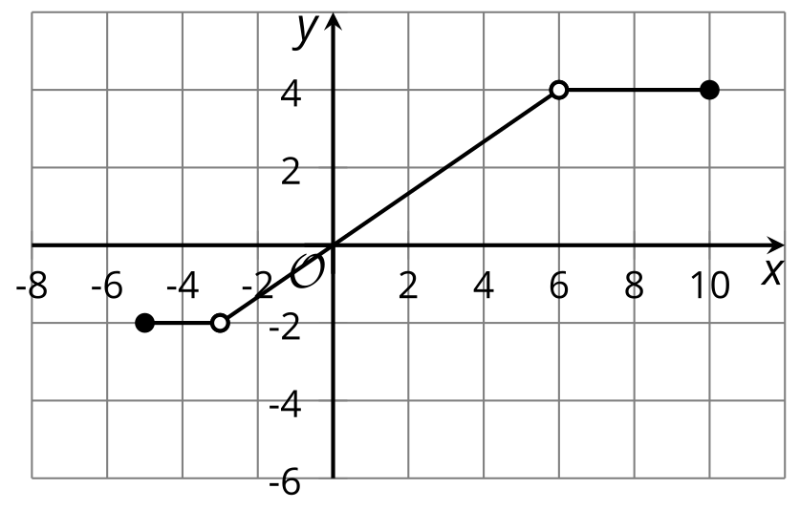
- (From Unit 4, Lesson 12.)
- The parking rate $R$ for a car in a garage is a function of $t$, the hours it is parked.
  - Find $R\left(1\right)$.
  - Find $R\left(4.5\right)$.
  - Find $R\left(8\right)$.
- (From Unit 4, Lesson 12.)
- Here are rules that define function $f$.
- $f\left(x\right)=\left\{\begin{matrix}2, & \text{-}5≤x≤1 \\ x, & 1<x<5 \\ 7, & 5≤x≤7\end{matrix}\right.$
- Draw the graph of $f$.
- 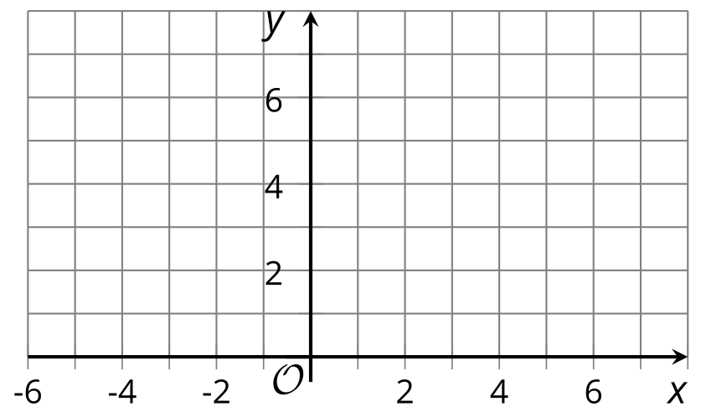
- (From Unit 4, Lesson 12.)
© CC BY 2019 by Illustrative Mathematics®

