Lesson 1 Practice Problems
- Which square—large, medium, or small—covers more of the plane? Explain your reasoning.
- 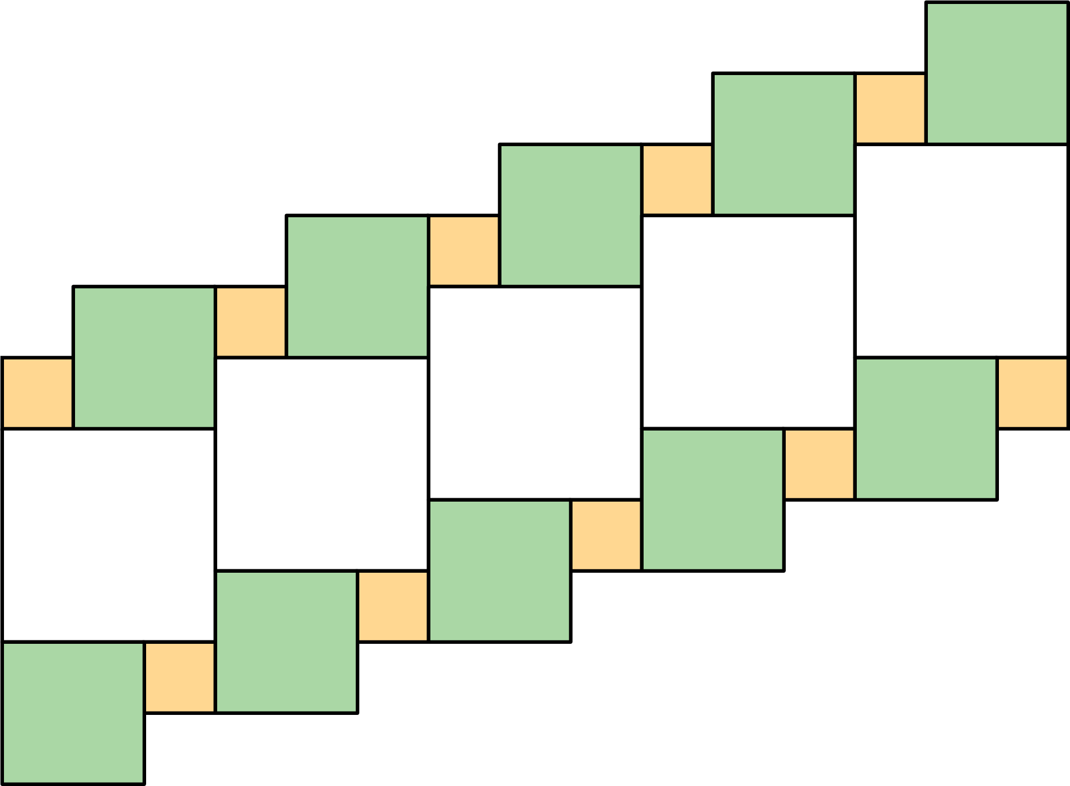
- Draw three different quadrilaterals, each with an area of 12 square units.
- Use copies of the rectangle to show how a rectangle could:
- a. tile the plane.
- 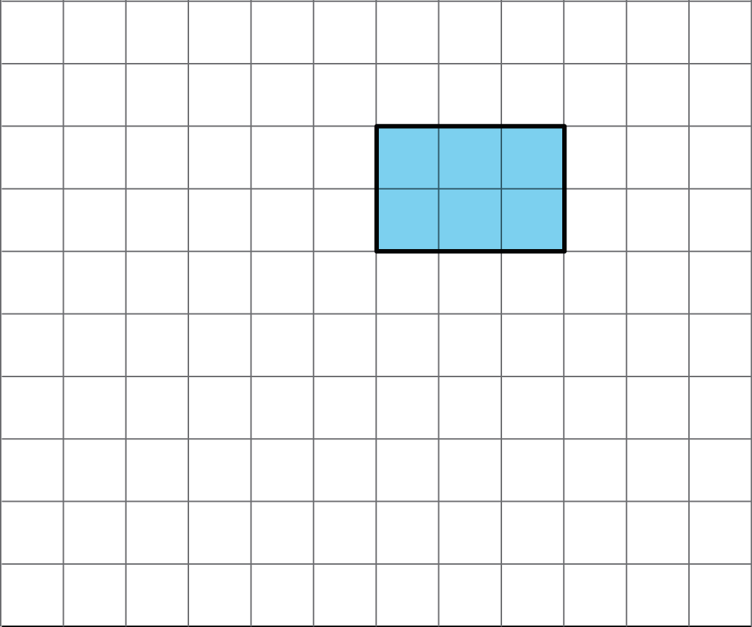
- b. not tile the plane.
- The area of this shape is 24 square units. Which of these statements is true about the area? Select all that apply.
- 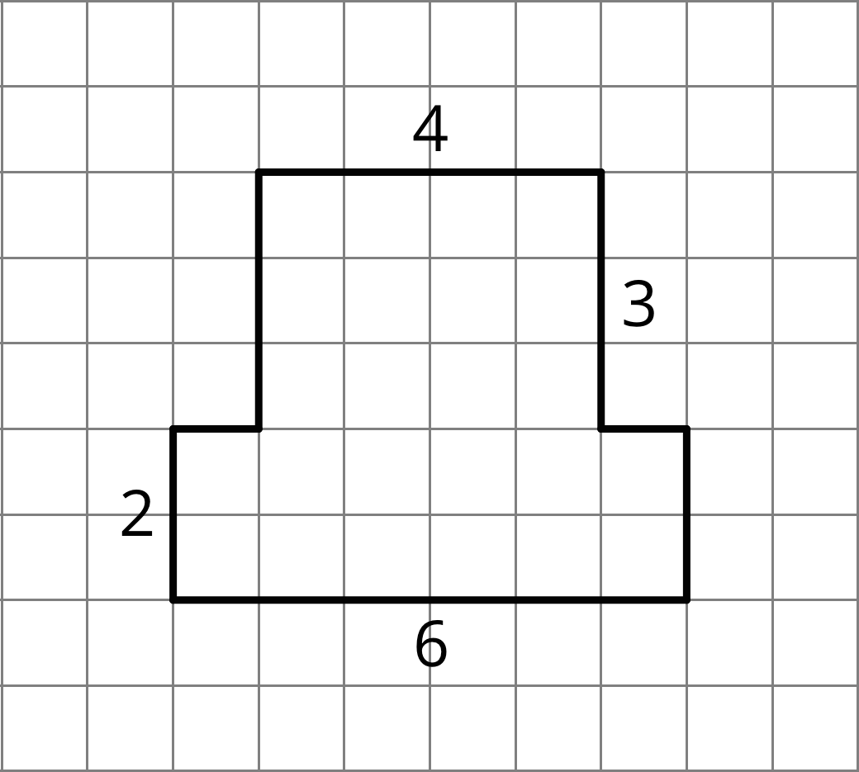
  - The area can be found by counting the number of squares that touch the edge of the shape.
  - It takes 24 grid squares to cover the shape without gaps and overlaps.
  - The area can be found by multiplying the sides lengths that are 6 units and 4 units.
  - The area can be found by counting the grid squares inside the shape.
  - The area can be found by adding $4×3$ and $6×2$.
- Here are two copies of the same figure. Show two different ways for finding the area of the shaded region. All angles are right angles.
- 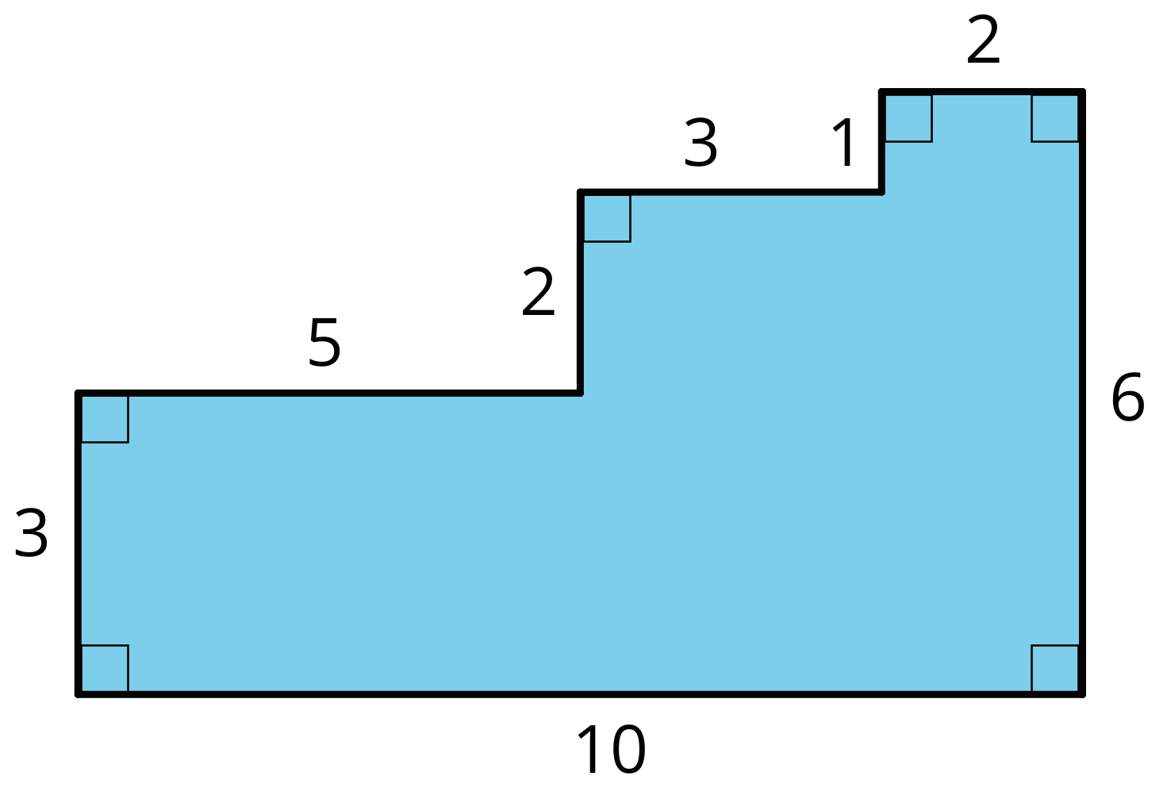

- Which shape has a larger area: a rectangle that is 7 inches by $\frac{3}{4}$ inch, or a square with side length of $2\frac{1}{2}$ inches? Show your reasoning.
© CC BY Open Up Resources. Adaptations CC BY IM.

