Unit 6 Lesson 9: Introduction to Trigonometric Functions

1 An Angle and a Circle (Warm up)

Student Task Statement
Suppose there is a point $P$ on the unit circle at $\left(1,0\right)$.
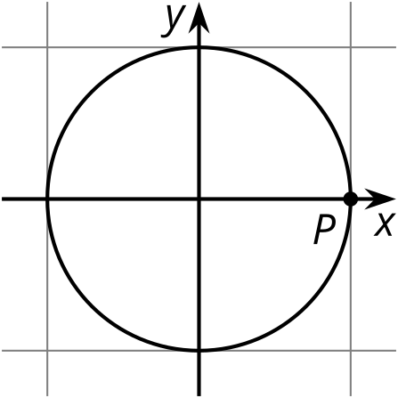
- Describe how the $x$-coordinate of $P$ changes as it rotates once counterclockwise around the circle.
- Describe how the $y$-coordinate of $P$ changes as it rotates once counterclockwise around the circle.

2 Do the Wave

Student Task Statement
- For each tick mark on the horizontal axis, plot the value of $y=cos\left(θ\right)$, where $θ$ is the measure of an angle in radians. Use the class display of the unit circle, the unit circle from an earlier lesson, or technology to estimate the value of $cos\left(θ\right)$.
- 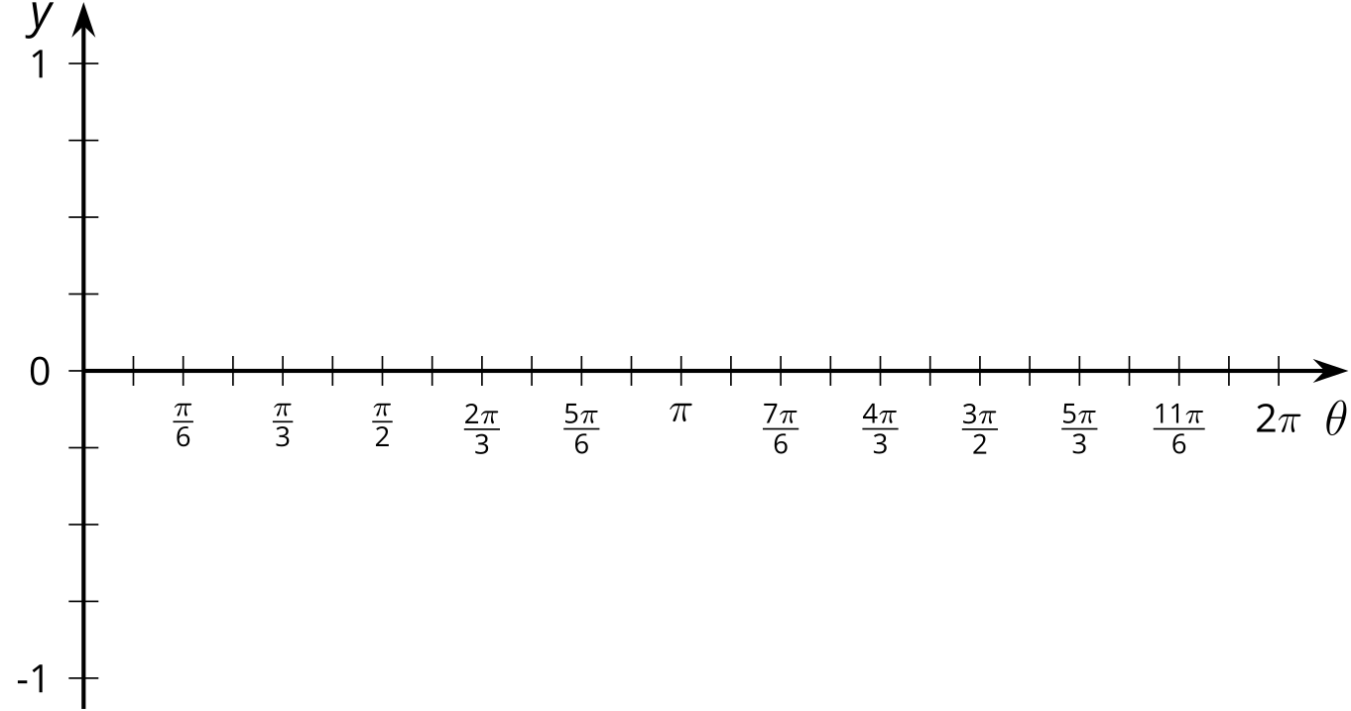
- For each tick mark on the horizontal axis, plot the value of $y=sin\left(θ\right)$. Use the class display of the unit circle, the unit circle from an earlier lesson, or technology to estimate the value of $sin\left(θ\right)$.
- What do you notice about the two graphs?
- Explain why any angle measure between 0 and $2π$ gives a point on each graph.
- Could these graphs represent functions? Explain your reasoning.

3 Graphs of Cosine and Sine

Student Task Statement
- Looking at the graphs of $y=cos\left(θ\right)$ and $y=sin\left(θ\right)$, at what values of $θ$ do $cos\left(θ\right)=sin\left(θ\right)$? Where on the unit circle do these points correspond to?
- For each of these equations, first predict what the graph looks like, and then check your prediction using technology.
  - $y=cos\left(θ\right)+sin\left(θ\right)$
  - $y=\cos^{2}\left(θ\right)$
  - $y=\sin^{2}\left(θ\right)$
  - $y=\cos^{2}\left(θ\right)+\sin^{2}\left(θ\right)$

Images for Activity Synthesis
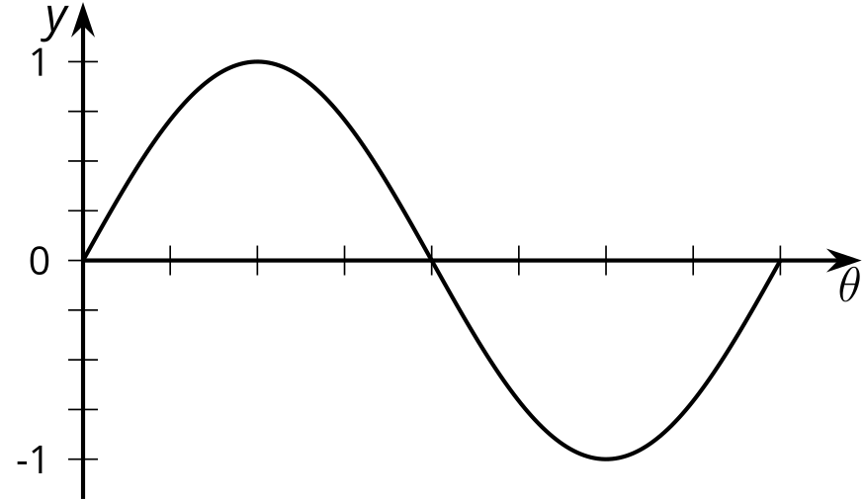
© CC BY 2019 by Illustrative Mathematics®

