Unit 6 Lesson 19: The Volume of a Cone

1 Which Has a Larger Volume? (Warm up)

Student Task Statement
The cone and cylinder have the same height, and the radii of their bases are equal.
- Which figure has a larger volume?
- Do you think the volume of the smaller one
is more or less than $\frac{1}{2}$ the volume of the
larger one? Explain your reasoning.
- Sketch two different sized cones. The oval doesn’t have to be on the bottom! For each drawing, label the cone’s radius with $r$ and height with $h$.
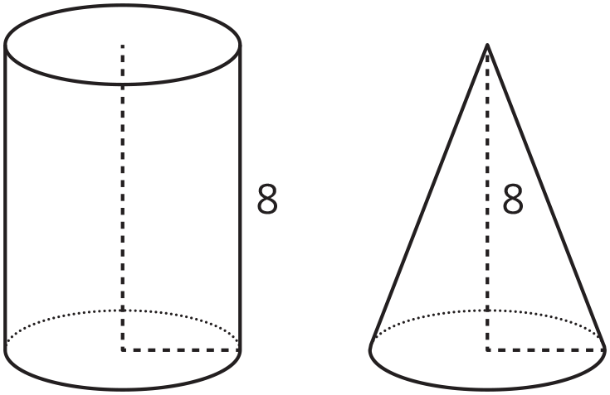
Here is a method for quickly sketching a cone:
- Draw an oval.
- Draw a point centered above the oval.
- Connect the edges of the oval to the point.
- Which parts of your drawing would be hidden
behind the object? Make these parts dashed lines.

Activity Synthesis
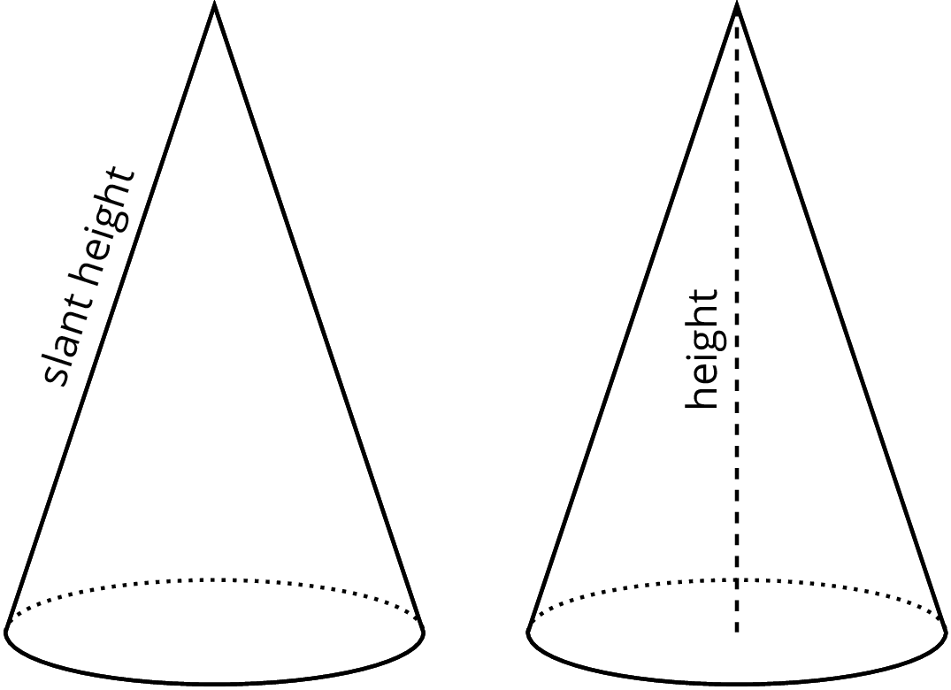

2 From Cylinders to Cones

Student Task Statement
A cone and cylinder have the same height and their bases are congruent circles.
- If the volume of the cylinder is 90 cm³, what is the volume of the cone?
- If the volume of the cone is 120 cm³, what is the volume of the cylinder?
- If the volume of the cylinder is $V=πr^{2}h$, what is the volume of the cone? Either write an expression for the cone or explain the relationship in words.
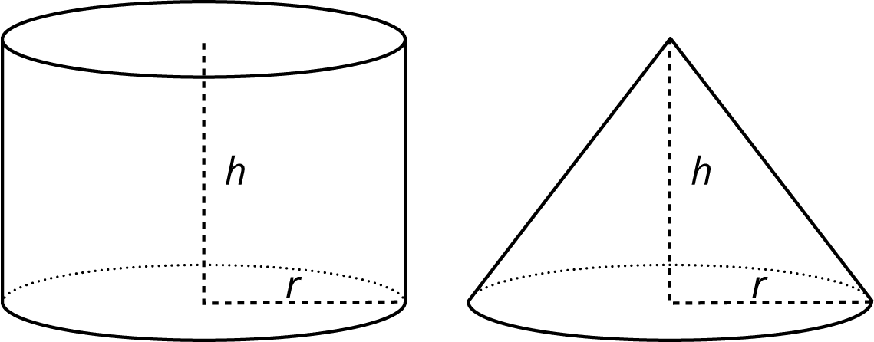

3 Calculate That Cone

Student Task Statement
- Here is a cylinder and cone that have the same height and the same base area.
- What is the volume of each figure? Express your answers in terms of $π$.
- 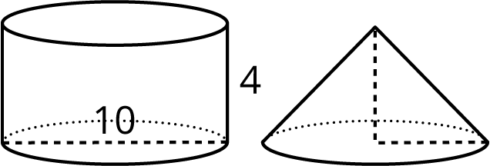
- Here is a cone.
  - What is the area of the base? Express your answer in terms of $π$.
  - What is the volume of the cone? Express your answer in terms of $π$.
- 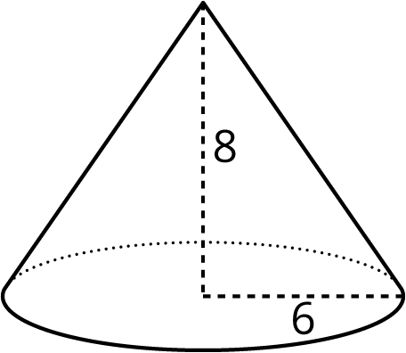
- A cone-shaped popcorn cup has a radius of 5 centimeters and a height of 9 centimeters. How many cubic centimeters of popcorn can the cup hold? Use 3.14 as an approximation for $π$, and give a numerical answer.

© CC BY Open Up Resources. Adaptations CC BY IM.

