Unit 5 Lesson 6: Analyzing Graphs

1 Fractions and Decimals (Warm up)

Student Task Statement
fraction | $\frac{1}{2}$ | $\frac{1}{4}$ | $\frac{1}{8}$ | $\frac{1}{16}$ | $\frac{1}{32}$
decimal | 0.5 | 0.25 | 0.125
In the table, find as many patterns as you can. Use one or more patterns to help you complete the table. Be prepared to explain your reasoning.

2 Falling and Falling

Student Task Statement
The value of some cell phones changes exponentially after initial release. Here are graphs showing the depreciation of two phones 1, 2, and 3 years after they were released.
Phone A
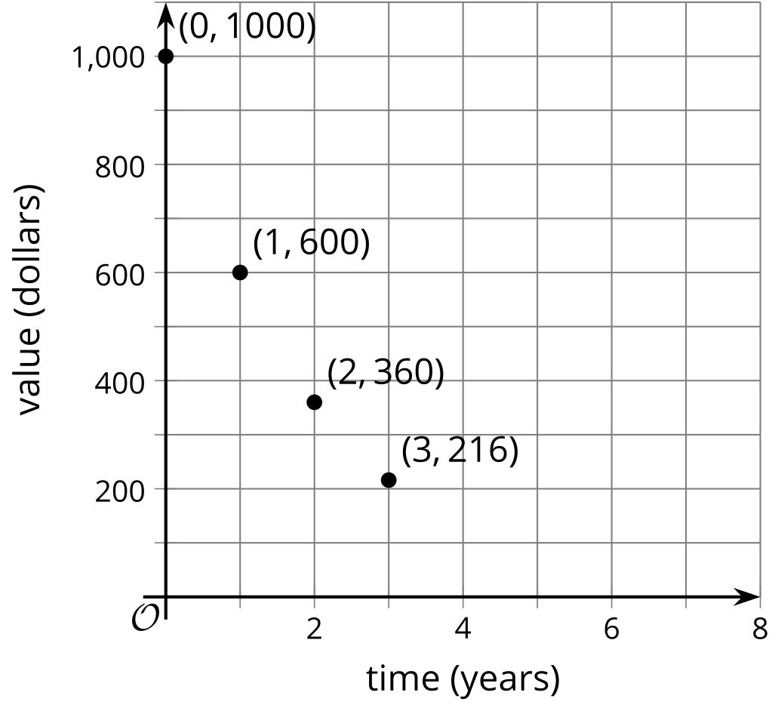
Phone B
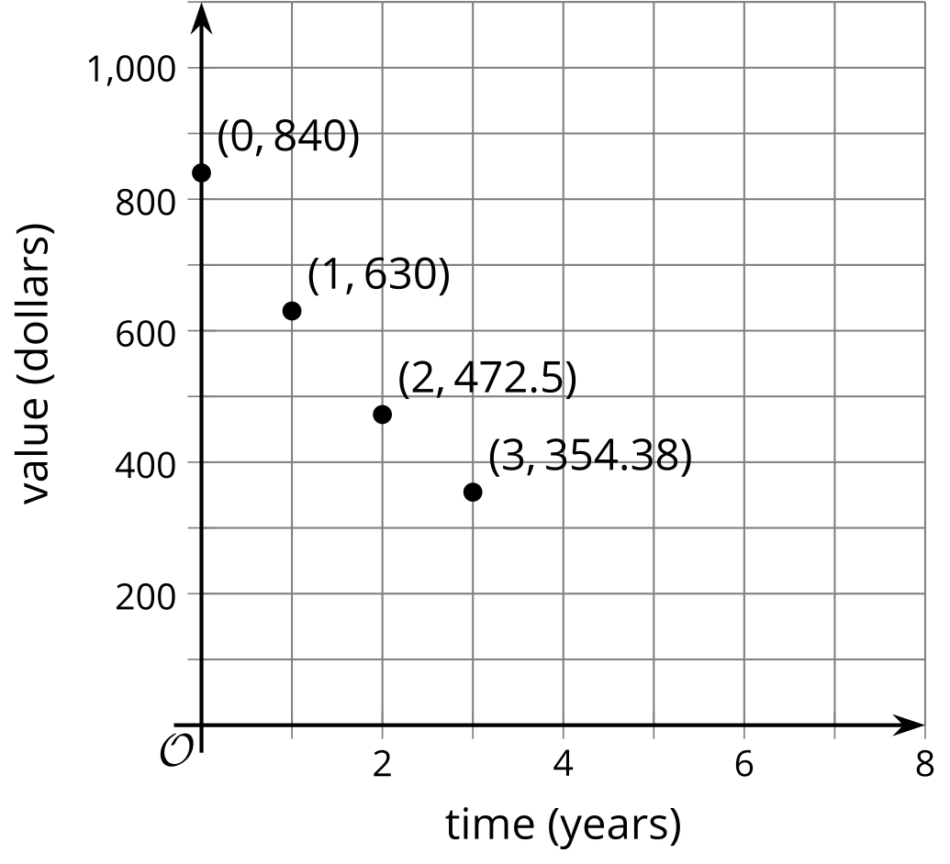
- Which phone is more expensive to buy when it is first released?
- How does the value of each phone change with every passing year?
- Which one is falling in value more quickly? Explain or show how you know.
- If the phones continue to depreciate by the same factor each year, what will the value of each phone be 4 years after its initial release?
- For each cell phone, write an equation that relates the value of the phone in dollars to the years since release, $t.$ Use $v$ for the value of Phone A and $w$ for the value of Phone B.

3 Card Sort: Matching Descriptions to Graphs

Student Task Statement
Your teacher will give you a set of cards containing descriptions of situations and graphs. Match each situation with a graph that represents it. Record your matches and be prepared to explain your reasoning.
© CC BY 2019 by Illustrative Mathematics®

