Unit 6 Lesson 8: Rising and Falling

1 Notice and Wonder: A Bouncing Curve (Warm up)

Student Task Statement
What do you notice? What do you wonder?
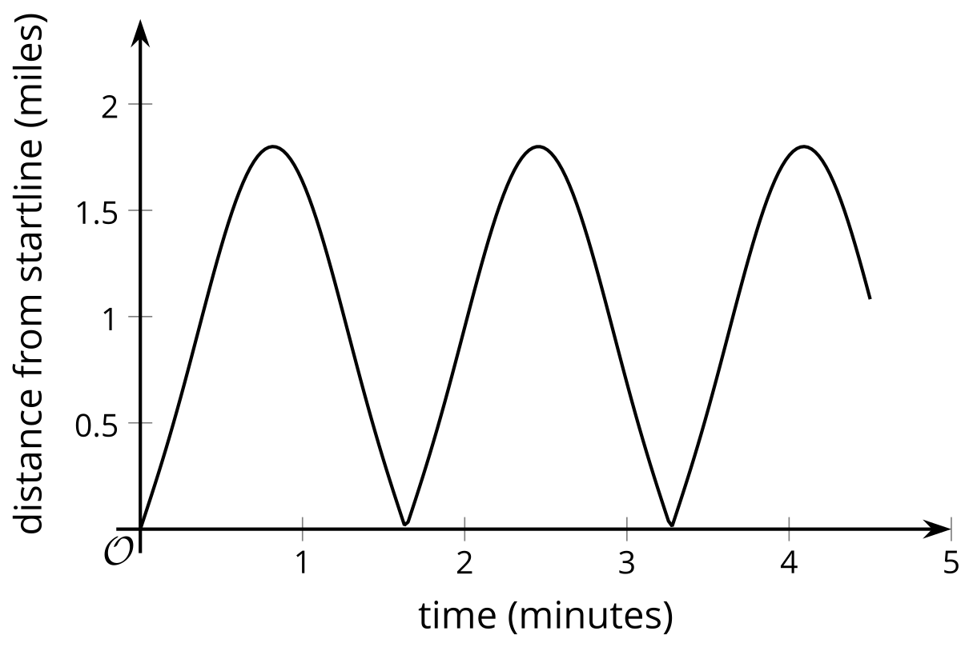

2 What is Happening?

Student Task Statement
Here are some relationships that produce graphs that have a repetitive nature. For each situation, describe the dependent and independent variable. How does the dependent variable change? What might cause this change?
- This is the graph of the distance of a race car from the starting line as it goes around a track.
- This is the graph of the temperature in a city in Australia over 21 days.
- 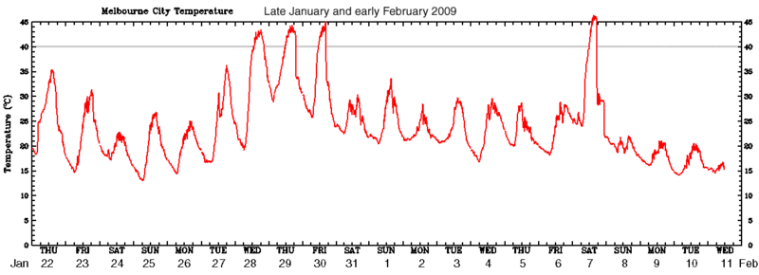
- This is the graph of two populations over time.
- 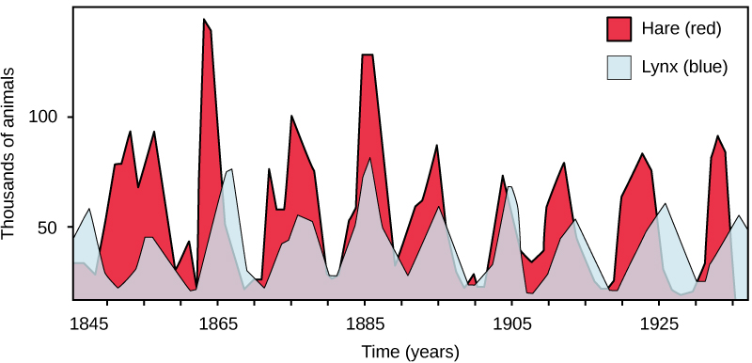

3 Card Sort: Graphs of Functions

Student Task Statement
Your teacher will give you a set of cards that show graphs.
- Sort the cards into categories of your choosing. Be prepared to describe your categories.
Pause for a whole-class discussion.
- Sort the cards into new categories in a different way. Be prepared to describe your new categories.
© CC BY 2019 by Illustrative Mathematics®

