Lesson 19: Solve Problems Involving Arrays
- Let’s solve problems involving arrays.

Warm-up: Number Talk: One Less Group
Find the value of each expression mentally.
- $10×2$
- $9×2$
- $8×2$
- $7×2$

19.1: Array of Colors
There are 7 rows. Each row has 5 crayons. How many crayons are there?
- Solve this problem. Explain or show your reasoning.
- Represent the situation with an array and an equation with a symbol for the unknown.

19.2: Tyler’s Trees
For each problem:
- Write an equation with a symbol for the unknown to represent the situation.
- Solve the problem. Show your reasoning.
- A field of coconut trees in Mexico has 5 rows of trees. Each row has 9 trees. How many trees are there?
- After learning about growing coconuts in Mexico, Tyler wants to plant coconut trees in his backyard in Florida. His mom will only let him plant 2 rows of 4 trees in his backyard.
- How many trees will Tyler plant?
- 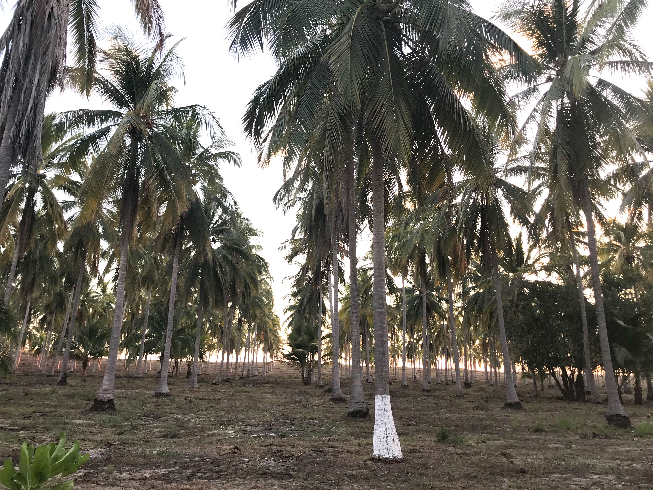
© CC BY 2021 Illustrative Mathematics®

