Lesson 7: More than Two Choices
Let's explore different ways to determine a winner.

7.1: Field Day
Students in a sixth-grade class were asked, “What activity would you most like to do for field day?” The results are shown in the table.
activity | number of votes
softball game | 16
scavenger hunt | 10
dancing talent show | 8
marshmallow throw | 4
no preference | 2
- What percentage of the class voted for softball?
- What percentage did not vote for softball as their first choice?

7.2: School Lunches (Part 1)
Suppose students at our school are voting for the lunch menu over the course of one week. The following is a list of options provided by the caterer.
Menu 1: Meat Lovers
- Meat loaf
- Hot dogs
- Pork cutlets
- Beef stew
- Liver and onions
Menu 2: Vegetarian
- Vegetable soup and peanut butter sandwich
- Hummus, pita, and veggie sticks
- Veggie burgers and fries
- Chef’s salad
- Cheese pizza every day
- Double desserts every day
Menu 3: Something for Everyone
- Chicken nuggets
- Burgers and fries
- Pizza
- Tacos
- Leftover day (all the week’s leftovers made into a casserole)
- Bonus side dish: pea jello (green gelatin with canned peas)
Menu 4: Concession Stand
- Choice of hamburger or hot dog, with fries, every day
To vote, draw one of the following symbols next to each menu option to show your first, second, third, and last choices. If you use the slips of paper from your teacher, use only the column that says “symbol.”
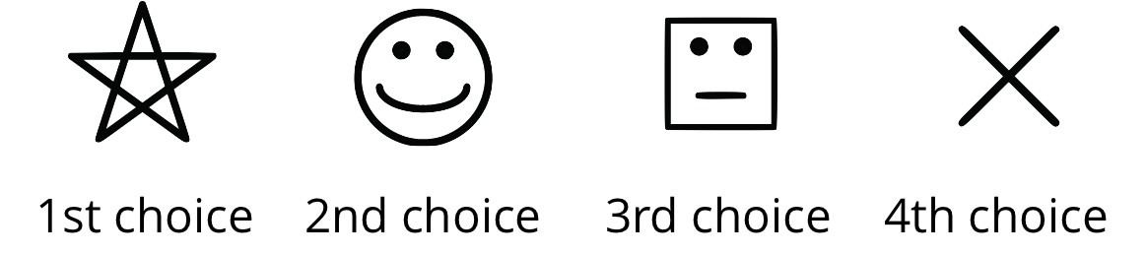
- Meat Lovers __________
- Vegetarian __________
- Something for Everyone __________
- Concession Stand __________
Here are two voting systems that can be used to determine the winner.
- Voting System #1. Plurality: The option with the most first-choice votes (stars) wins.
- Voting System #2. Runoff: If no choice received a majority of the votes, leave out the choice that received the fewest first-choice votes (stars). Then have another vote.
- If your first vote is still a choice, vote for that. If not, vote for your second choice that you wrote down.
- If there is still no majority, leave out the choice that got the fewest votes, and then vote again. Vote for your first choice if it’s still in, and if not, vote for your second choice. If your second choice is also out, vote for your third choice.
- How many people in our class are voting? How many votes does it take to win a majority?
- How many votes did the top option receive? Was this a majority of the votes?
- People tend to be more satisfied with election results if their top choices win. For how many, and what percentage, of people was the winning option:
  - their first choice?
  - their second choice?
  - their third choice?
  - their last choice?
- After the second round of voting, did any choice get a majority? If so, is it the same choice that got a plurality in Voting System #1?
- Which choice won?
- How satisfied were the voters by the election results? For how many, and what percentage, of people was the winning option:
  - their first choice?
  - their second choice?
  - their third choice?
  - their last choice?
- Compare the satisfaction results for the plurality voting rule and the runoff rule. Did one produce satisfactory results for more people than the other?

7.3: School Lunch (Part 2)
Let’s analyze a different election.
In another class, there are four clubs. Everyone in each club agrees to vote for the lunch menu exactly the same way, as shown in this table.
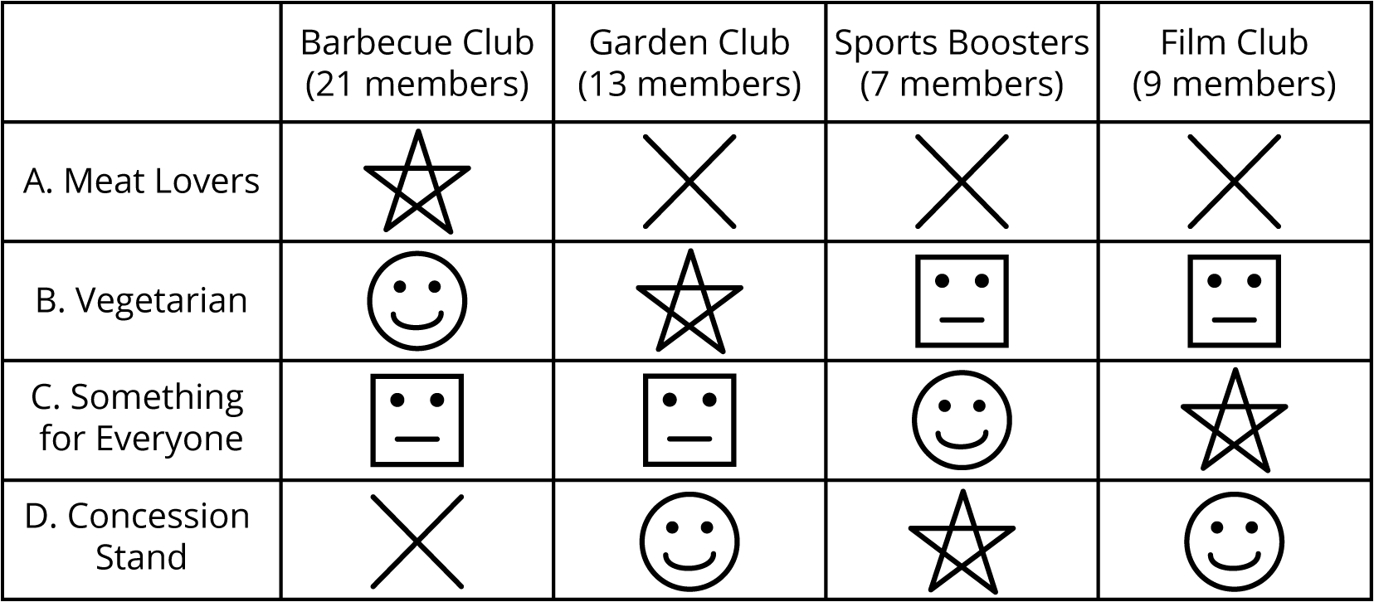
- Figure out which option won the election by answering these questions.
  - On the first vote, when everyone voted for their first choice, how many votes did each option get? Did any choice get a majority?
  - Which option is removed from the next vote?
  - On the second vote, how many votes did each of the remaining three menu options get? Did any option get a majority?
  - Which menu option is removed from the next vote?
  - On the third vote, how many votes did each of the remaining two options get? Which option won?
- Estimate how satisfied all the voters were.
  - For how many people was the winner their first choice?
  - For how many people was the winner their second choice?
  - For how many people was the winner their third choice?
  - For how many people was the winner their last choice?
- Compare the satisfaction results for the plurality voting rule and the runoff rule. Did one produce satisfactory results for more people than the other?

7.4: Just Vote Once
Your class just voted using the instant runoff system. Use the class data for following questions.
- For our class, which choice received the most points?
- Does this result agree with that from the runoff election in an earlier activity?
- For the other class, which choice received the most points?
- Does this result agree with that from the runoff election in an earlier activity?
- The runoff method uses information about people’s first, second, third, and last choices when it is not clear that there is a winner from everyone’s first choices. How does the instant runoff method include the same information?
- After comparing the results for the three voting rules (plurality, runoff, instant runoff) and the satisfaction surveys, which method do you think is fairest? Explain.

Are you ready for more?
Numbering your choices 0 through 3 might not really describe your opinions. For example, what if you really liked A and C a lot, and you really hated B and D? You might want to give A and C both a 3, and B and D both a 0.
- Design a numbering system where the size of the number accurately shows how much you like a choice. Some ideas:
  - The same 0 to 3 scale, but you can choose more than one of each number, or even decimals between 0 and 3.
  - A scale of 1 to 10, with 10 for the best and 1 for the worst.
- Try out your system with the people in your group, using the same school lunch options for the election.
- Do you think your system gives a more fair way to make choices? Explain your reasoning.

7.5: Weekend Choices
Clare, Han, Mai, Tyler, and Noah are deciding what to do on the weekend. Their options are cooking, hiking, and bowling. Here are the points for their instant runoff vote. Each first choice gets 2 points, the second choice gets 1 point, and the last choice gets 0 points.
 | cooking | hiking | bowling
Clare | 2 | 1 | 0
Han | 2 | 1 | 0
Mai | 2 | 1 | 0
Tyler | 0 | 2 | 1
Noah | 0 | 2 | 1
- Which activity won using the instant runoff method? Show your calculations and use expressions or equations.
- Which activity would have won if there was just a vote for their top choice, with a majority or plurality winning?
- Which activity would have won if there was a runoff election?
- Explain why this happened.
© CC BY Open Up Resources. Adaptations CC BY IM.

