Unit 5 Lesson 4: Working with Fractions

1 Math Talk: Subtracting from 1 (Warm up)

Student Task Statement
Evaluate mentally:
$1−\frac{1}{2}$
$1−\frac{1}{10}$
$1−\frac{3}{10}$
$1−\frac{5}{17}$

2 Partway There

Student Task Statement
Suppose a driver is traveling from one city to another. A diagram is provided to help with the first question. Create additional diagrams as needed. Be prepared to explain your reasoning.
- The distance between the cities is 60 miles and the driver has driven $\frac{1}{3}$ of the way.
  - How many miles has she driven?
  - How many miles remain?
- She has driven $\frac{2}{5}$ of the way.
  - How many miles has she driven?
  - How many miles remain?
- The distance between the cities is 300 miles and she has driven $\frac{1}{6}$ of the way.
  - How many miles has she driven?
  - How many miles remain?
- A trip is $x$ miles long, and the driver has gone $\frac{1}{4}$ of the way. Write an expression to represent how many miles remain in her trip.

Activity Synthesis
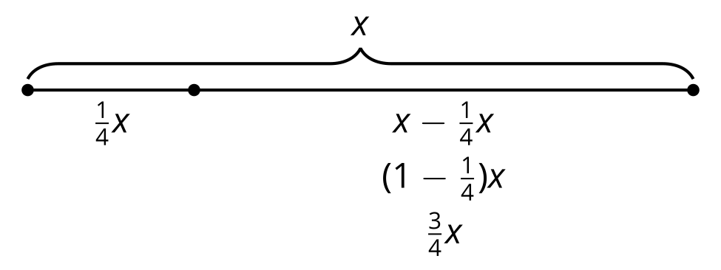

3 Distribute and Subtract and Multiply!

Student Task Statement
- Explain why each pair of expressions is equal.
  - $\left(1−\frac{1}{5}\right)⋅20$ and $\frac{4}{5}⋅20$
  - $24−\frac{1}{3}⋅24$ and $24\left(1−\frac{1}{3}\right)$
  - $64−\frac{1}{4}⋅64$ and $\frac{3}{4}⋅64$
- Match each expression in List A with an equal expression in List B.
List A
$\frac{1}{4}⋅80$
$\frac{3}{4}⋅80$
$80\left(1−\frac{5}{8}\right)$
$80−\frac{1}{8}⋅80$
$\frac{3}{10}⋅80$
$\frac{7}{10}⋅80$
$80{\left(\frac{1}{4}\right)}^{2}$
$80{\left(\frac{1}{2}\right)}^{3}$
$80{\left(\frac{3}{4}\right)}^{0}$
List B
$80−\frac{5}{8}⋅80$
20
$80⋅\left(\frac{1}{16}\right)$
$\left(1−\frac{1}{4}\right)⋅80$
56
70
80
$\left(1−\frac{7}{10}\right)⋅80$
10
© CC BY 2019 by Illustrative Mathematics®

