Lesson 6: Unidades cuadradas diferentes (parte 1)

Standards Alignments
Addressing | 3.MD.C.6

Teacher-facing Learning Goals
- Describe square units based on different linear units of measurement.
- Use square inches and square centimeters to measure the area of a rectangle.

Student-facing Learning Goals
- Aprendamos sobre diferentes unidades que podemos usar para medir el área.

Lesson Purpose
The purpose of this lesson is for students to learn that there are different units that can be used to measure area, specifically square centimeters and square inches.
In previous lessons, students learned the meaning of area and measured area in square units. In this lesson, students work with standard units of area, based on linear measurement units they worked with in grade 2. Students consider the difference in size between the same amount of square inches and square centimeters, then they measure the area of a rectangle with both square inches and square centimeters.

Access for:

Students with Disabilities
- Action and Expression (Activity 2)

English Learners
- MLR8 (Activity 1)

Instructional Routines
MLR2 Collect and Display (Activity 2), Notice and Wonder (Warm-up)

Materials to Gather
- Patty paper: Activity 2
- Rulers (whole units): Activity 1
- Scissors: Activity 2

Materials to Copy
- Same Rectangle, Different Units, Spanish (groups of 2): Activity 1
- Same Rectangle, Different Units, Spanish (groups of 2): Activity 2

Lesson Timeline
Warm-up | 10 min
Activity 1 | 15 min
Activity 2 | 20 min
Lesson Synthesis | 10 min
Cool-down | 5 min

Teacher Reflection Question
What question do you wish you had asked today? When and why should you have asked it?

Cool-down
(to be completed at the end of the lesson) 5min
¿Cuál cuadrado?

Standards Alignments
Addressing | 3.MD.C.6

Student-facing Task Statement
Este es un rectángulo.
Estos son 2 cuadrados diferentes que puedes usar para recubrir.
A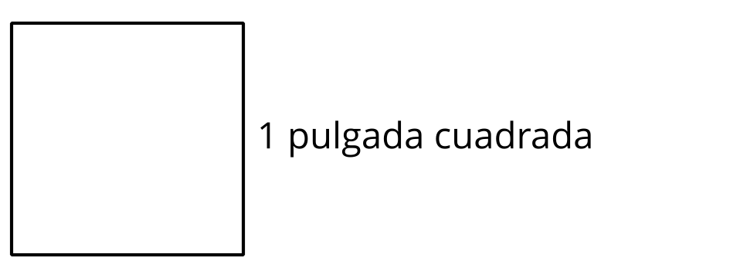
B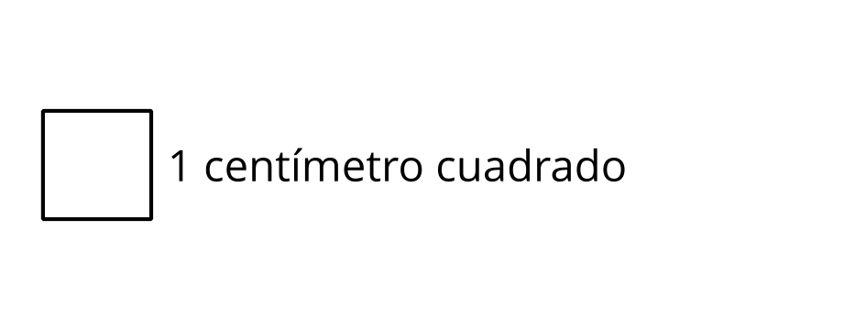
¿Cuál cuadrado te permitiría recubrir el rectángulo con el menor número de cuadrados? Explica tu razonamiento.

Student Responses
Sample response: A, because it’s larger than B, so it wouldn’t take as many squares to fill the rectangle as with B.

