Lesson 13: Proofs about Parallelograms
- Let’s prove theorems about parallelograms.

13.1: Notice and Wonder: Diagonals
Here is parallelogram $ABCD$ and rectangle $EFGH$. What do you notice? What do you wonder?
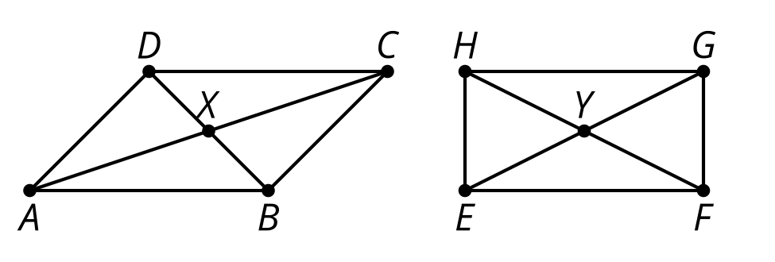

13.2: The Diagonals of a Parallelogram
Conjecture: The diagonals of a parallelogram bisect each other.
- Use the tools available to convince yourself the conjecture is true.
- Convince your partner that the conjecture is true for any parallelogram. Can the 2 of you think of different ways to convince each other?
- What information is needed to prove that the diagonals of a parallelogram bisect each other?
- Prove that segment $AC$ bisects segment $BD$, and that segment $BD$ bisects segment $AC$.

13.3: Work Backwards to Prove
Given: $ABCD$ is a parallelogram with $AB$ parallel to $CD$ and $AD$ parallel to $BC$. Diagonal $AC$ is congruent to diagonal $BD$.
Prove: $ABCD$ is a rectangle (angles $A,B,C,$ and $D$ are right angles).
With your partner, you will work backwards from the statement to the proof until you feel confident that you can prove that $ABCD$ is a rectangle using only the given information.
Start with this sentence: I would know $ABCD$ is a rectangle if I knew $\underset{_}{}$.
Then take turns saying this sentence: I would know [what my partner just said] if I knew $\underset{_}{}$.
Write down what you each say. If you get to a statement and get stuck, go back to an earlier statement and try to take a different path.

Are you ready for more?
Two intersecting segments always make a quadrilateral if you connect the endpoints. What has to be true about the intersecting segments in order to make a(n):
- rectangle
- rhombus
- square
- kite
- isosceles trapezoid

Lesson 13 Summary
A quadrilateral is a parallelogram if and only if its diagonals bisect each other. The “if and only if” language means that both the statement and its converse are true. So we need to prove:
- If a quadrilateral has diagonals that bisect each other, then it is a parallelogram.
- If a quadrilateral is a parallelogram, then its diagonals bisect each other.
To prove part 1, make the statement specific: If quadrilateral $EFGH$ with diagonals $EG$ and $FH$ intersecting at $Y$ so that $EY$ is congruent to $YG$ and $FY$ is congruent to $YH$, then side $EF$ is parallel to side $GH$ and side $EH$ is parallel to side $FG$.
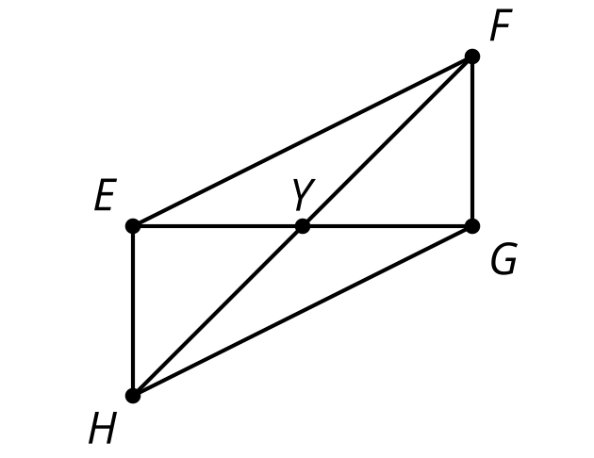
We could prove triangles $EYH$ and $GYF$ are congruent by the Side-Angle-Side Triangle Congruence Theorem. That means that corresponding angles in the triangles are congruent, so angle $YEH$ is congruent to $YGF$. This means that alternate interior angles formed by lines $EH$ and $FG$ are congruent, so lines $EH$ and $FG$ are parallel. We could also make an argument that shows triangles $EYF$ and $GYH$ are congruent, so that angles $FEY$ and $HGY$ are congruent, which means that lines $EF$ and $GH$ must be parallel.
To prove part 2, make the statement specific: If parallelogram $ABCD$ has side $AB$ parallel to side $CD$ and side $AD$ parallel to side $BC$, and diagonals $AC$ and $BD$ that intersect at $X$, then we are trying to prove that $X$ is the midpoint of $AC$ and of $BD$.
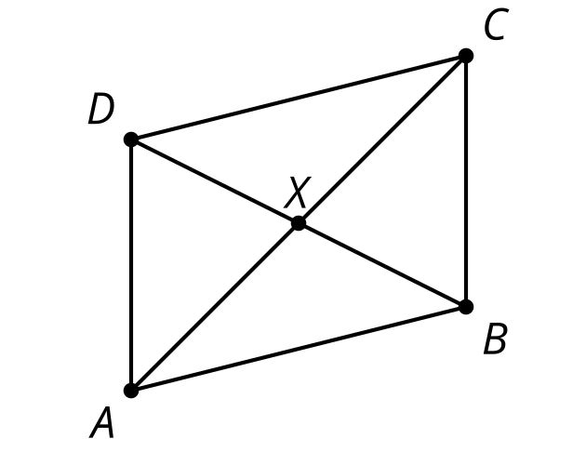
We could use a transformation proof. Rotate parallelogram $ABCD$ by ${180}^{∘}$ using the midpoint of diagonal $AC$ as the center of the rotation. Then show that the midpoint of diagonal $AC$ is also the midpoint of diagonal $BD$. That point must be $X$ since it is the only point on both line $AC$ and line $BD$. So $X$ must be the midpoints of both diagonals, meaning the diagonals bisect each other.
We have proved that any quadrilateral with diagonals that bisect each other is a parallelogram, and that any parallelogram has diagonals that bisect each other. Therefore, a quadrilateral is a parallelogram if and only if its diagonals bisect each other.
© CC BY 2019 by Illustrative Mathematics®

