Lesson 24: Using Quadratic Equations to Model Situations and Solve Problems
- Let’s analyze a situation modeled by a quadratic equation.

24.1: Equations of Two Lines and A Curve
- Write an equation representing the line that passes through each pair of points.
  - $\left(3,3\right)$ and $\left(5,5\right)$
  - $\left(0,4\right)$ and $\left(\text{-}4,0\right)$
- Solve this equation: $x+1={\left(x−2\right)}^{2}−3$. Show your reasoning.

24.2: The Dive
The function $h$, defined by $h\left(t\right)=\text{-}5t^{2}+10t+7.5$, models the height of a diver above the water (in meters), $t$ seconds after the diver leaves the board. For each question, explain how you know.
- How high above the water is the diving board?
- When does the diver hit the water?
- At what point during her descent toward the water is the diver at the same height as the diving board?
- When does the diver reach the maximum height of the dive?
- What is the maximum height the diver reaches during the dive?

Are you ready for more?
Another diver jumps off a platform, rather than a springboard. The platform is also 7.5 meters above the water, but this diver hits the water after about 1.5 seconds.
Write an equation that would approximately model her height over the water, $h$, in meters, $t$ seconds after she has left the platform. Include the term $\text{-}5t^{2}$, which accounts for the effect of gravity.

24.3: A Linear Function and A Quadratic Function
Here are graphs of a linear function and a quadratic function. The quadratic function is defined by the expression ${\left(x−4\right)}^{2}−5$.
Find the coordinates of $P,Q$, and $R$ without using graphing technology. Show your reasoning.
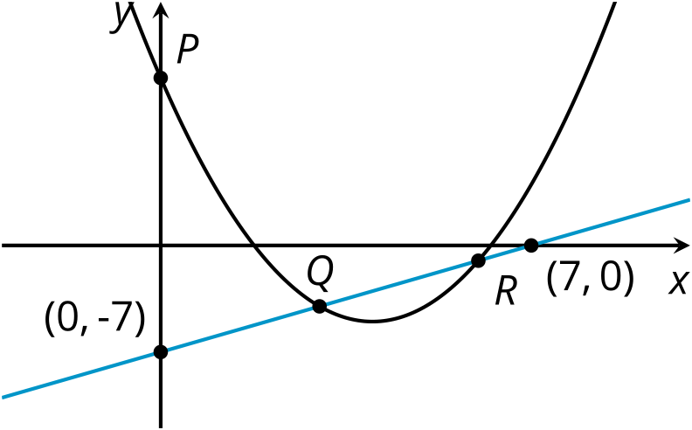

Lesson 24 Summary
Certain real-world situations can be modeled by quadratic functions, and these functions can be represented by equations. Sometimes, all the skills we have developed are needed to make sense of these situations. When we have a mathematical model and the skills to use the model to answer questions, we are able to gain useful or interesting insights about the situation.
Suppose we have a model for the height of a launched object, $h$, as a function of time since it was launched $t$, defined by $h\left(t\right)=\text{-}4.9t^{2}+28t+2.1$. We can answer questions such as these about the object’s flight:
- From what height was the object launched?
(An expression in standard form can help us with this question. Or, we can evaluate $h\left(0\right)$ to find the answer.)
- At what time did it hit the ground?
(When an object hits the ground, its height is 0, so we can find the zeros using one of the methods we learned: graphing, rewriting in factored form, completing the square, or using the quadratic formula.)
- What was its maximum height, and at what time did it reach the maximum height?
(We can rewrite the expression in vertex form, but we can also use the zeros of the function or a graph to do so.)
Sometimes, relationships between quantities can be effectively communicated with graphs and expressions rather than with words. For example, these graphs represent a linear function, $f$, and a quadratic function, $g$, with the same variables for their input and output.
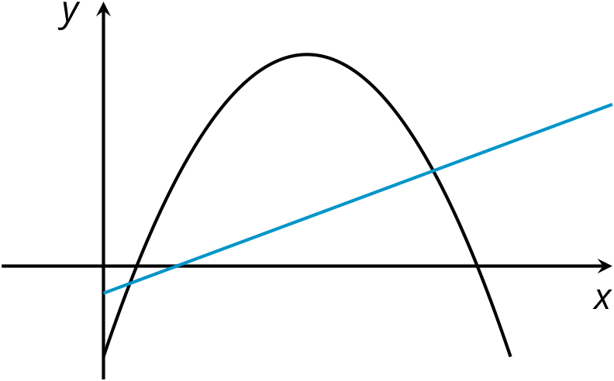
If we know the expressions that define these functions, we can use our knowledge of quadratic equations to answer questions such as:
- Will the two functions ever have the same value?
(Yes. We can see that their graphs intersect in a couple of places.)
- If so, at what input values does that happen? What are the output values they have in common?
(To find out, we can write and solve this equation: $f\left(x\right)=g\left(x\right)$.)
© CC BY 2019 by Illustrative Mathematics®

