Unit 6 Lesson 4: The Unit Circle (Part 2)

1 Notice and Wonder: Angles Around the Unit Circle (Warm up)

Student Task Statement
What do you notice? What do you wonder?
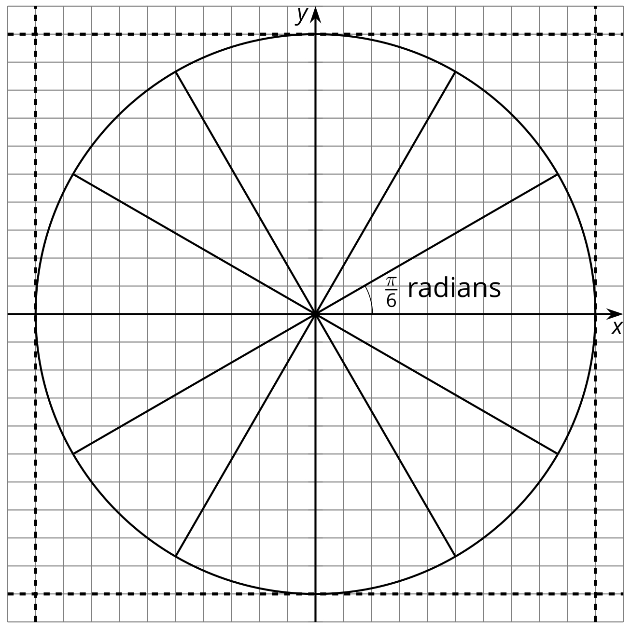

2 Angles Everywhere

Student Task Statement
Here is a circle of radius 1 with some radii drawn.
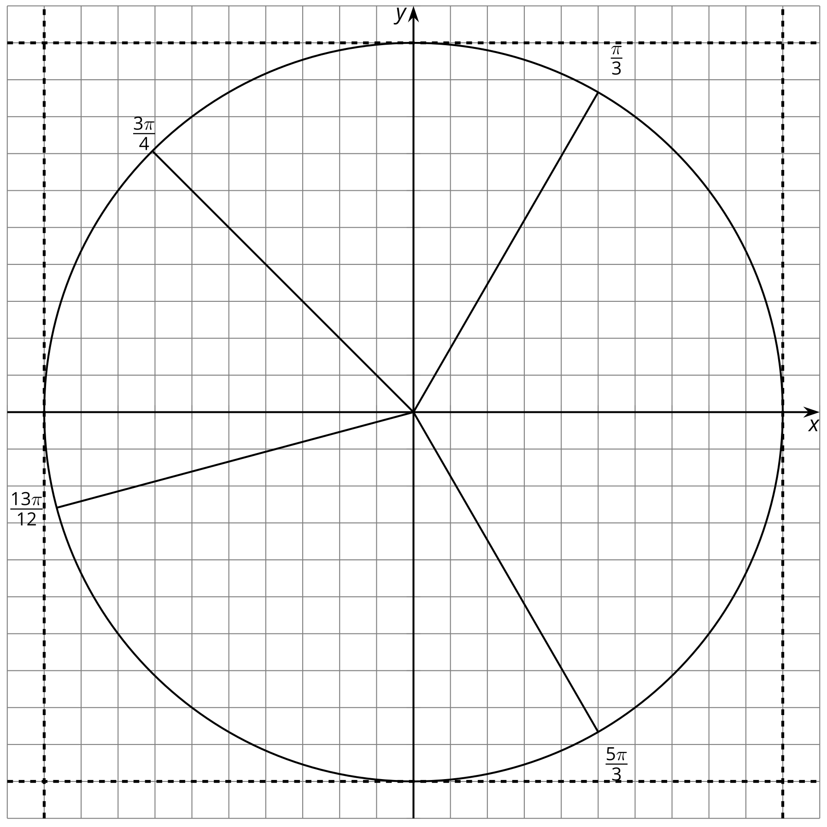
- Draw and label angles, with the positive $x$-axis as the starting ray for each angle, measuring $\frac{π}{12},\frac{π}{6},\frac{π}{4}…,2π$ in the counterclockwise direction. Four of these angles, one in each quadrant, have been drawn for you. There should be a total of 24 angles labeled when you are finished, including those that line up with the axes. Be prepared to share any strategies you used to make the angles.
- Label the points, where the rays meet the unit circle, for which you know the exact coordinate values.

3 Angle Coordinates Galore

Student Task Statement
Your teacher will assign you a section of the unit circle.
- Find and label the coordinates of the points assigned to you where the angles intersect the circle.
- Compare and share your values with your group.
- What relationships or patterns do you notice in the coordinates? Be prepared to share what you notice with the class.
© CC BY 2019 by Illustrative Mathematics®

