Lesson 5: Representemos productos como áreas

Standards Alignments
Addressing | 3.MD.C.7.b, 3.OA.B.5

Teacher-facing Learning Goals
- Relate multiplication to finding the area of rectangles.

Student-facing Learning Goals
- Conectemos expresiones de multiplicación con el área.

Lesson Purpose
The purpose of this lesson is for students to connect multiplication expressions to rectangular areas.
In previous lessons, students counted unit squares to find the area of rectangles. In this lesson they explicitly connect multiplication to rectangular areas. Students match multiplication expressions to rectangular areas, specifically relating the factors of the expressions to the rows and columns of squares in the rectangle. Then, students are given multiplication expressions and create matching rectangles with inch tiles and drawings on grids.

Access for:

Students with Disabilities
- Engagement (Activity 2)

Instructional Routines
How Many Do You See? (Warm-up)

Materials to Gather
- Inch tiles: Activity 2

Materials to Copy
- Match Expressions and Areas (groups of 30): Activity 1

Lesson Timeline
Warm-up | 10 min
Activity 1 | 15 min
Activity 2 | 20 min
Lesson Synthesis | 10 min
Cool-down | 5 min

Teacher Reflection Question
In previous lessons students worked with arrays as a way to represent multiplication. How did students’ previous work with arrays support them in representing products as rectangular areas?

Cool-down
(to be completed at the end of the lesson) 5min
Crea un área rectangular

Standards Alignments
Addressing | 3.MD.C.7.b

Student-facing Task Statement
Usa la cuadrícula para crear un área rectangular que represente la expresión $7×4$.
Explica tu razonamiento.
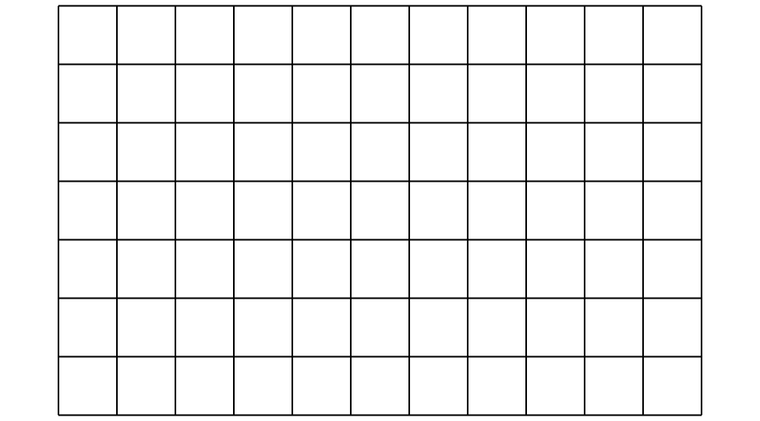

Student Responses
Sample response: There are 4 rows and each row has 7 squares, so it’s 4 groups of 7.
