Lesson 12: Finding the Percentage
Let’s find unknown percentages.

12.1: Tax, Tip, and Discount
What percentage of the car price is the tax?
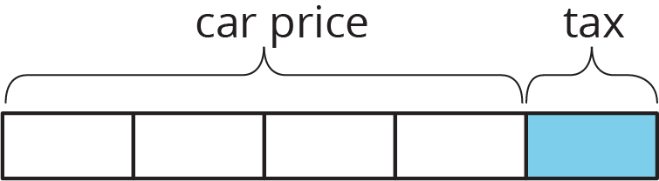
What percentage of the food cost is the tip?
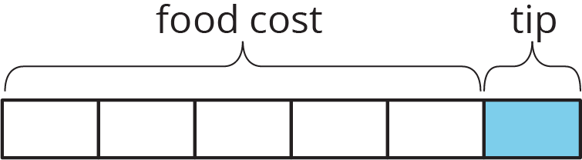
What percentage of the shirt cost is the discount?
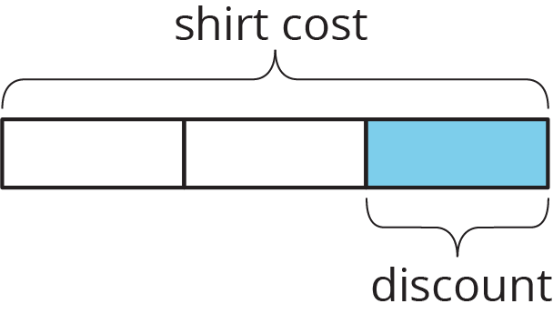

12.2: What Is the Percentage?
- A salesperson sold a car for $18,250 and their commission is $693.50. What percentage of the sale price is their commission?
- The bill for a meal was $33.75. The customer left $40.00. What percentage of the bill was the tip?
- The original price of a bicycle was $375. Now it is on sale for $295. What percentage of the original price was the markdown?

Are you ready for more?
To make a Koch snowflake,
- Start with an equilateral triangle. This is step 1.
- Divide each side into 3 equal pieces. Construct a smaller equilateral triangle on the middle third. This is step 2.
- Do the same to each of the newly created sides. This is step 3.
- Keep repeating this process.
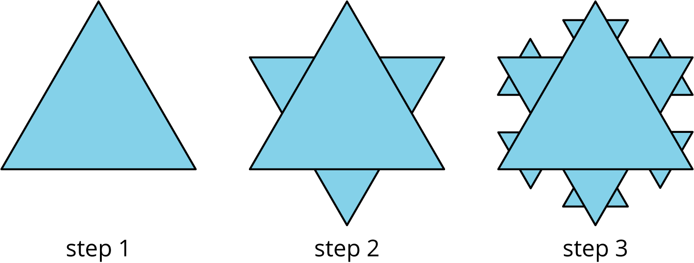
By what percentage does the perimeter increase at step 2? Step 3? Step 10?

12.3: Info Gap: Sporting Goods
Your teacher will give you either a problem card or a data card. Do not show or read your card to your partner.
If your teacher gives you the problem card:
- Silently read your card and think about what information you need to be able to answer the question.
- Ask your partner for the specific information that you need.
- Explain how you are using the information to solve the problem.
- Continue to ask questions until you have enough information to solve the problem.
- Share the problem card and solve the problem independently.
- Read the data card and discuss your reasoning.
If your teacher gives you the data card:
- Silently read your card.
- Ask your partner “What specific information do you need?” and wait for them to ask for information.
- If your partner asks for information that is not on the card, do not do the calculations for them. Tell them you don’t have that information.
- Before sharing the information, ask “Why do you need that information?” Listen to your partner’s reasoning and ask clarifying questions.
- Read the problem card and solve the problem independently.
- Share the data card and discuss your reasoning.
Pause here so your teacher can review your work. Ask your teacher for a new set of cards and repeat the activity, trading roles with your partner.

Lesson 12 Summary
To find a 30% increase over 50, we can find 130% of 50.
$1.3⋅50=65$
To find a 30% decrease from 50, we can find 70% of 50.
$0.7⋅50=35$
If we know the initial amount and the final amount, we can also find the percent increase or percent decrease. For example, a plant was 12 inches tall and grew to be 15 inches tall. What percent increase is this? Here are two ways to solve this problem:
The plant grew 3 inches, because $15−12=3$. We can divide this growth by the original height, $3÷12=0.25$. So the height of the plant increased by 25%.
The plant's new height is 125% of the original height, because $15÷12=1.25$. This means the height increased by 25%, because $125−100=25$.
Here are two ways to solve the problem: A rope was 2.4 meters long. Someone cut it down to 1.9 meters. What percent decrease is this?
The rope is now $2.4−1.9$, or 0.5 meters shorter. We can divide this decrease by the original length, $0.5÷2.4=0.208\overset{¯}{3}$. So the length of the rope decreased by approximately 20.8%.
The rope's new length is about 79.2% of the original length, because $1.9÷2.4=0.791\overset{¯}{6}$. The length decreased by approximately 20.8%, because $100−79.2=20.8$.
© CC BY Open Up Resources. Adaptations CC BY IM.

