Unit 5 Lesson 1: Growing and Growing

1 Splitting Bacteria (Warm up)

Student Task Statement
There are some bacteria in a dish. Every hour, each bacterium splits into 3 bacteria.
- This diagram shows a bacterium in hour 0 and then hour 1. Draw what happens in hours 2 and 3.
- How many bacteria are there in hours 2 and 3?

2 A Genie in a Bottle

Student Task Statement
You are walking along a beach and your toe hits something hard. You reach down, grab onto a handle, and pull out a bottle! It is sandy. You start to brush it off with your towel. Poof! A genie appears.
He tells you, "Thank you for freeing me from that bottle! I was getting claustrophobic. You can choose one of these purses as a reward."
- Purse A which contains $1,000 today. If you leave it alone, it will contain $1,200 tomorrow (by magic). The next day, it will have $1,400. This pattern of $200 additional dollars per day will continue.
- Purse B which contains 1 penny today. Leave that penny in there, because tomorrow it will (magically) turn into 2 pennies. The next day, there will be 4 pennies. The amount in the purse will continue to double each day.
- How much money will be in each purse after a week? After two weeks?
- The genie later added that he will let the money in each purse grow for three weeks. How much money will be in each purse then?
- Which purse contains more money after 30 days?

3 Graphing the Genie's Offer

Student Task Statement
Here are graphs showing how the amount of money in the purses changes. Remember Purse A starts with $1,000 and grows by $200 each day. Purse B starts with $0.01 and doubles each day.
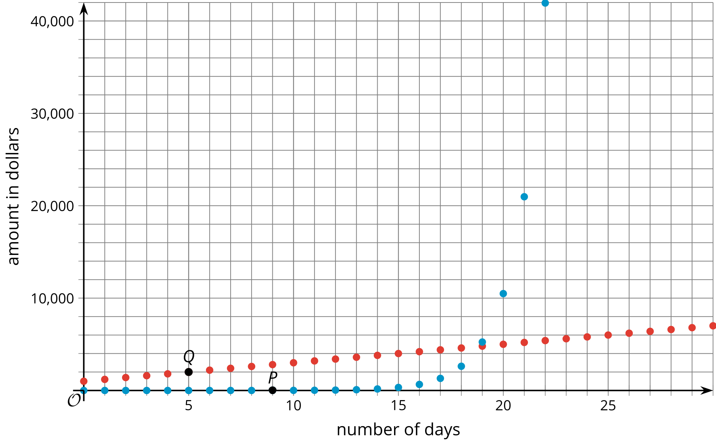
- Which graph shows the amount of money in Purse A? Which graph shows the amount of money in Purse B? Explain how you know.
- Points $P$ and $Q$ are labeled on the graph. Explain what they mean in terms of the genie’s offer.
- What are the coordinates of the vertical intercept for each graph? Explain how you know.
- When does Purse B become a better choice than Purse A? Explain your reasoning.
- Knowing what you know now, which purse would you choose? Explain your reasoning.
© CC BY 2019 by Illustrative Mathematics®

