Unit 6 Lesson 3: The Unit Circle (Part 1)

1 Finding Coordinates of Points on the Unit Circle (Warm up)

Student Task Statement
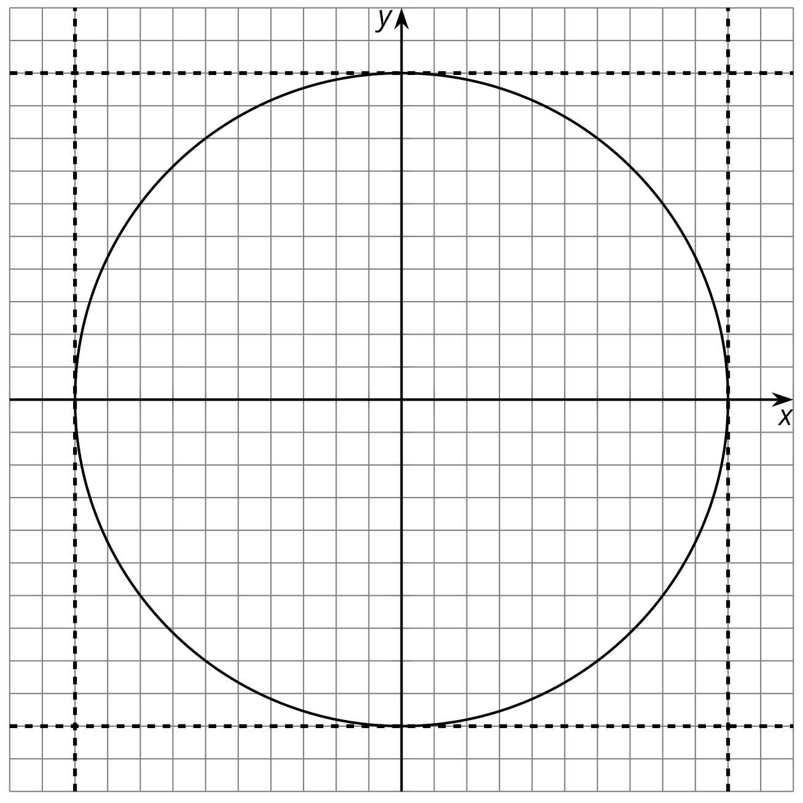
- The $x$-coordinate of a point on the unit circle is $\frac{3}{5}$. What does this tell you about where the point might lie on the unit circle? Find any possible $y$-coordinates of the point and plot them on the unit circle.
- The $y$-coordinate of a point on the unit circle is $\text{-}0.4$. What does this tell you about where the point might lie on the unit circle? Find any possible $x$-coordinates of the point and plot them on the unit circle.

2 Which Point?

Student Task Statement
All points are 1 unit from the origin.
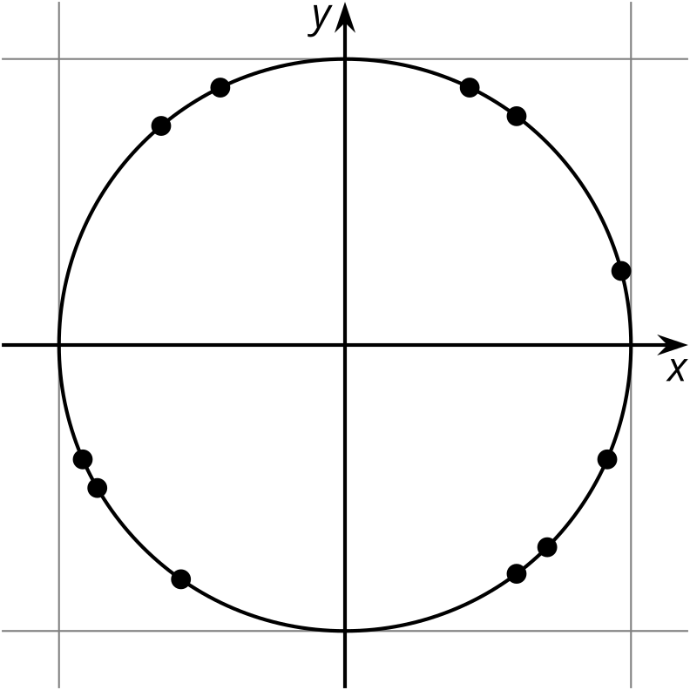
Choose one of the points. Be prepared to describe its location using only words.

Activity Synthesis
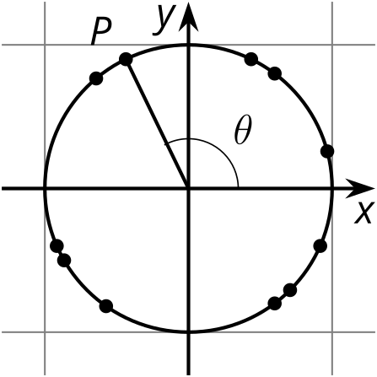

3 Measuring Circles (Optional)

Student Task Statement
- Your teacher will give you a circular object.
  - About how many radii does it take to go halfway around the circle?
  - About how many radii does it take to go all the way around the circle?
  - Compare your answers to the previous two questions with your partners.
- What is the exact number of radii that fit around the circumference of the circle? Explain how you know.
- Why doesn’t the number of radii that fit around the circumference of a circle depend on the radius of the circle? Explain how you know.

Activity Synthesis
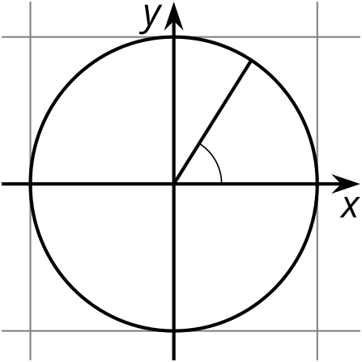

4 Around a Bike Wheel

Student Task Statement
A bicycle wheel has a 1 foot radius. The wheel rolls to the left (counterclockwise).
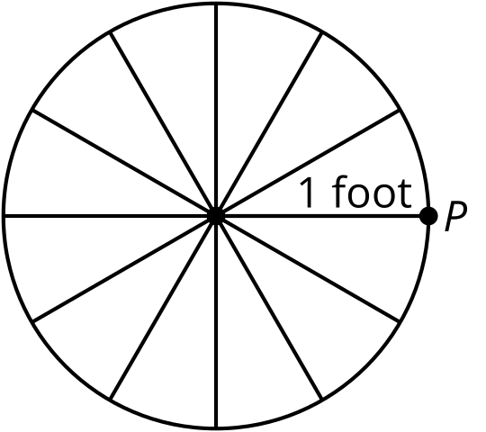
- What is the circumference of this wheel?
- Mark the point $Q$ where $P$ will be after the wheel has rolled 1 foot to the left. Be prepared to explain your reasoning.
- Mark the point $R$ where $P$ will be after the wheel has rolled 3 feet to the left. What angle, in radians, does $P$ rotate through to get to $R$? Explain your reasoning.
- Where will point $P$ be after the bike has traveled $π$ feet to the left? What about $10π$ feet? $100π$ feet? Mark these points on the circle. Explain your reasoning.
- After traveling some distance to the left, the point $P$ is at the lowest location in its rotation. How far might the bike have traveled? Explain your reasoning.
© CC BY 2019 by Illustrative Mathematics®

