Unit 1 Lesson 5: Calculating Measures of Center and Variability

1 Calculating Centers (Warm up)

Student Task Statement
Decide if each situation is true or false. Explain your reasoning.
- The mean can be found by adding all the numbers in a data set and dividing by the number of numbers in the data set.
- The mean of the data in the dot plot is 4.
- 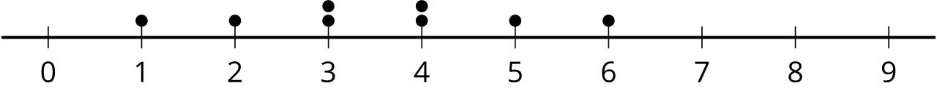
- The median of the data set is 9 for the data: 4, 5, 9, 1, 10.
- The median of the data in the dot plot is 3.5.
- 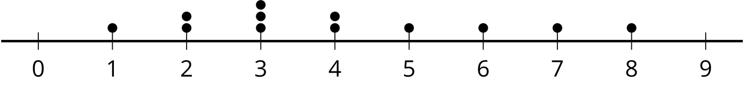

2 Heartbeats: Part 1 (Optional)

Student Task Statement
The heart rates of eight high school students are listed in beats per minute:
72 | 75 | 81 | 76 | 76 | 77 | 79 | 78

- What is the interquartile range?
- How many values in the data set are:
  - less than Q1?
  - between Q1 and the median?
  - between the median and Q3?
  - greater than Q3?
- A pod of dolphins contains 800 dolphins of various ages and lengths. The median length of dolphins in this pod is 5.8 feet. What information does this tell you about the length of dolphins in this pod?
- The same vocabulary test with 50 questions is given to 600 students from fifth to tenth grades and the number of correct responses is collected for each student in this group. The interquartile range is 40 correct responses. What information does this tell you about the number of correct responses for students taking this test?

3 Heartbeats: Part 2 (Optional)

Student Task Statement
- Calculate the MAD using the same data from the previous activity by finding the average distance from each data value to the mean. You may find it helpful to organize your work by completing the table provided.
- data values | - mean | - deviation from mean  (data value - mean) | - absolute deviation |deviation|
- 72
- 75
- 81
- 76
- 76
- 77
- 79
- 78
- MAD:
- For another data set, all of the values are either 3 beats per minute above the mean or 3 beats per minute below the mean. Is that enough information to find the MAD for this data set? If so, find the MAD. If not, what other information is needed? Explain your reasoning.
- Several pennies are placed along a meter stick and the position in centimeters of each penny is recorded. The mean position is the 50 centimeter mark and the MAD is 10 centimeters. What information does this tell you about the position of the pennies along the meter stick?

Activity Synthesis
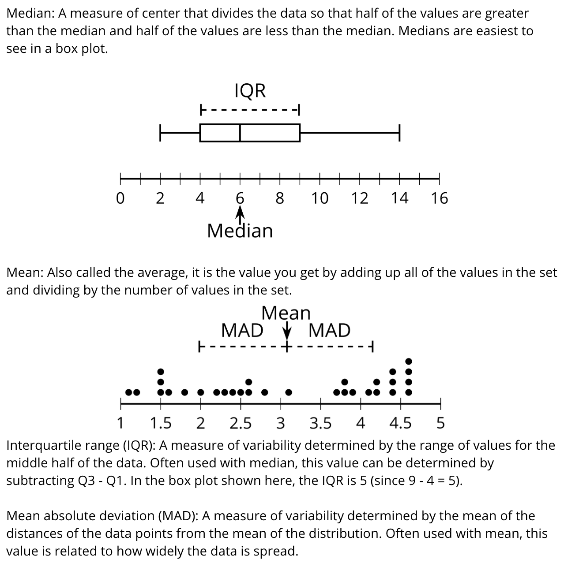
© CC BY 2019 by Illustrative Mathematics®

