Lesson 6: Symmetry in Equations
- Let’s use equations to decide if a function is even, odd, or neither.

6.1: Notice and Wonder: Same and Different
What do you notice? What do you wonder?

A. Graph of $g\left(x\right)=x^{5}+x$
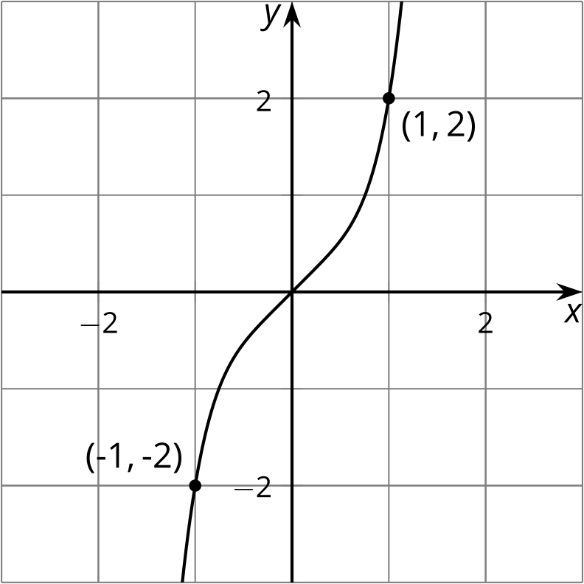

B. Graph of $\text{-}g\left(x\right)=\text{-}\left(x^{5}+x\right)$
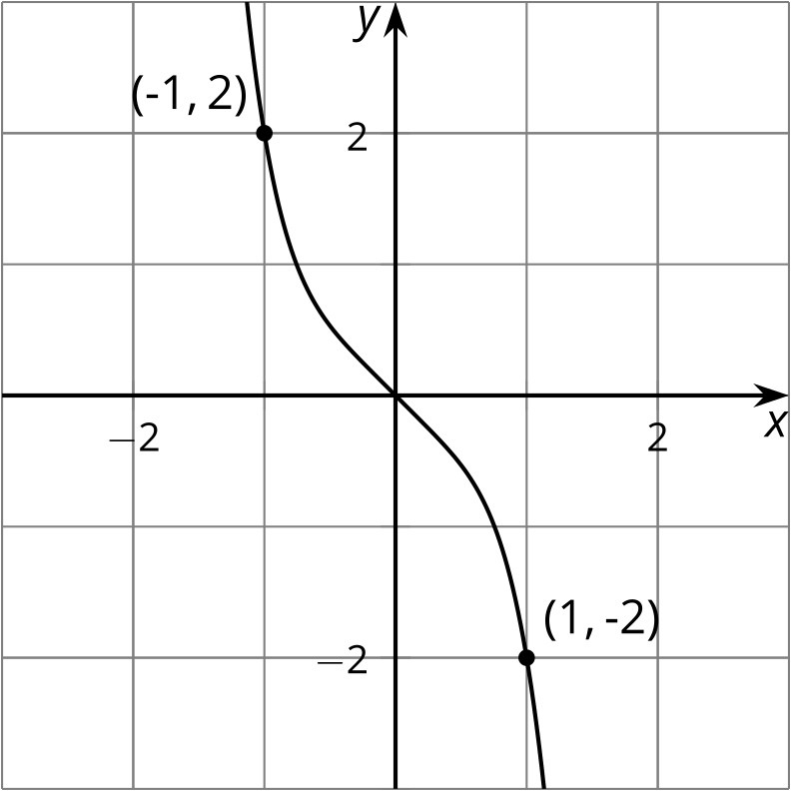

C. Graph of $g\left(\text{-}x\right)={\left(\text{-}x\right)}^{5}+\left(\text{-}x\right)$

D. Graph of $\text{-}g\left(\text{-}x\right)=\text{-}\left({\left(\text{-}x\right)}^{5}+\left(\text{-}x\right)\right)$

6.2: Finish the Graph
Here is a graph of $y=f\left(x\right)$ for $\text{-}5≤x≤0$. Draw the graph for $0≤x≤5$ and be prepared to explain your reasoning if:
- $f$ is even
- 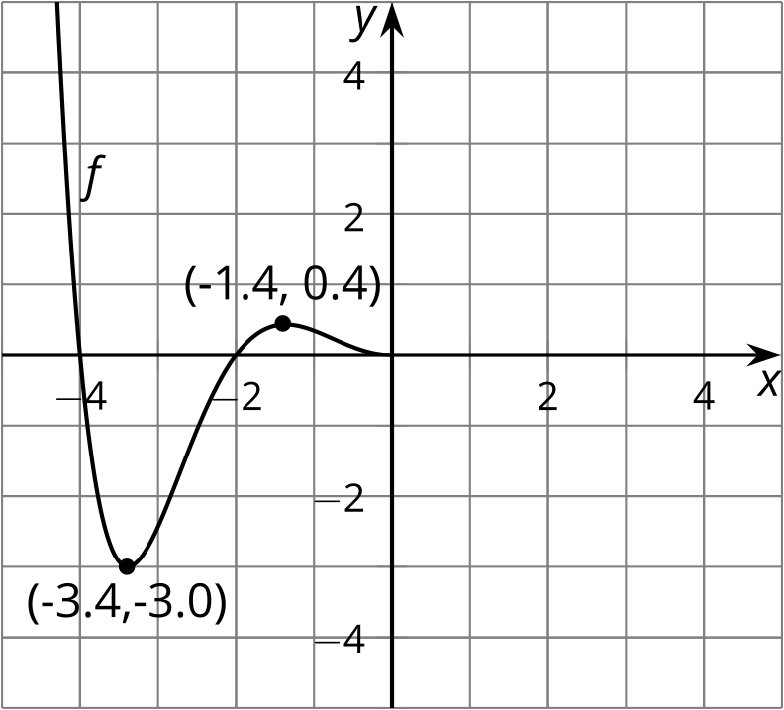
- $f$ is odd
- $f$ is neither even nor odd

6.3: Odd and Even Equations
Take turns with your partner to decide if the function is even, odd, or neither. If it’s your turn, explain to your partner how you decided. If it’s your partner’s turn, listen carefully to their reasons and decide if you agree. If you disagree, discuss your thinking and work to reach an agreement.
- $f\left(x\right)=3x^{4}−2x^{2}+1$
- $g\left(x\right)=x^{3}−x$
- $h\left(x\right)=\left(x^{2}−1\right)\left(x^{2}−4\right)$
- $j\left(x\right)=2^{x}+2^{\text{-}x}$
- $k\left(x\right)=\left(x^{3}−1\right)x$
- $m\left(x\right)=\left(x−0.9\right)x\left(x+1.1\right)$
- $n\left(x\right)=x\left(x^{2}−1\right)\left(x^{2}−4\right)$
- $p\left(x\right)=\left(x^{2}+4\right)\left(x^{2}−3\right)$
- $q\left(x\right)=\frac{1}{x}+x$
- $r\left(x\right)=\frac{1}{x}−x$

Are you ready for more?
Write three equations with at least three terms each where one represents an even function, one an odd function, and one is neither even nor odd. Swap equations with your partner and identify which equations represent which type of function.

Lesson 6 Summary
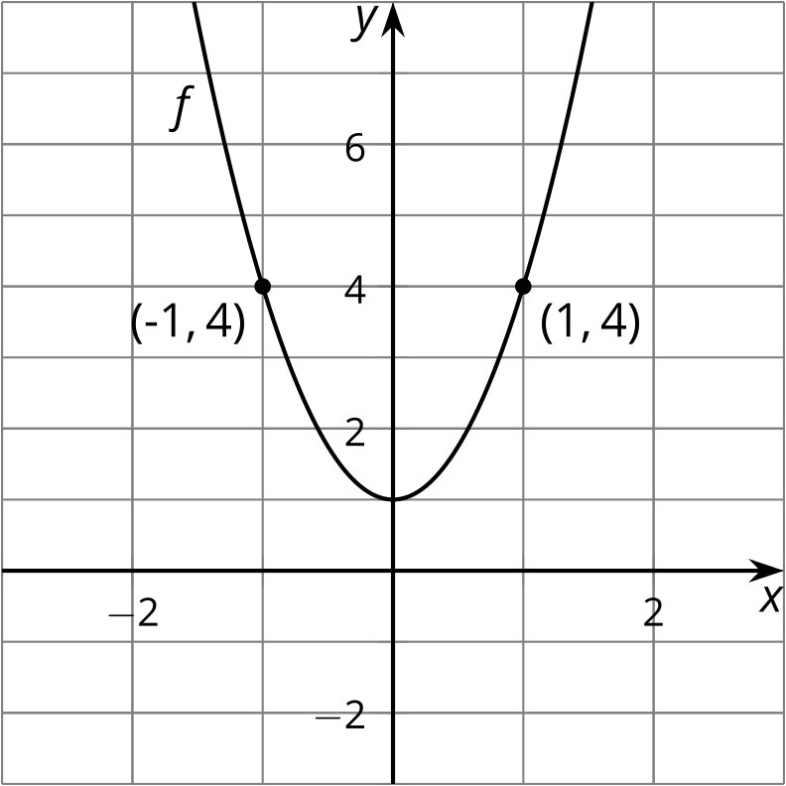
Remember the even function $f$ with this graph from earlier?
An equation for $f$ is $f\left(x\right)=3x^{2}+1$. Since we already know $f$ is even, we also know that the output at $x$ and $\text{-}x$ is the same for any value of $x$ in the domain of $f$. Said another way, $f\left(x\right)=f\left(\text{-}x\right)$ for all inputs $x$. If we didn't know $f$ was even, we could check by using $\text{-}x$ as the input.
For example, since $f\left(x\right)=3x^{2}+1$,
$\begin{matrix}f\left(\text{-}x\right) & =3{\left(\text{-}x\right)}^{2}+1 \\ f\left(\text{-}x\right) & =3x^{2}+1 \\ f\left(\text{-}x\right) & =f\left(x\right)\end{matrix}$
which shows the function $f$ is even.
Let's look at a different function. Consider the function $g$ defined as $g\left(x\right)=e^{x}−e^{\text{-}x}$. Using $\text{-}x$ as the input, we have:
$\begin{matrix}g\left(\text{-}x\right) & =e^{\text{-}x}−e^{\text{-}\left(\text{-}x\right)} \\ g\left(\text{-}x\right) & =e^{\text{-}x}−e^{x} \\ g\left(\text{-}x\right) & =\text{-}e^{x}+e^{\text{-}x} \\ \text{-}g\left(\text{-}x\right) & =e^{x}−e^{\text{-}x} \\ \text{-}g\left(\text{-}x\right) & =g\left(x\right)\end{matrix}$
This means $g$ is odd since $g\left(x\right)=\text{-}g\left(\text{-}x\right)$.
© CC BY 2019 by Illustrative Mathematics®

