Lesson 4: Área de rectángulos

Standards Alignments
Addressing | 3.MD.C.6

Teacher-facing Learning Goals
- Describe and represent the area of a rectangle as the total number of unit squares arranged in equal groups of rows and columns.
- Find the area of rectangles (within 60 square units) by counting unit squares.

Student-facing Learning Goals
- Encontremos el área de más rectángulos.

Lesson Purpose
The purpose of this lesson is for students to continue to count squares to create rectangles and to find the area of rectangles with larger numbers than in the previous lesson.
In previous lessons, students identified equal groups in the rows and columns of arrays. In this lesson, students describe rectangles in terms of the rows and columns. They find the area of rectangles that have rows or columns of 2, 5, or 10 squares to encourage students to skip-count to find the total number of squares. Students should be encouraged to use the term “square units” in preparation for working with more specific units like square centimeters in future lessons. For example, if students find that a rectangle has 12 squares, they should say the area is 12 square units. In the next section, students formally relate area to multiplication.
This lesson has a Student Section Summary.

Access for:

Students with Disabilities
- Representation (Activity 1)

English Learners
- MLR8 (Activity 2)

Instructional Routines
Which One Doesn’t Belong? (Warm-up)

Materials to Gather
- Folders: Activity 1

Lesson Timeline
Warm-up | 10 min
Activity 1 | 20 min
Activity 2 | 15 min
Lesson Synthesis | 10 min
Cool-down | 5 min

Teacher Reflection Question
Reflect on your norms and routines. Are they promoting engagement from all of your students? Are there any adjustments you might make so that all students do math tomorrow?

Cool-down
(to be completed at the end of the lesson) 5min
¿Cuál es el área?

Standards Alignments
Addressing | 3.MD.C.6

Student-facing Task Statement
Encuentra el área de este rectángulo. Explica o muestra tu razonamiento.
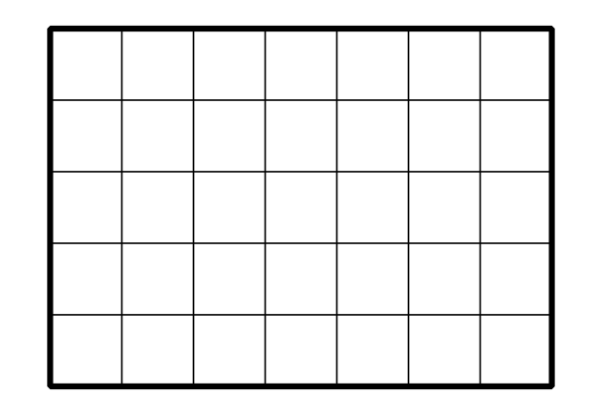

Student Responses
35 square units. Sample response: I counted 7 groups of 5 as 5, 10, 15, 20, 25, 30, 35.

